31 +- acres high of larger site
Zoned Mixed Use + Approved for “Senior Living Campus”

0 River Road
Swygert’s Landing Phase 4, John’s Island
Commercial MLS# 30017789

Zoning does NOT allow for Single Family, Multi Family homes or Apartments!

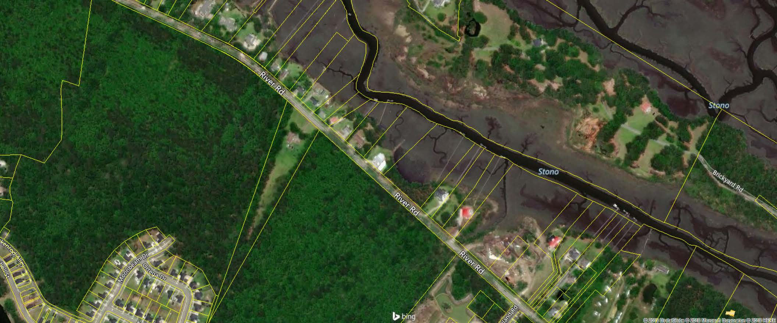

LOOKING FOR A MEDICAL OFFICE and RETAIL/OFFICE DEVELOPER
Senior Living Group is interested but looking for support development on remaining available land. Need all development that would benefit from a complete “Senior Living Campus” and surrounding homes in Swygert’s Landing along with several new communities on River and Brownswood Roads.
Please give me a call and let’s discuss all possibilities for this excellent location between Maybank and Main with plenty of frontage on River Rd.

Contact:
Doug Wells
843.452.5553
Harbourtowne Real Estate

