Wagener Terrace  Open House  This Saturday 12-2  101 Hester St. | 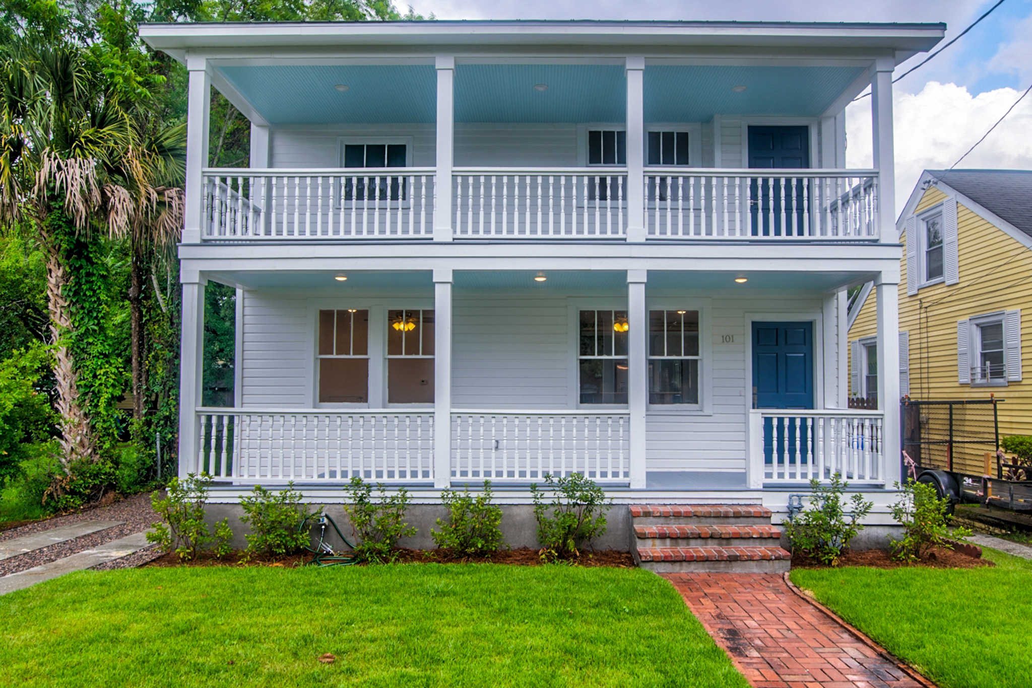
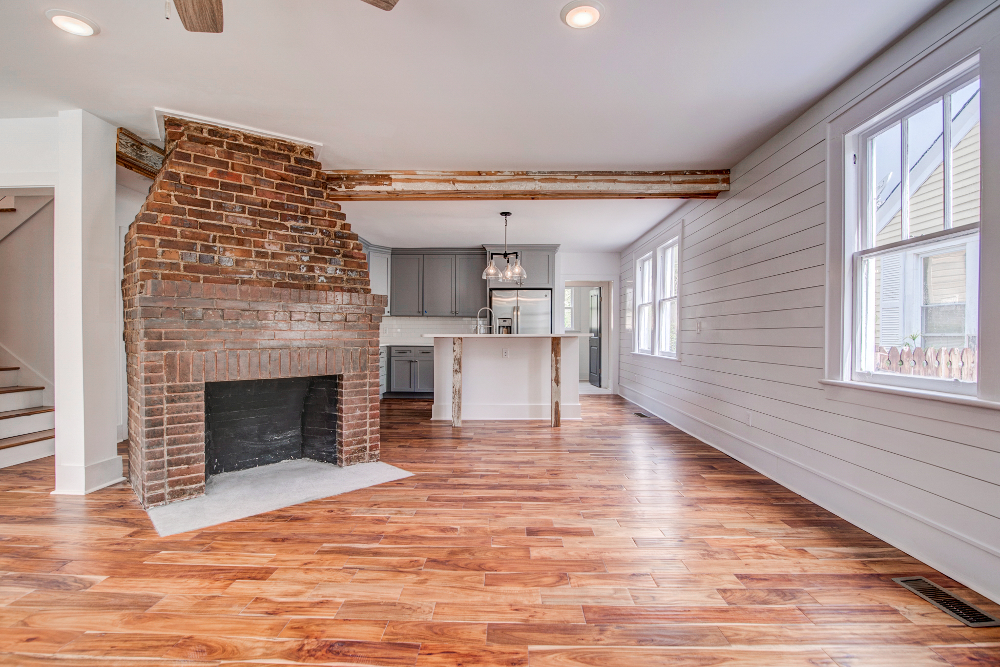 | 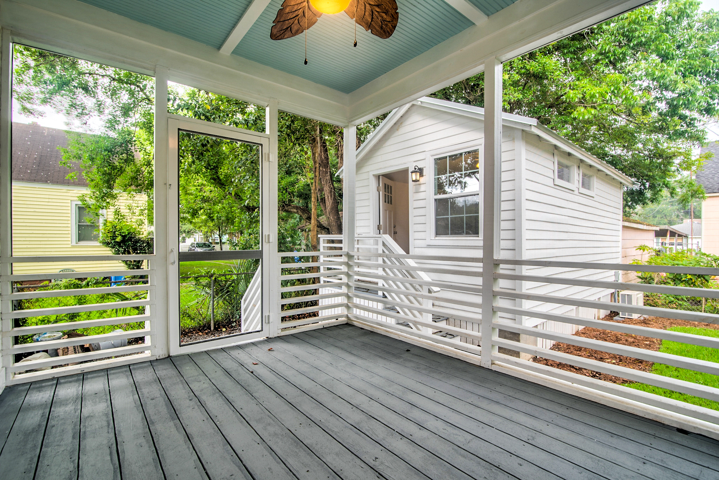

  - 101 Hester St.
This ''Mother-Daughter'' home was originally built in 1938 and radiates charm and historic appeal. It has been totally renovated and converted into a spacious single family 3bd 2.5ba home with a bonus room downstairs, mudroom, laundry room, completely restored front porches, and a legally compliant efficiency apartment in the rear that can be used for guests or to rent out for short-term or long-term rent income. $835,000. MLS #20016070. Call for more info. 919-638-5618


