AGENT OPEN HOUSE – TUESDAY AUGUST 1ST – 11:30 AM – 1:30 PM
GAHAGAN EAST – SUMMERVILLE – 101 YORK COURT
LUNCH PROVIDED!!!! COME PREVIEW THIS WONDERFUL HOME!!!
GREAT Location! Close to everything!! Custom floorplan, one of the largest lots in Gahagan East and wooded in back. 2-story foyer, hardwood floors, large Family room with gas logs fireplace and formal dining room is oversized with crown molding, tray ceiling and wainscoting. The kitchen has ceramic floors, tile backsplash, island and a large bay window, and includes lots of cabinets and pull-out drawers. Master bedroom includes tray ceiling, bay window and 2-door entry, and Master bath has garden tub, shower and dual vanities. Lots of closets. Private backyard - fully fenced!! Large screened porch! New Roof in 2015, new HVAC in 2013. $1000 BONUS to Selling agent at Closing. This is a GREAT Home!!!
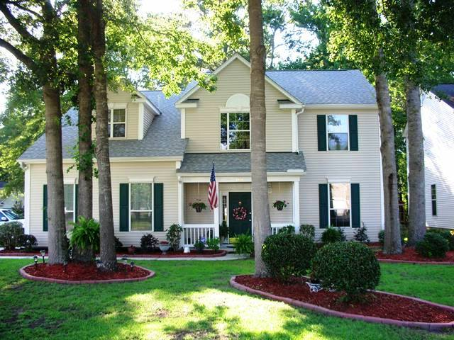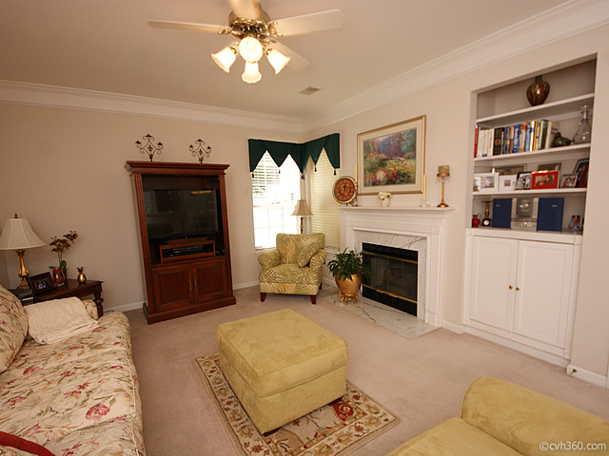
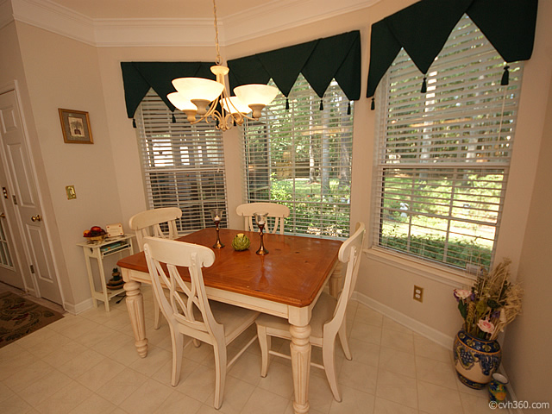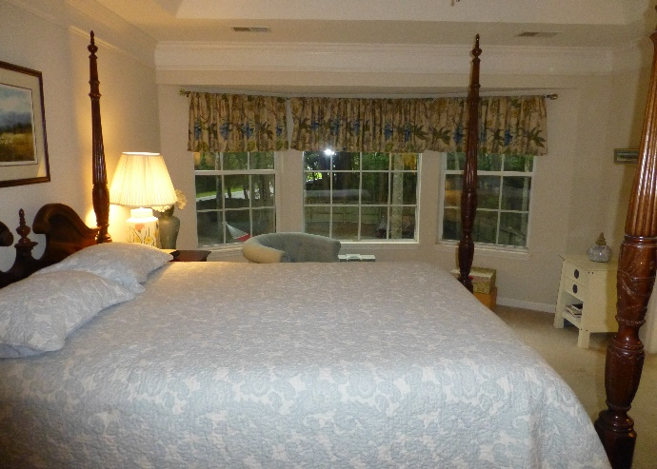
101 York Court, Summerville, SC 29485 (MLS # 17020484)
Randy Espeseth, Carolina Elite Real Estate
843-743-1025 Randy@RandyEHomes.com

