




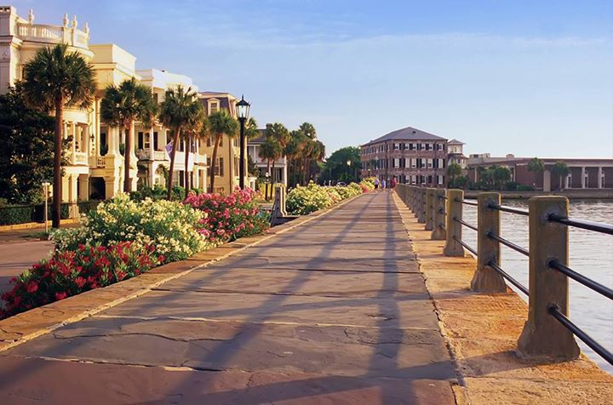
~
1025-617 Riverland Woods Pl
MLS # 16015258

- 2Bdr / 2 Bath
- 3rd FLOOR UNIT
- ELEVATOR

- SCREENED IN PORCH / COVERED PATIO
- WOODED NATURAL SETTING
- GREAT AMENITIES ~ POOL ~ FITNESS CENTER ~ BOAT STORAGE

AGENTS PLEASE DO NOT MISS THIS CONDO SO WORTH YOUR CLIENTS TIME AND PRICED TO SELL!

Welcome Home to The Retreat at Riverland Woods

WELCOME HOME TO YOUR GATED NATURAL SETTING RETREAT!

JUST 10 MIN TO HISTORIC CHARLESTON AND 4MIN TO
FOLLY BEACH! ~ ESCAPE IN THE RESORT STYLE POOL SURROUNDED BY GORGEOUS LANDSCAPING, GRILL AREA, WALKING TRAILS OR HIT THE GYM!

GREAT LAYOUT! 2 BEDROOM PLAN ~ PERFECT FOR GUESTS OR A ROOMMATE.

3rd FLOOR UNIT MEANS NO ONE ABOVE YOU AND THE VIEW FROM THE PORCH/PATIO WILL MAKE YOU THINK YOU ARE LIVING IN A TREEHOUSE!

Offered at $199,750
FACTS & FEATURES

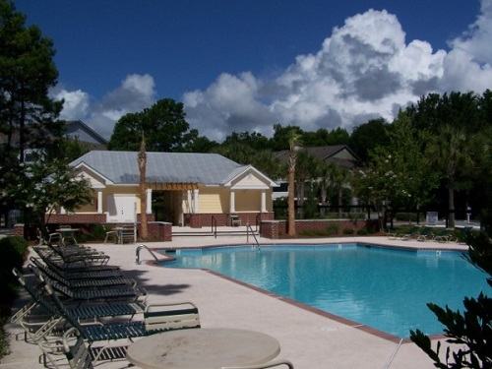
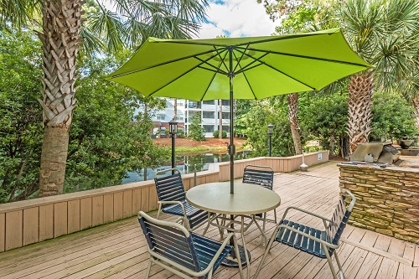
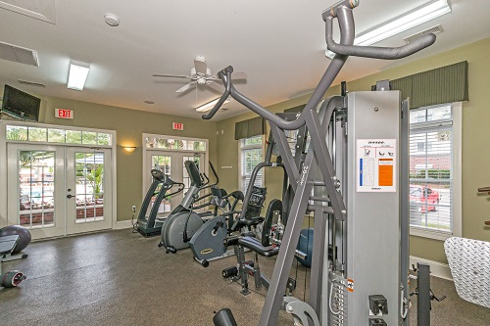
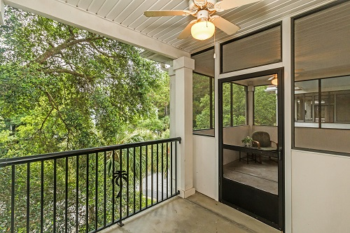
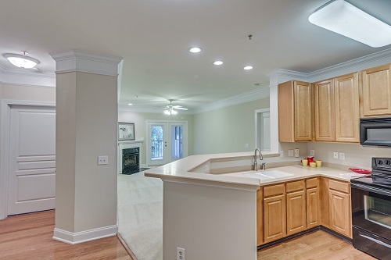
“Charleston is your forever love. It is a perfect blend of character and class. There is always something, but not too much. It is playful and it romances you.”
– Rebekah Phillips
Heather Lord
Broker Associate, GRI, e-PRO, RSPS
Keller Williams Realty Charleston
www.heatherlord.com
heather@heatherlord.com
Phone: 843.810.9414

