$5,000 AGENT BONUS!!!
Mount Pleasant area 42, IMPROVED PRICE! $944,963
MLS 18021907
1039 Wharf Indigo Place
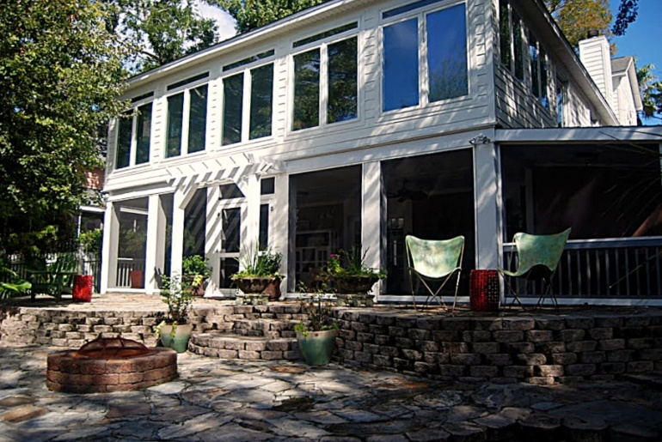
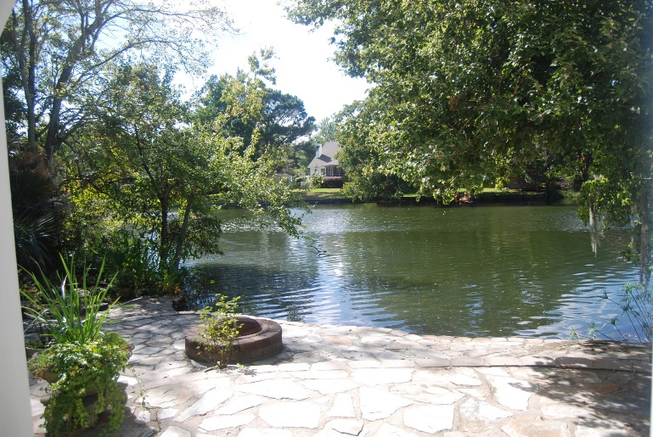
4 BR, 4.5 Bath 5123 Sq. Ft.
Overlooking Lake Cooper
No HOA, Flood Insurance not required
Located in the back of Creekside
Deep water access via Creekside Boat Landing
Exterior recently painted!

Kathleen Jordan
The Boulevard Company
843.442.0782
kathycharleston@gmail.com

