$10,000 AGENT BONUS!!!
Mount Pleasant area 42 $994,963

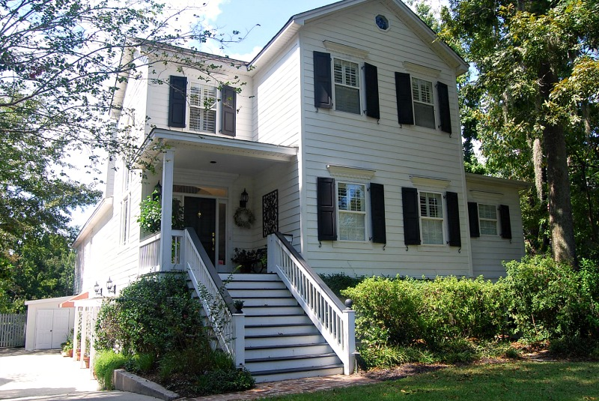
MLS 18021907
1039 Wharf Indigo Place
4 BR, 4.5 Bath 5123 Sq. Ft.
On Lake Cooper
No HOA, located in back of Creekside
Deep water access via Creekside Boat Landing
*Exterior paint color has been changed to white

Kathy Jordan
The Boulevard Company
843.442.0782
kathycharleston@gmail.com

