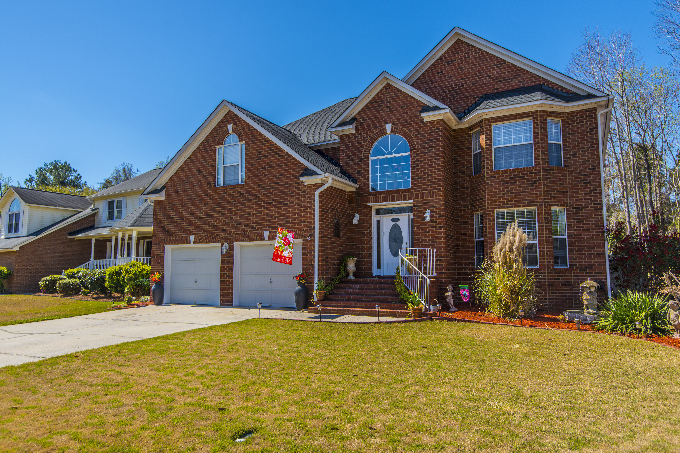
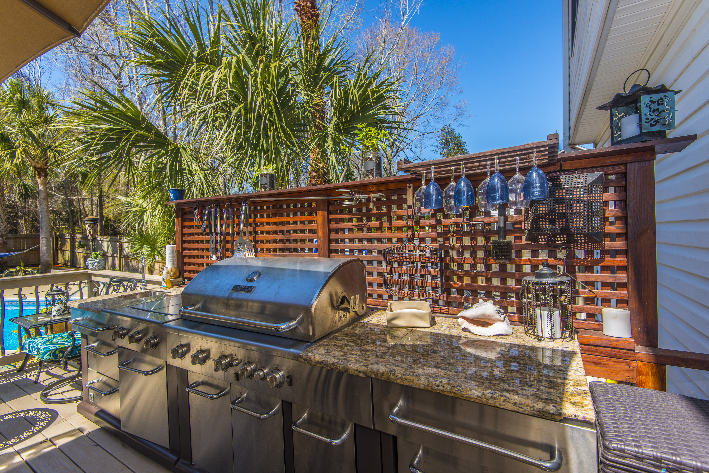
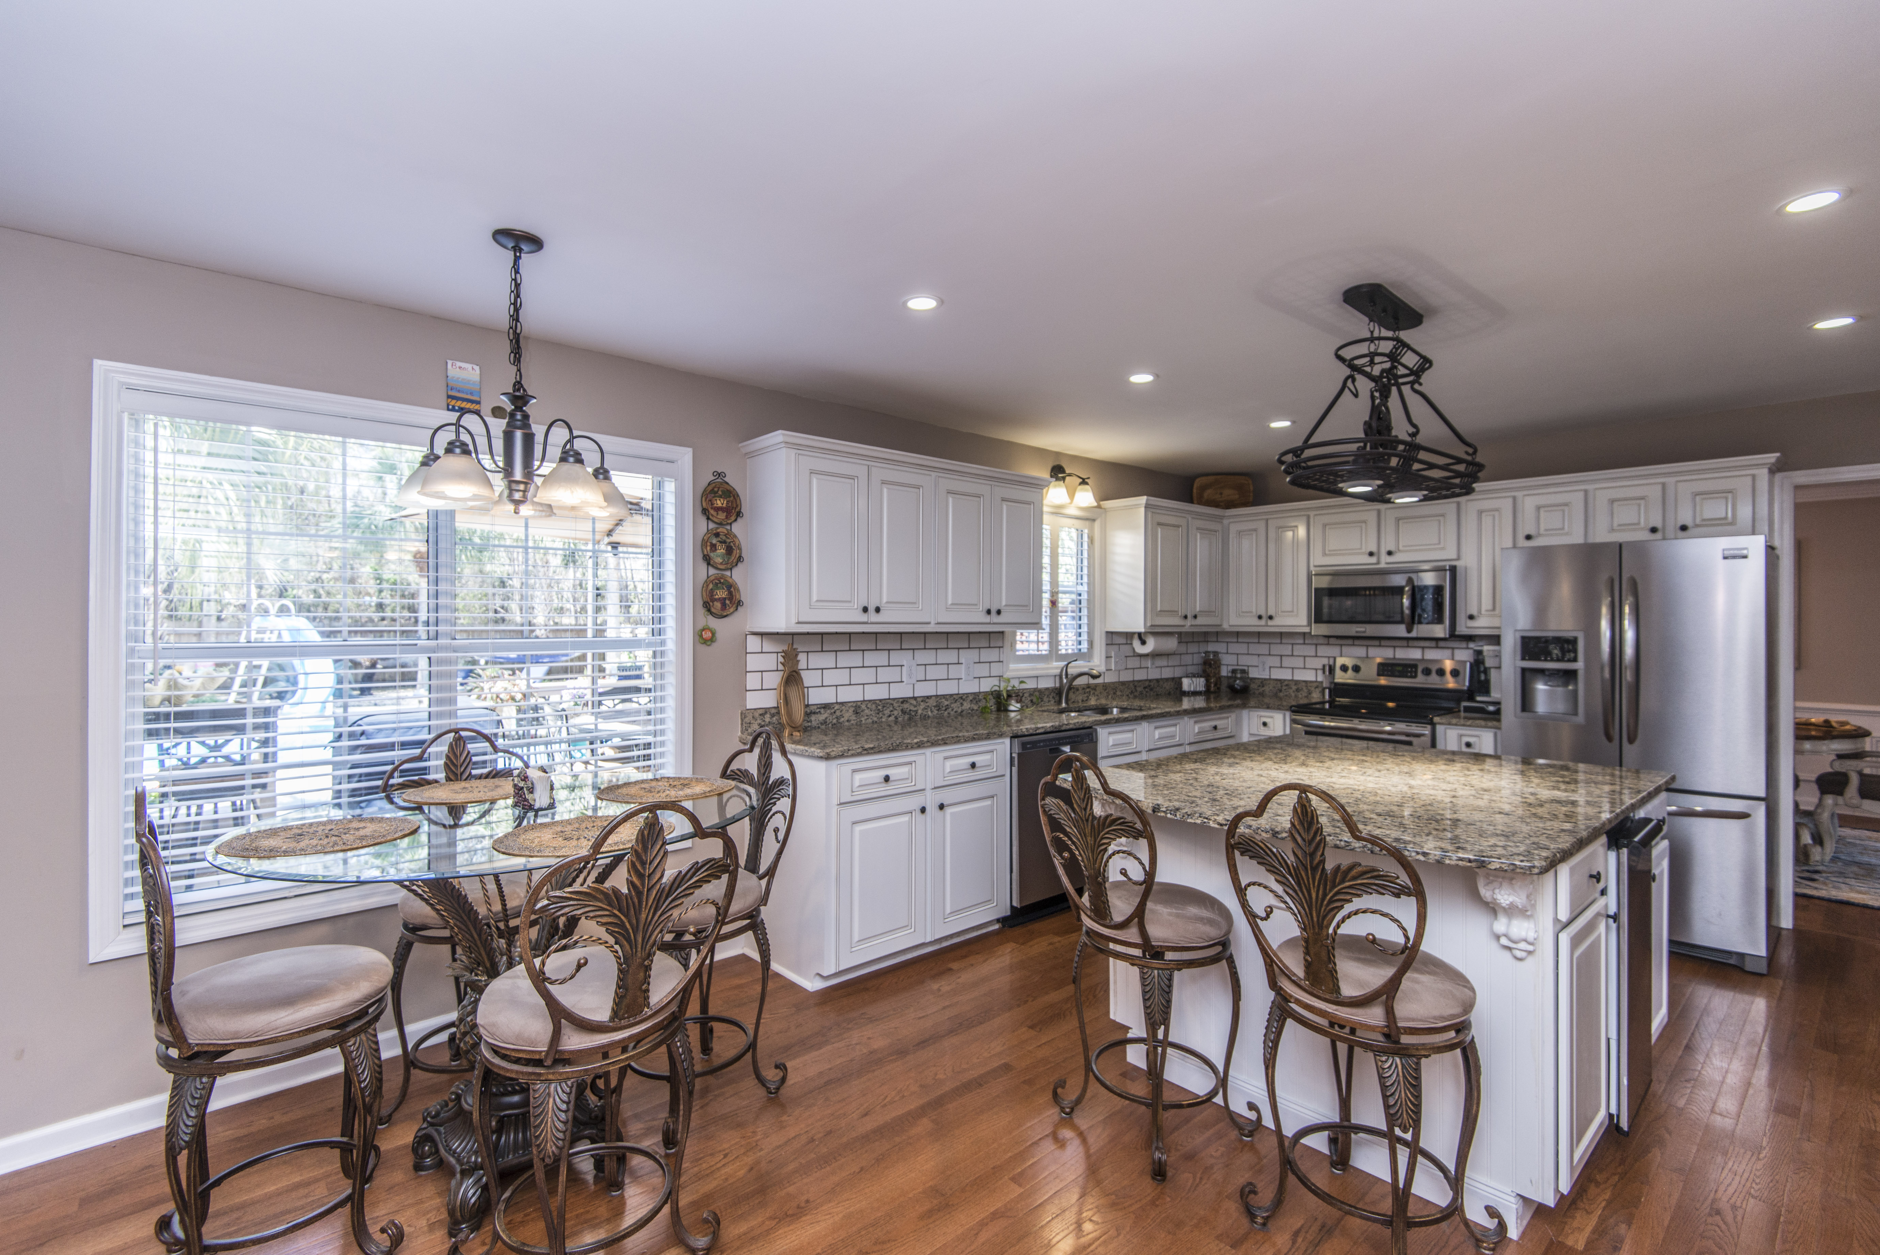



103 N. Warwick
The Hamlets at
Crowfield Plantation

$425,000

Beautiful Home Updated Throughout with Saltwater Pool and Outdoor Kitchen.

Agent Open House
Thursday April 5 ~ 10am-Noon
$100 Gift Card
- 2730 Square Feet
- 4BR/2.5BA
- Chef’s Kitchen with Large Island
- Hardwood Floors and New Carpet in FR
- Chef’s Kitchen
- Inground Pool + Outdoor Kitchen

Financing Incentives

$2200 in Closing Cost Assistance with Use of Preferred Lender.

Geri Lipps 843.810.8398
glipps@carolinaone.com

