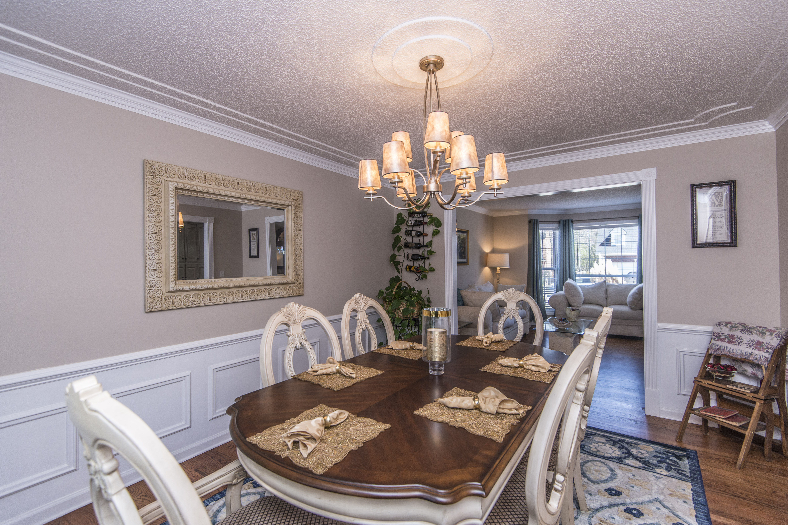
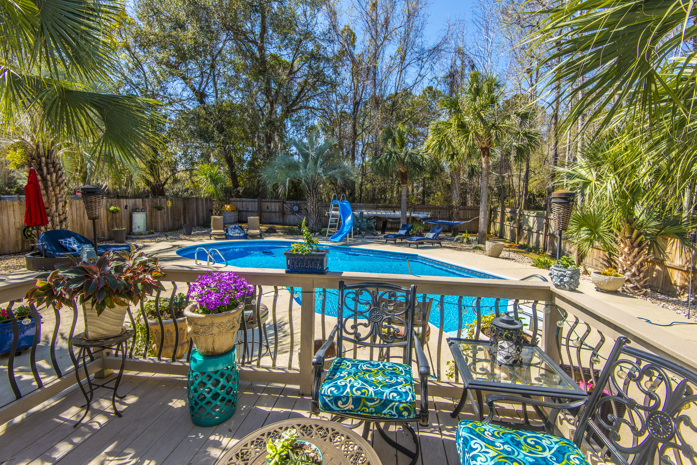
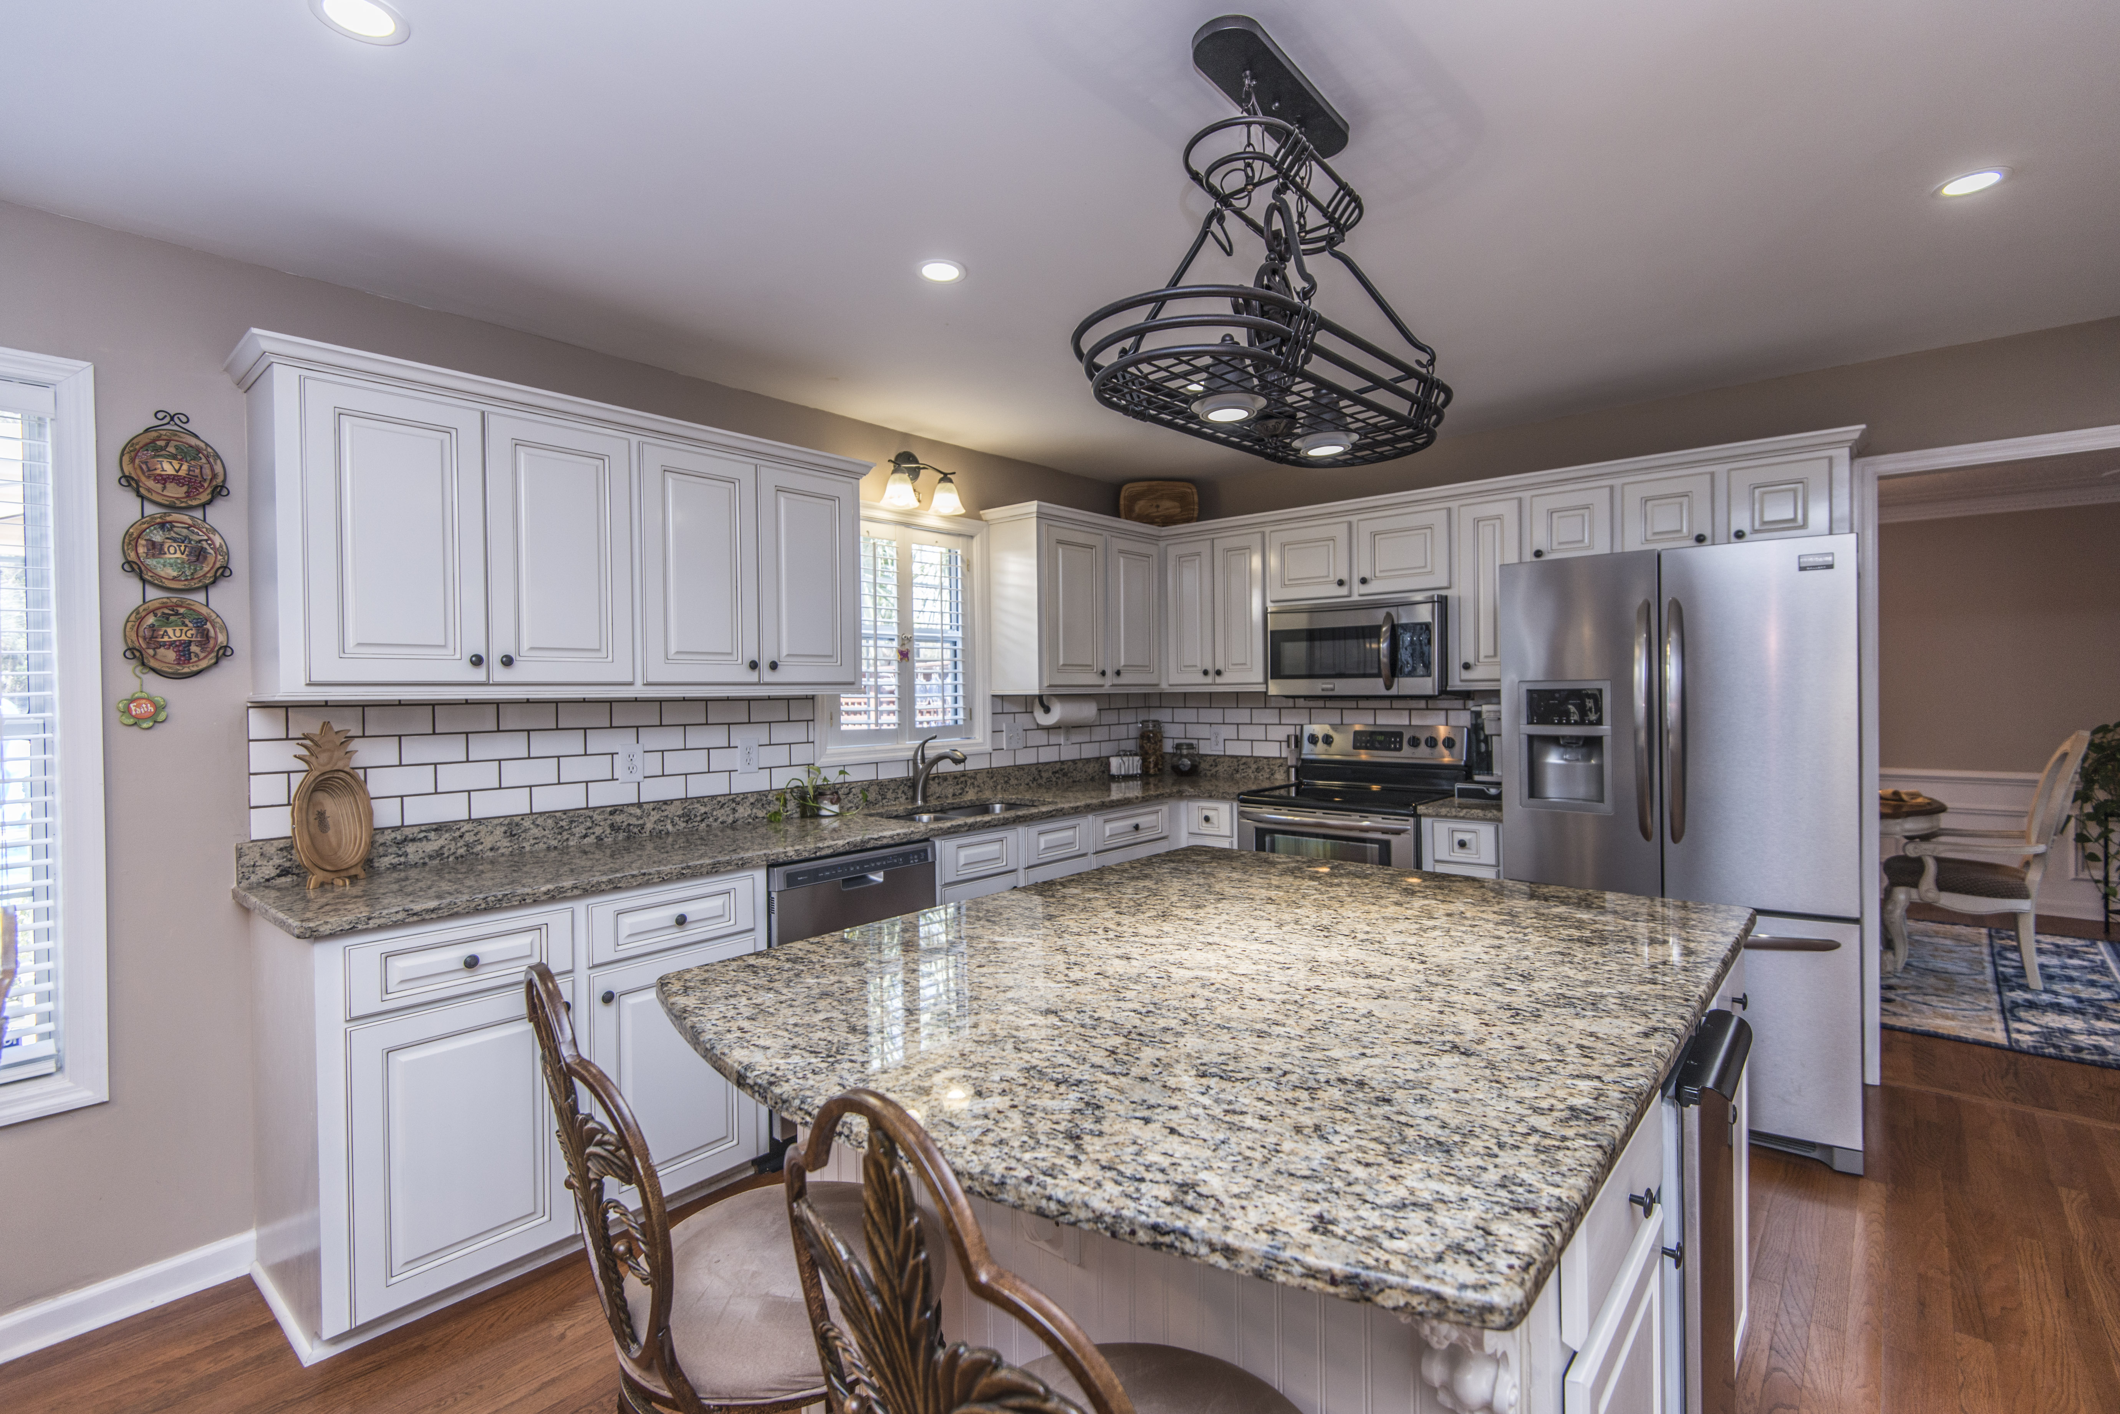


Beautiful Home
with
Updates Throughout
- 2730 Square Feet
- 4BR/2.5BA
- Chef’s Kitchen with Large Island
- Hardwood Floors and New Carpet in FR
- Chef’s Kitchen
- Inground Pool + Outdoor Kitchen
- Hurricane Shutters
The Hamlets
In
Crowfield Plantation

Financing Incentives

$2200 in Closing Cost Assistance with Use of Preferred Lender.

$425,000

103 N. Warwick
Geri Lipps 843.810.8398
glipps@carolinaone.com

