1054 Dominion Drive Hanahan, 29410
Open House – Sunday June 28th 1-4pm

5 Bedrooms 4 Bath – Executive home perfect for Entertaining. Located on a cud-de-sac
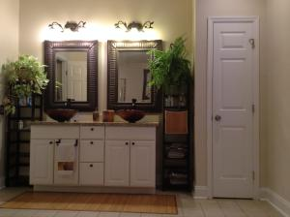
700(sq ft) First Floor Master Suite
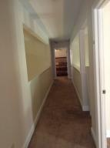
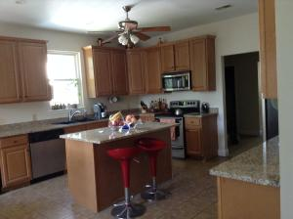
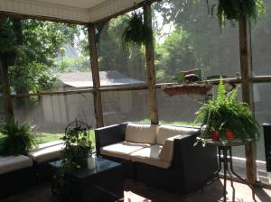
Location- Location – 15 minutes to the airport, Tanger Outlets, Daniel Island
The 2nd Floor has 3 Bedrooms 2 full Bathrooms a Game Room and an office.
Don’t forget the Frog or 5th Bedroom with ½ Bath off the Kitchen

