1054 Dominion Drive Hanahan, 29410
Just Reduced
Now 384,000
Open House – Sunday August 2nd 1-4pm

5 Bedrooms 5 Bath –Spacious home perfect for Entertaining. Located on a cul-de-sac
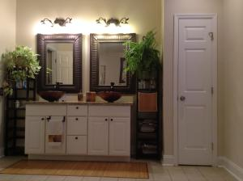
700(sq ft) First Floor Master Suite
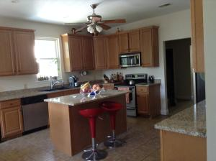
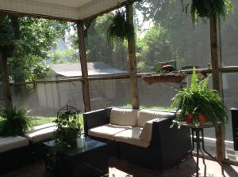
Location- Location – 15min to the airport, Tanger Outlets, Daniel Island and downtown
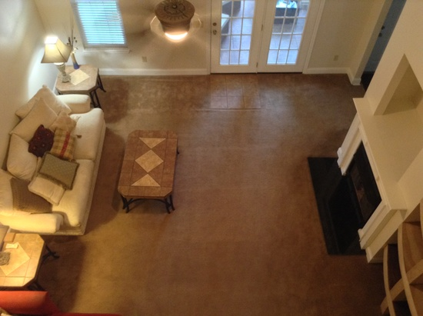
No HOA and room to park your boat!
Large Private Yard- 12x14 Shed with Electric -Walking distance to schools

3K Agent bonus and AHS warranty

