1054 Dominion Drive Hanahan, 29410

5 Bedroom – 5 Bath Home perfect for a big Family

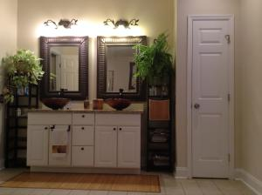
700 sq ft - First Floor Master Suite
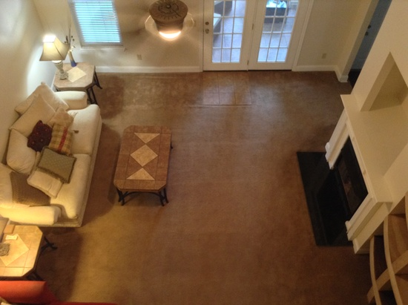
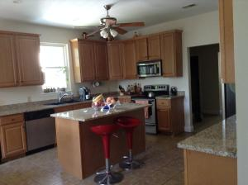
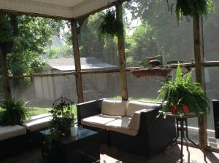
Location, Location – 15 minutes to the airport, Tanger Outlets, Daniel Island
and downtown
Features: Workshop/Shed with Electric
Granite, Updated Fixtures, tiled Porch
Walking distance to schools
Closets Galore, Great floorplan

