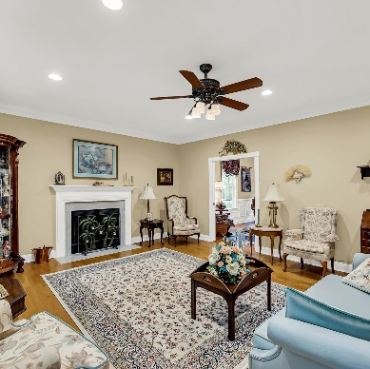
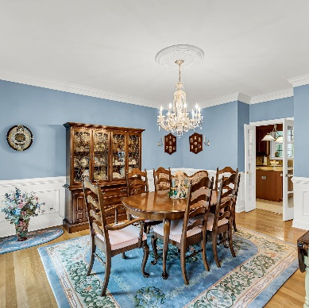
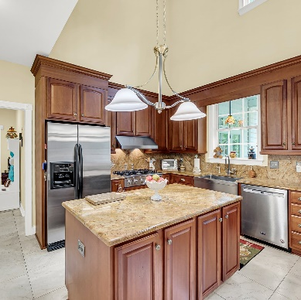
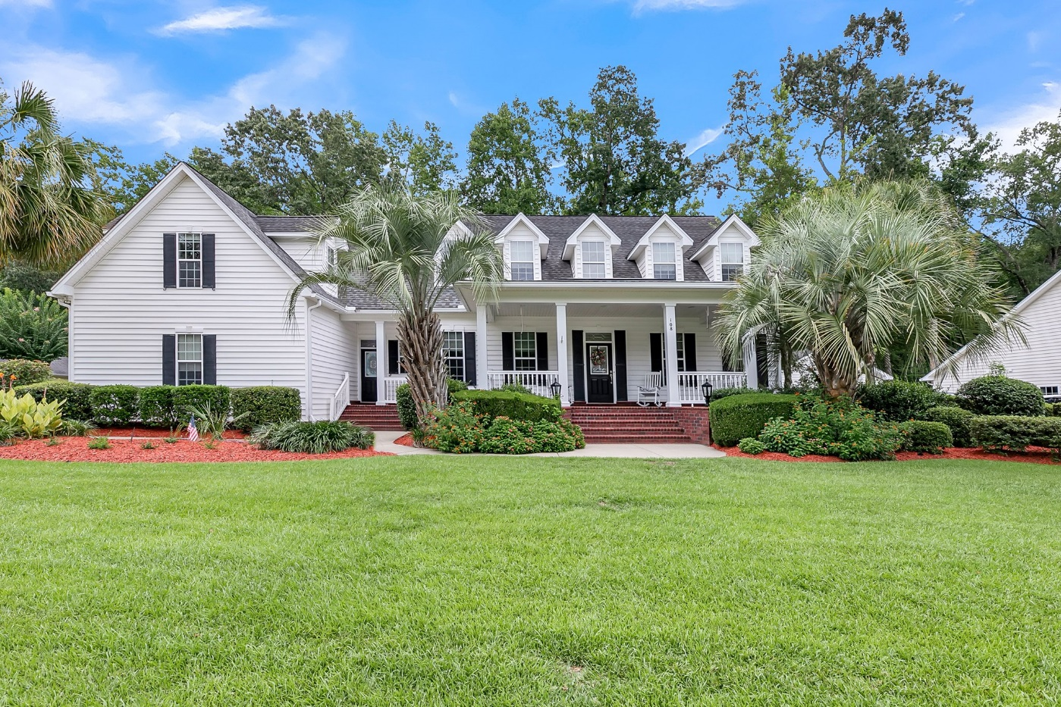
OFFERED AT $749,000
108 Duck Blind Ct.
Boykin Creek Subdivision
Summerville, SC 29483
MOTIVATED SELLER
HAS REDUCED PRICE AGAIN!
on this Gorgeous Home
Carolina One Real Estate Elise H. Stutts, Realtor 843-437-5242 www.lowcountryschomes.com
En
MLS# 24018647

Year Built: 2005
Approx. 3600 sq. ft.
0.84 acre lot
Master bedroom downstairs with access to screened porch.
3 Bedrooms up and a huge FROG.
3.5 baths with marble floors and jetted tubs.
Huge Chef’s kitchen with 6 burner gas stove, double ovens and granite countertops.
2 Car Garage
Hardwood Floors in living areas.
Slate tile front porch and back screened porch.
Fenced backyard with view of golf course.
Beautifully landscaped with irrigation and night lighting.
Dorchester District II Schools.

PRICE REDUCED AGAIN AND NOW OFFERED AT $749,000!! That is $208/SF for this gorgeous executive home in Boykin Creek conveniently to shopping, schools, and Summerville’s best restaurants! This home was a builder’s home so there are upgrades galore including lots of crown moulding, paneled wainscoting, door and window mouldings with rosettes, Spanish stone tile in the kitchen and FROG as well as a walk-in attic storage area. Hardwoods can be found throughout the home including the master bedroom. Only the upstairs bedrooms have carpet. Enjoy the 36 ft long screened porch with 3 ceiling fans while overlooking the beautiful yard and golf course beyond. There are separate HVAC’s for each floor and both are fairly new. Crawlspace has been fully encapsulated. Fully fenced yard for the safety of children and pets. Come view this special home to appreciate all it has to offer. SELLER IS READY TO MOVE!!!!!

