EASY TO SHOW!!!

108 Duck Blind Court
Boykin Creek Subdivision
Summerville, 29483
MLS# 24018647
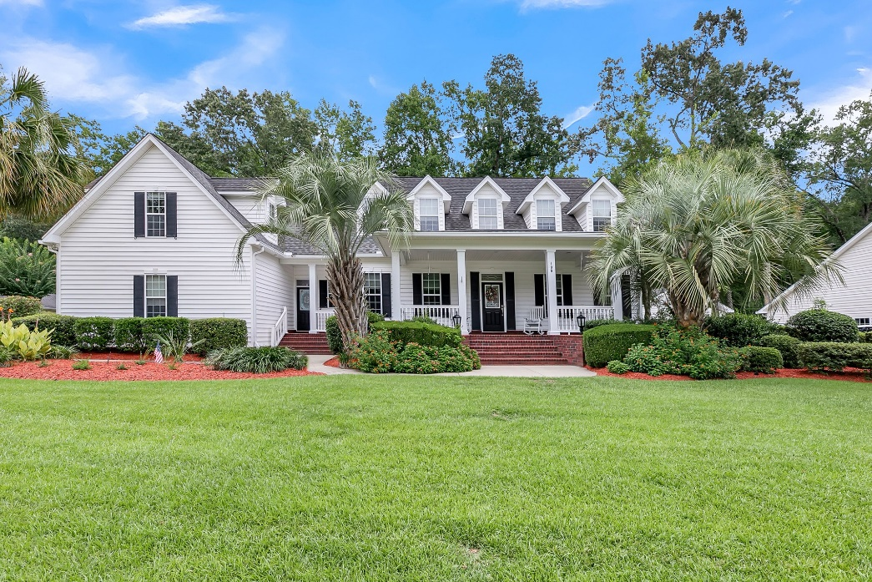
Elise Stutts
900 N. Main Street
Summerville, SC 29483
Phone: 843-437-5242
Email: ehstutts@carolinaone.com

REDUCED TO $699,000!!!

SHOWINGS ARE NOW “GO AND SHOW”!! Listed at $194/square foot, this is a buyer’s opportunity to own this beautiful 3600 SF executive home on 0.84 acre lot, hardwoods, master down, chef’s kitchen, huge screened porch, walk-in attic storage and much more. Less than 3 miles to downtown Summerville. Dorchester District II schools. Lot backs up to Summerville Country Club golf course. Schedule your tour today!


