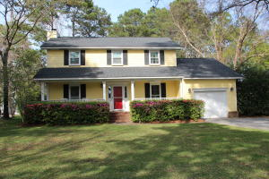
1101 Ambling Way
Snee Farm
4 bedrooms, 2 ½ bathrooms
2090 square feet
$450,000
Beautiful 4 bedroom 2.5 bath home on a gorgeous corner lot (.39 acres) in highly desired Snee Farm. Home has an inviting front porch and hardwood flooring throughout the main living space. The bright, open den flows effortlessly to the peaceful sunroom. Here, find loads of custom built-ins, wainscoting and access to the deck overlooking the lush back yard. The kitchen has a large bay window which also overlooks the back yard. From the kitchen, a separate staircase leads to the FROG which could be used as a 4th bedroom, playroom, or office. The three remaining bedrooms and two full bathrooms make up the remainder of the upstairs. The updated guest bathroom includes tiled shower and double sinks. The spacious master bedroom has a large walk-in closet.
Easily ride bikes or take your golf cart to the private club (membership available) which includes golf, tennis, and swim. Snee Farm is an established neighborhood just minutes from Town Center, 526, and the beaches.

Lauren D. Courcoux, REALTOR®
843-224-8613

