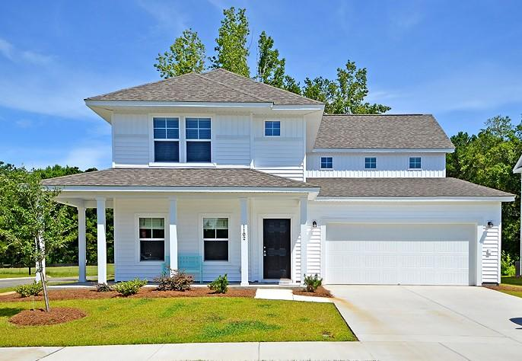
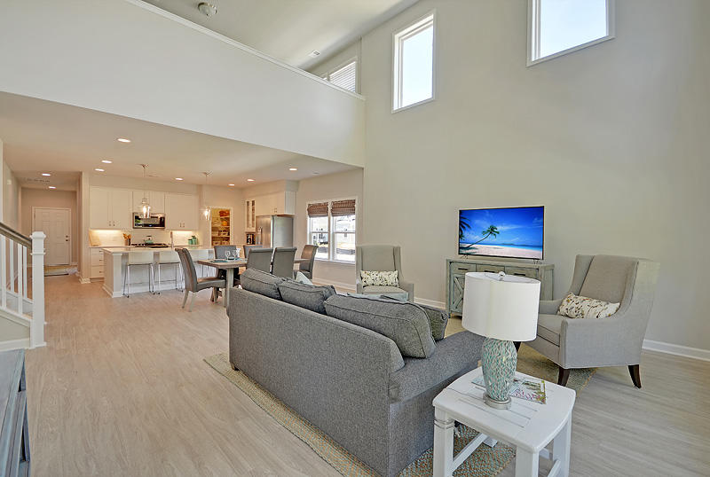
1102 Turkey Trot Drive

Open House

Sunday….1:00 to 4:00

August 5, 2018
Gorgeous Upgrades throughout- Built 2018
Open concept, Soaring Ceilings, Custom Lighting

