    - Just Listed!
  1105 Somerset Court
  Mount Pleasant, SC 29464
  4 bedrooms, 3.5 baths, 3,500+ sqft
  $695,000 - MLS #1423638
  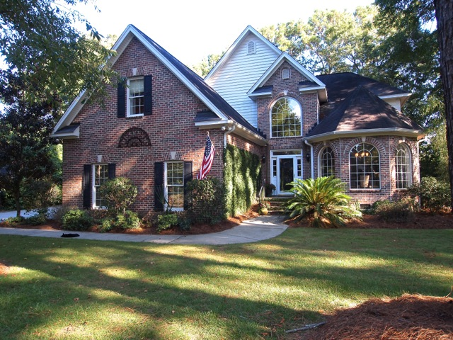
  Situated on an expansive lot this custom home offers privacy, lush landscaping, upgrades and quality craftsmanship throughout. Enjoy an open floor plan boasting large living spaces, hardwood floors, lovely crown molding and wainscoting. Great room features a gas log fireplace, built in cabinets, vaulted ceilings, transom windows and French doors leading to the backyard and patio. The spacious kitchen is an entertainer’s dream with granite countertops, updated Stainless steel appliances, Center Island with gas cooktop, wine fridge, built in desk, bay windows, pantry and storage galore. Kitchen leads to large formal dining room. Master suite downstairs includes en suite bath with 2 large walk in closets, dual vanities and garden tub. Large laundry room downstairs also offers space as mud room. Wooden staircase leads to 3 bedrooms, 2 baths and media room complete with attached theatre seating, movie screen and projector. Additional highlights include attached 2 car garage, fenced in backyard, patio, upgraded light fixtures, split A/C units, with the downstairs unit new in 2014, and the upstairs unit new in 2012, 80 gallon hot water heater new in 2014, Terminex bond, detached storage shed for yard equipment, security system, and loads of storage throughout. The best of Mount Pleasant living right in the heart of town.
  ****Agent Open House ****
  Thursday September 11th
  10:00am – 11:00am
  
  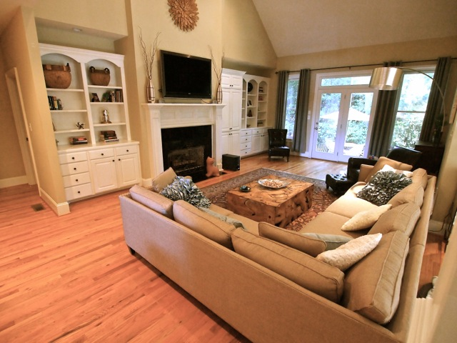
  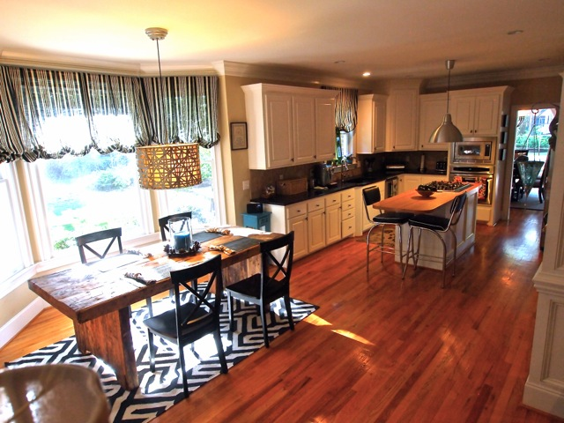
  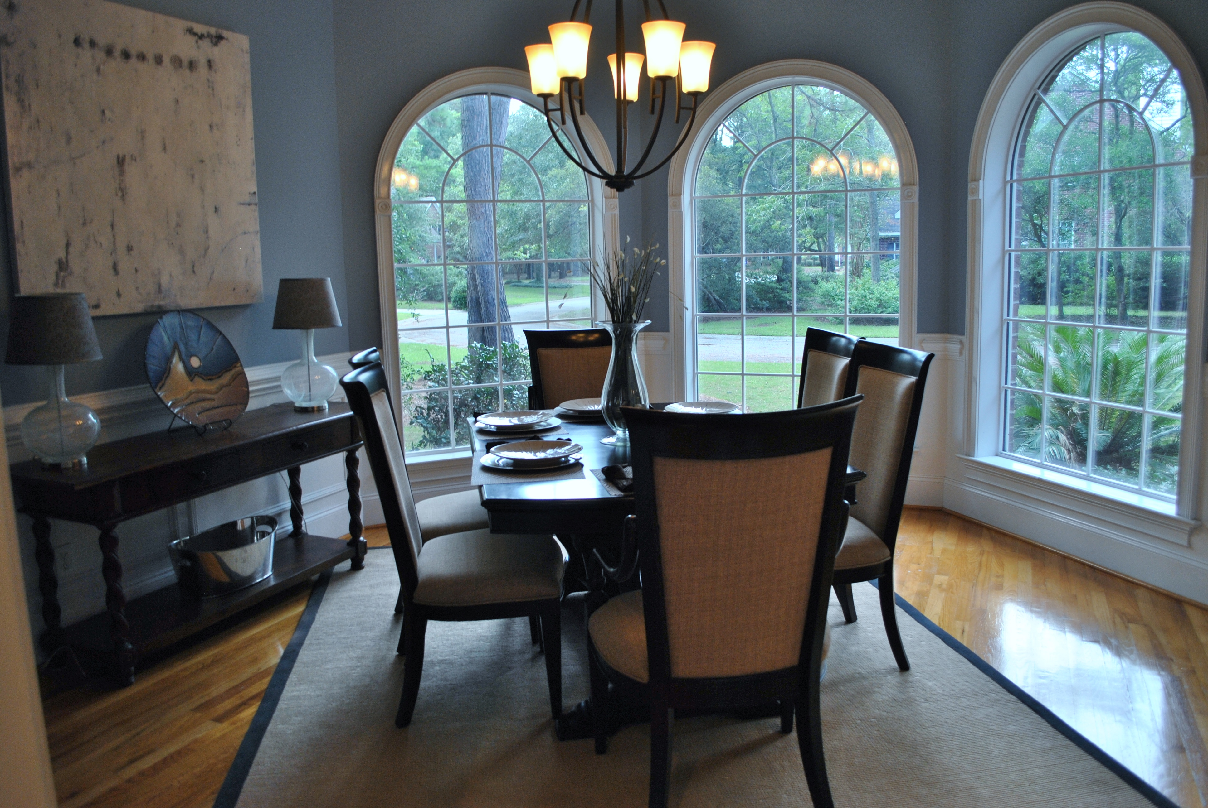
  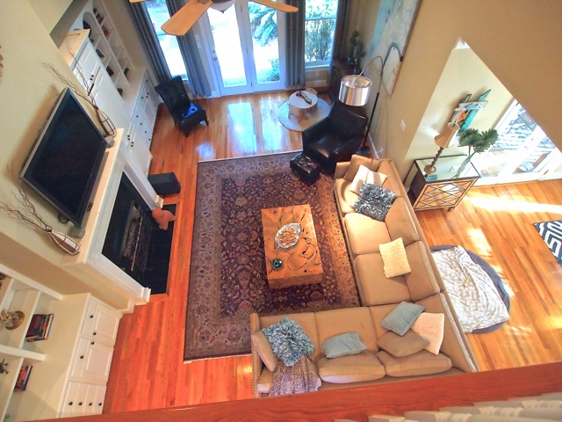
  Crissy Rowell, Realtor®
  Carolina One Real Estate
  843.377.5177
  crissy.rowell@carolinaone.com
  www.CrissyRowell.com
  
  

