Open House

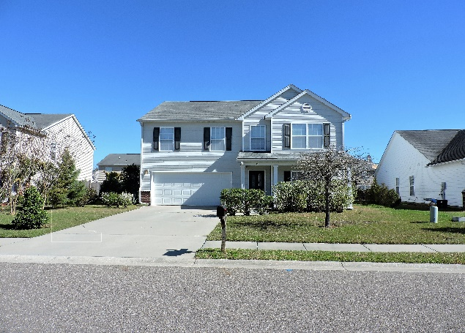
115 Rundle Lane, Summerville, SC 29483
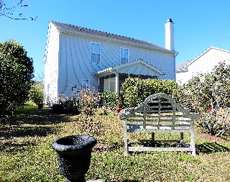
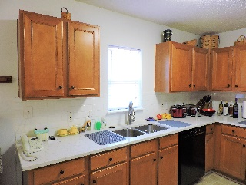

Great home in Weatherstone!
Come join us on Thursday April 13th, from 12-4 and enjoy snacks, refreshments, and a beautiful home!
There will be a raffle for a $25 gas card!!

Beautiful upgraded 2,300 square foot home
4 Bedrooms, 2.5 Baths
Garden tub and walk in shower
Silestone counter tops and subway tile backsplash in Kitchen
Close to interstate, restaurants, shopping, and more!
Move in ready and will not last long!
Only $221,990!



James Skelton
AgentOwned Realty
843.607.5533
Jskelton@agentownedrealty.com
JamesSkeltonRealty.com

