Available Sept 5th 2015

Gerri Sandford
Exit Realty The Tracey Group
843-817-8762

Southern Charmer

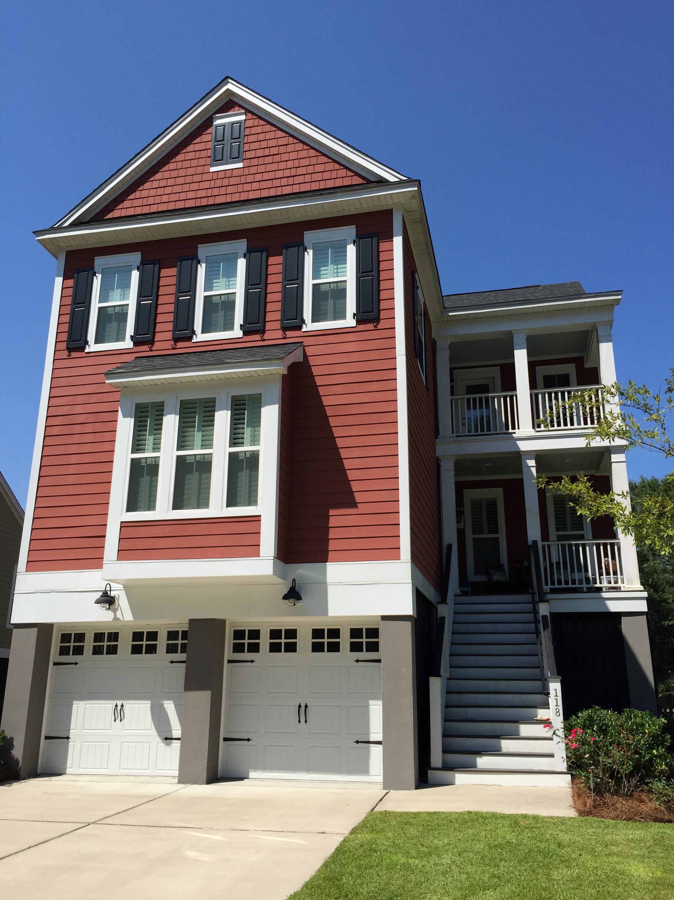
Shellring at St. Thomas
Daniel Island

Offered at $469,900

Highlights
4 Bedrooms 3.5 Baths
4 Porches
Upgraded Kitchen
Gameroom and Loft
Private lot
Gas FP
Possible rent until closing
Daniel Island Schools

