Southern Charmer

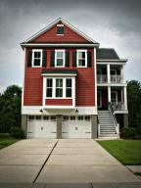
118 Clouter Creek Drive

Offered at $469,900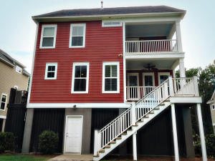

Highlights
4 Bedrooms 3.5 Baths
4 Porches
Upgraded Kitchen
Private lot
Gas FP and Stove
Daniel Island Schools
2 miles to downtown Daniel Island
Golf cart path

