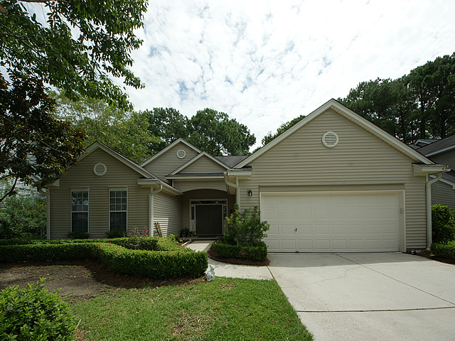
Open House Saturday August 6th 1-3 pm
1202 Willoughby Lane
Park West ~ MLS# 16020338 ~ $389,000
3 bedrooms, 2 bathrooms, 2,220 square feet
Welcome home!! A beautifully maintained one story home in the Foxmoor section of Park West. With 3 bedrooms and 2 bathrooms with an additional room for an office/study/or craft room, this home won't disappoint! Dark bamboo floors run throughout the home and master bedroom suite with carpet in other bedrooms and office. There are plantation shutters that give plenty of privacy or natural light. Upon entering the home, the large foyer opens into an impressive and sun filled living room that is perfect for entertaining. This room has a gas log fireplace as well as built-ins. The large eat-in kitchen features stainless steel appliances and a beautiful island. The numerous cabinets in the kitchen offer plenty of storage and feature pull out drawers! There is a separate formal dining area that connects to the family room. The master bedroom is situated in the back of the house. The master bathroom offers a garden tub, shower and double vanities as well as a separate toilet room. The master walk-in closet is very spacious. This home has 2 additional spacious bedrooms with great closet space that share an updated full bathroom. This home boasts a spacious screened porch that can be seen through the home with its beautiful windows. The porch has skylights and is accessible from the master bedroom, family room, as well as the additional fourth room. The porch overlooks an easy to maintain wooded and private backyard. A double car attached garage offers more storage. The Foxmoor neighborhood is ideally situated within Park West. This home allows you to easily walk or bike to the amenities center which offers two swimming pools, a park, volleyball, and tennis courts. The award winning Park West Schools and the Town of Mt. Pleasant Park and Recreation Department are also a short walk or bike ride away. Sellers are offering a 1 year home warranty with an acceptable offer. Make this your perfect family home today!

Lauren D. Courcoux, REALTOR®
843-224-8613
lauren.courcoux@carolinaone.com

