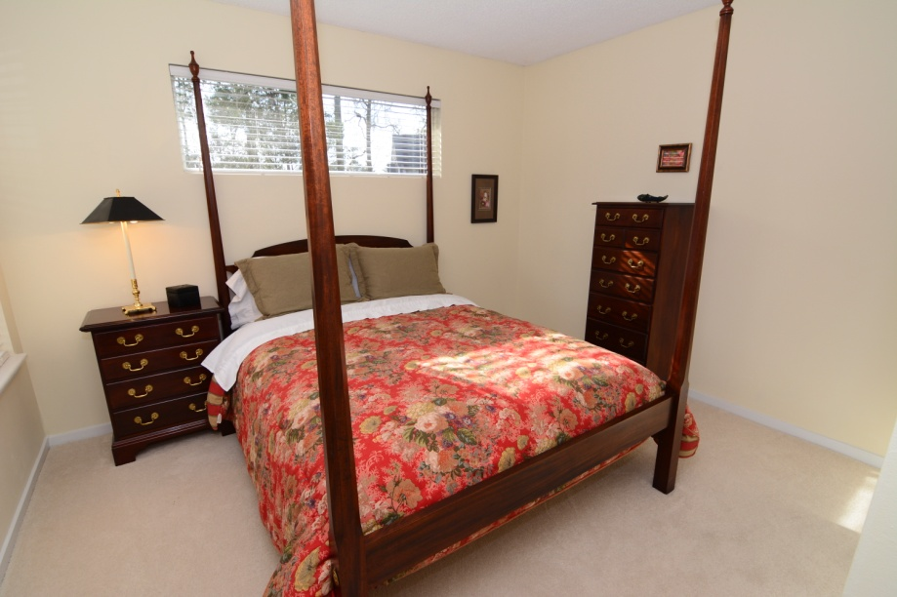
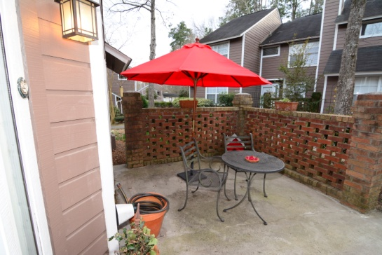
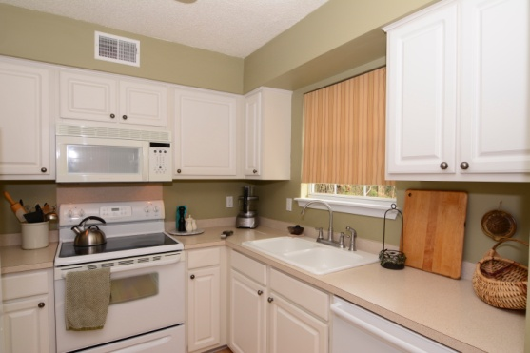
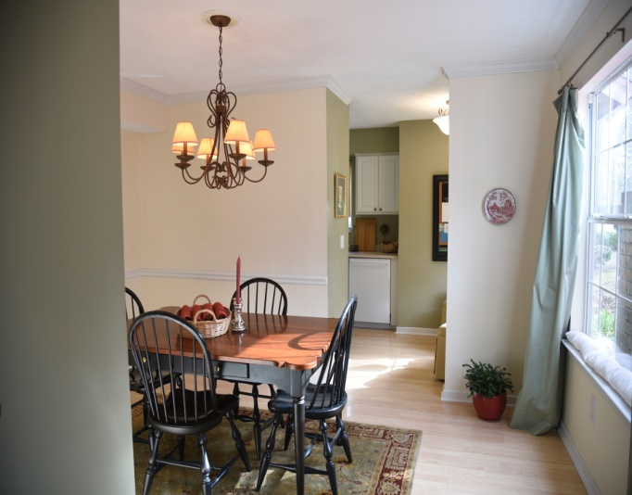
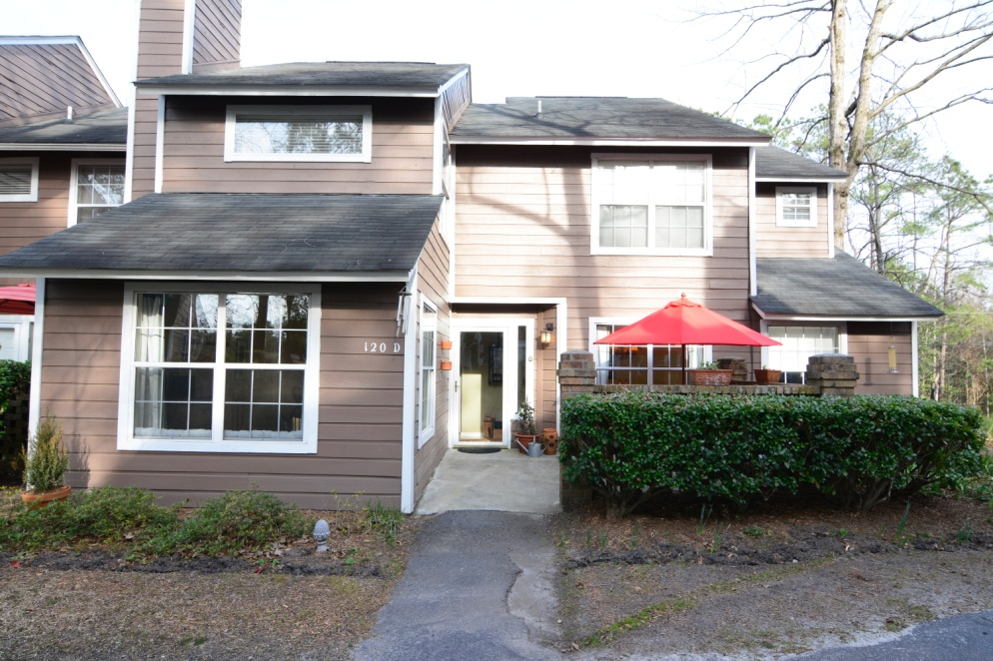
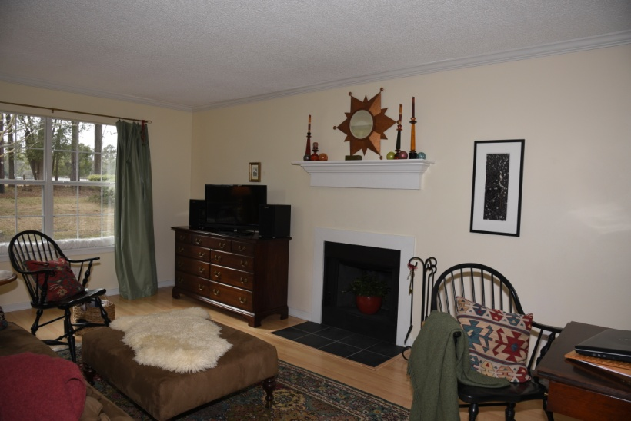
Lovely Condo in the Arbors of Summerville
2 Bedrooms w/ private baths, 2.5 Baths
Fireplace, laundry room, eat in kitchen and separate dining room, pool all just minutes from restaurants and shops of Historic Summerville
$104,000
Contact Gerri Sandford
(843) 817-8762

