COMING SOON ~ Best Location South of IOP Connector!
OPEN HOUSE: Saturday, 9/11/21, 1-3 p.m.

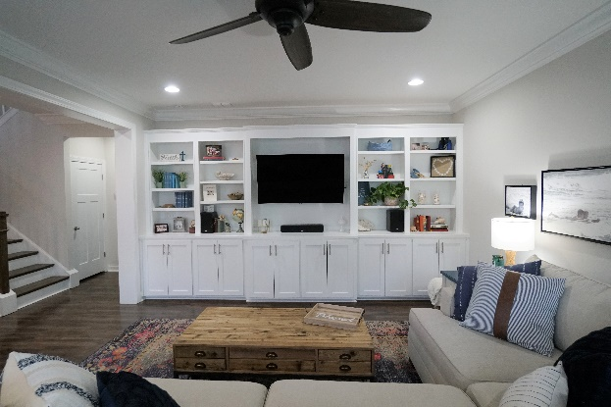
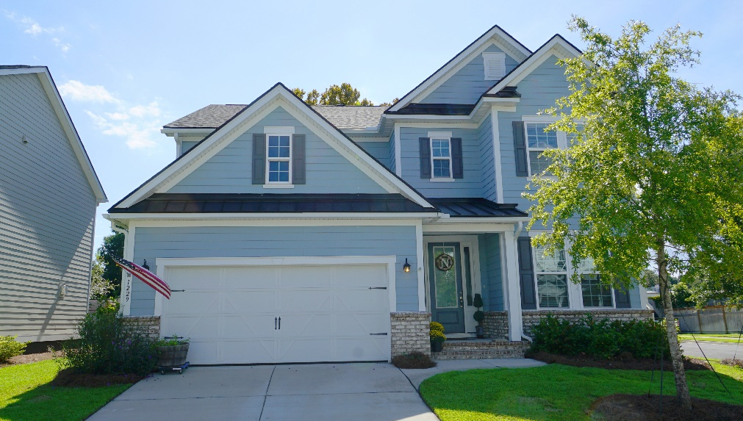

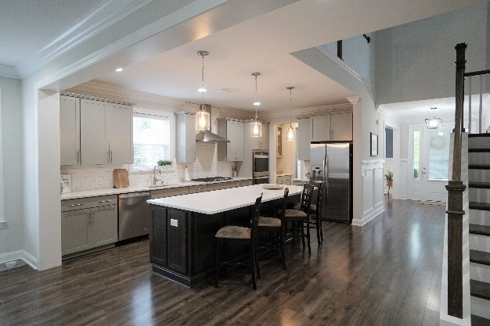
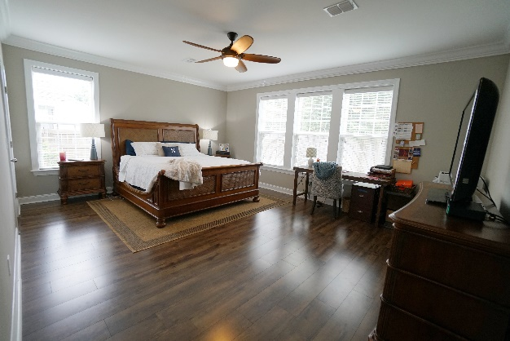
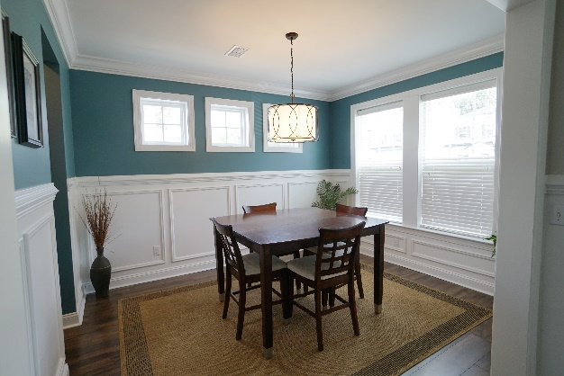
1229 Gannett Rd, Mt Pleasant 29464
$825,000
This charming, newer home in Bentley Park has all the extras you’ve been looking for… a personal design touch and the best location in S Mt Pleasant. Key features include:

- 5 Bedrooms, 4.5 Bathrooms, 3,607 sq ft
- Dual Master Suites – one upstairs and one downstairs
- Open floorplan
- No carpet downstairs
- Ceramic tile in bathrooms and laundry room
- Gourmet kitchen with shaker cabinets, pull out trays in cabinets and tons of storage space
- Stainless Steel appliances, including natural gas cooktop and built-in double ovens
- Tiled backsplash
- Natural stone countertops in kitchen and baths
- Upgraded trim package
- Tankless hot water heater
- Screened Porch and patio
- Private, fenced backyard
- Much, much more!
Carrie Newbern
Wilcat Realty
843-557-9001
carrienewbern@gmail.com

