Broker Open House & Lunch

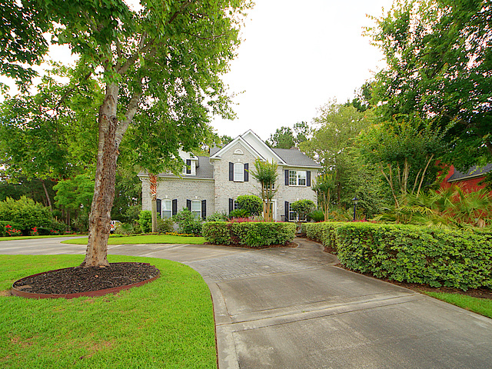
1351 Old Brickyard Road
Brickyard Plantation
Friday, June 22
11 am – 1 pm
Antique white brick, 4 BR, 2.5 Ba, beautifully landscaped half acre lot, open floorplan with wide arched openings and heavy moldings, hardwood floors, double stairways, new roof, new upstairs HVAC, new appliances, granite counters. Agent is owner. $650,000

