
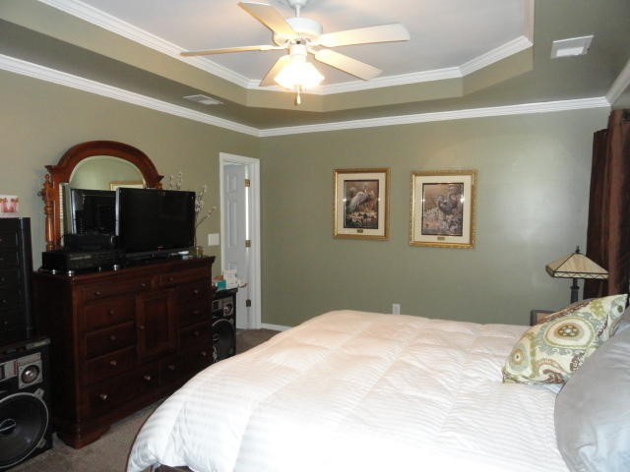
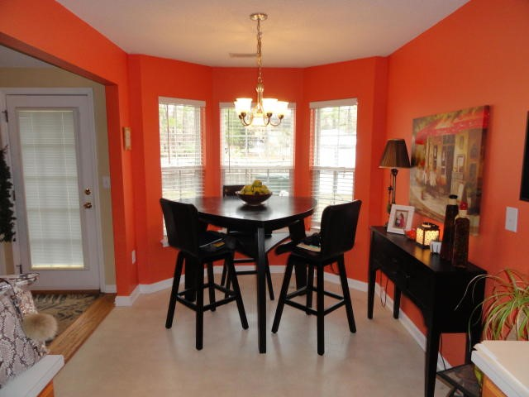

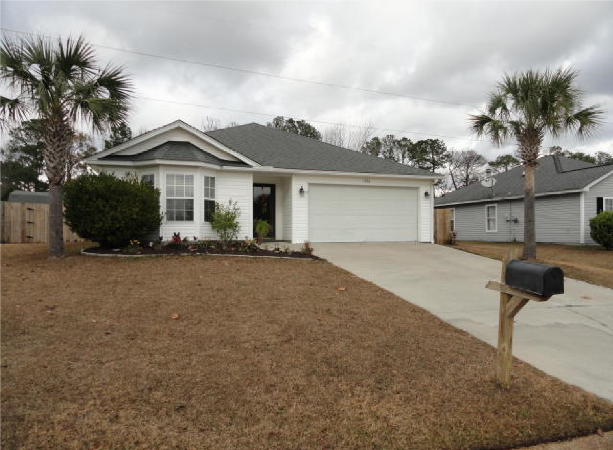
Diane Taber
843-530-6469
dianetaber725@gmail.com
Eagle Cove Subdivision
- Hanahan, SC 29410
$199,900
-

3
Bedroom/2 Bath
-

1278
Sq. ft.
MAJOR PRICE ADJUSTMENT
OPEN HOUSE ~ SUNDAY MARCH 10^{TH,} 12:30-2:00PM
1356
Belle Grove Cir

