

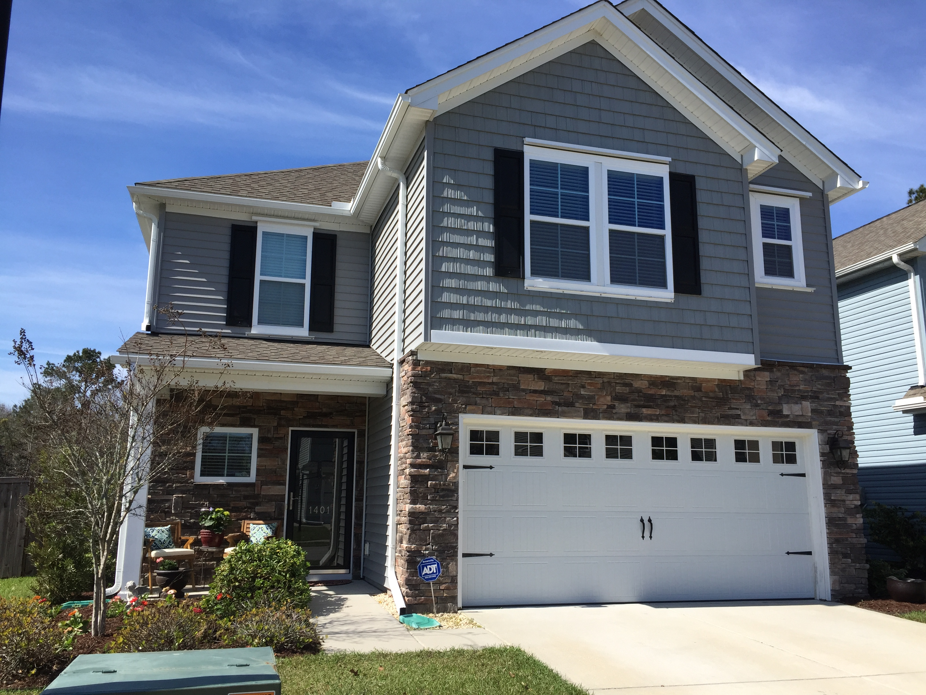
Geri Lipps 843.810.8398
glipps@carolinaone.com
$440,000

1401 Oldenburg
$440K
$175/SF

Upgraded Hardwoods throughout Main Level/Upgraded Carpet Upstairs

Upgraded Cabinets with Rope Trim and Crown

Wood Fence - $2500

Custom Monkey Bar System in Garage - $2500

Paver Patio

Hurricane Shutters - $4K

Granite in Kitchen and Baths

Tankless Water Heater

And MORE. . . .
$440K
$175/SF

Better Than New – All the Upgrades in Place!
DON’T WAIT ON NEW CONSTRUCTON

