
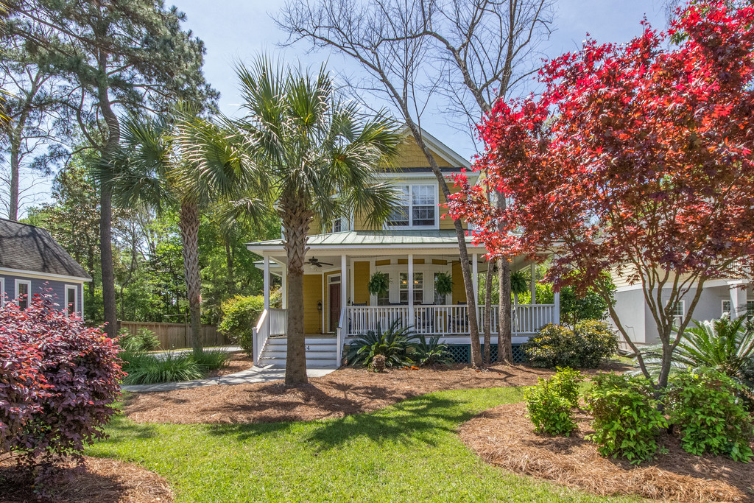
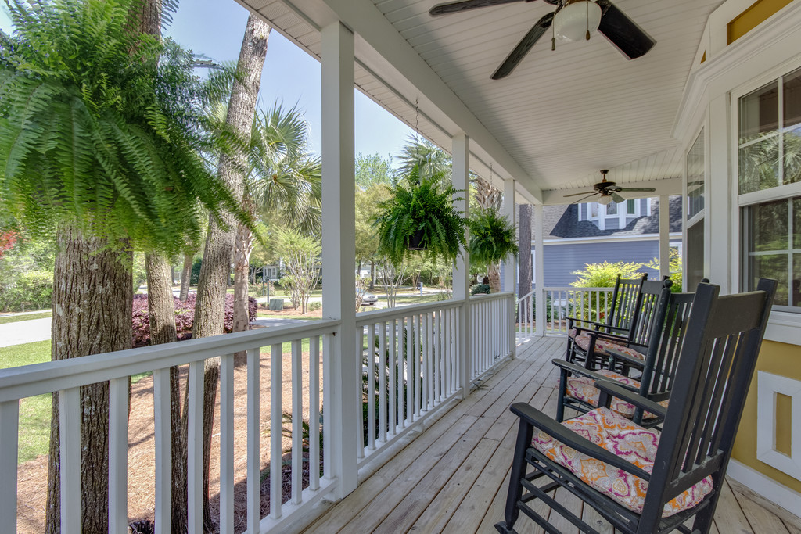
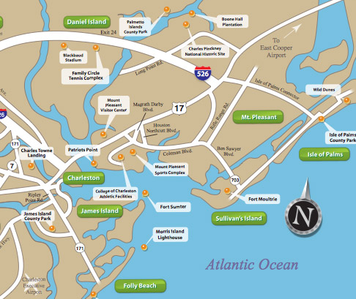


FIVE REASONS TO LIVE IN SHELLPOINT
- NEIGHBORHOOD FUN
- LOCATION
- GREAT PORCHES
- FANTASTIC SCHOOLS
- CUSTOM HOMES
Hurry before this desired location is no longer available. Classic, custom home in Mt Pleasant is waiting for you to make it your own. Beautiful, mature landscape and trees grace this large lot. No need to drive far to anything. Close enough to ride your bike to Coleman Blvd, the Old Village, and Sullivan’s Island. Shops, grocery stores and 526 are all minutes away. A 300 sq ft room over the detached garage with a full bath can be your work studio, office or play area. Australian Cypress wood floors on the first level are gorgeous.Butler’s pantry, large laundry room, open kitchen, garden tub and more.

Robin Windham
Realtor
843-991-6672
findmyporch.com
1404 Appling Drive
$640,900

