144 Bull Point Dr., Gardens Corner
.67 Acre Tidal Creek lot – Gated community 30 min. from Beaufort
$135,000
Bull point plantation

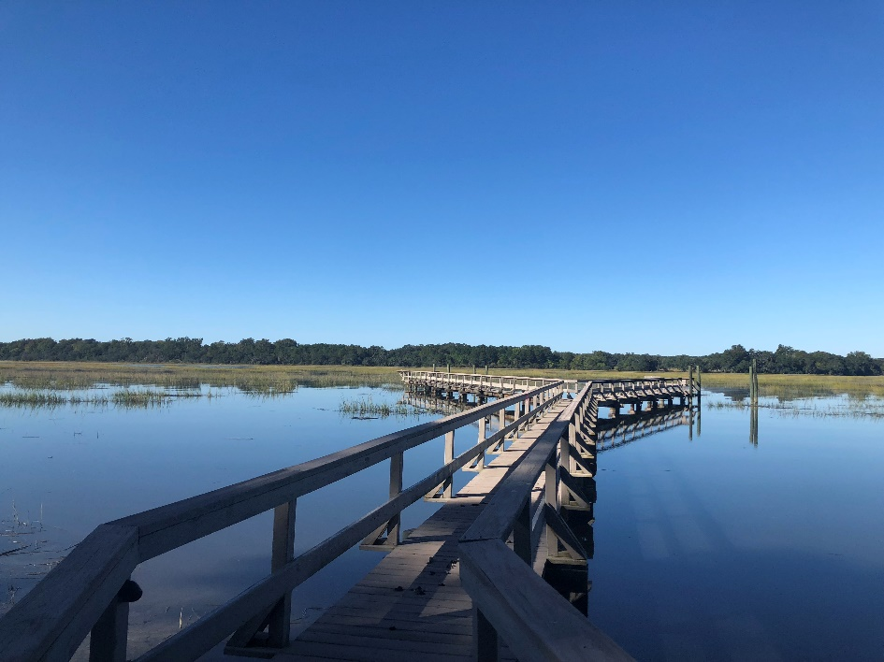


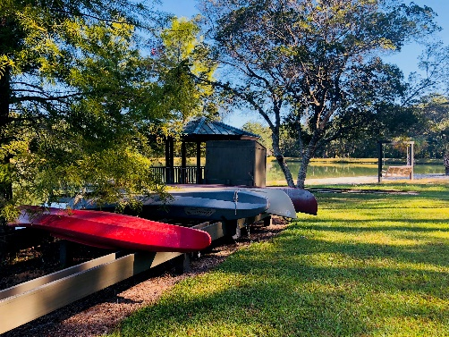
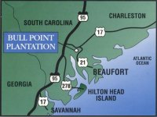
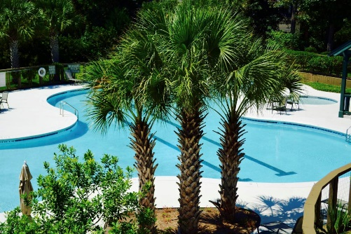

Sue LeFavi
(864) 603-3800
LeFavi.Sue@gmail.com
Sit on this dock and watch the gorgeous sunsets on the Huspah Creek! It has a shared dock with own pier head. High elevation, NO flood insurance required. Partially cleared and a recent survey completed. Dock has posts ready for a lift. It’s centrally located to enjoy all the amenities; clubhouse, fitness center, sauna, pool and tennis courts. Other amenities include 10 park areas consisting of 3 freshwater lakes, 3 deep water community docks, a river cabin with oyster pavilion, bird sanctuary and 5 miles of walking trails. A Must See community! 30 minutes from downtown Beaufort, about an hour from Savannah and Charleston and quick access to I-95.

