Coming Soon – Elevated New Construction in Mt Pleasant!
- 5 bedrooms
- 4.5 bathrooms
- 3652 SF
- Dual Master Suites (upstairs suite has private front porch, downstairs suite has back deck with pergola)
- Elevator Ready (shaft, door framing and electrical already in place!)
- Anderson Impact Resistant Windows and many additional high-end features
- Large lot with peaceful pond view
- Exclusive Parkers Landing in Rivertowne Country Club
- July 2018 anticipated completion date


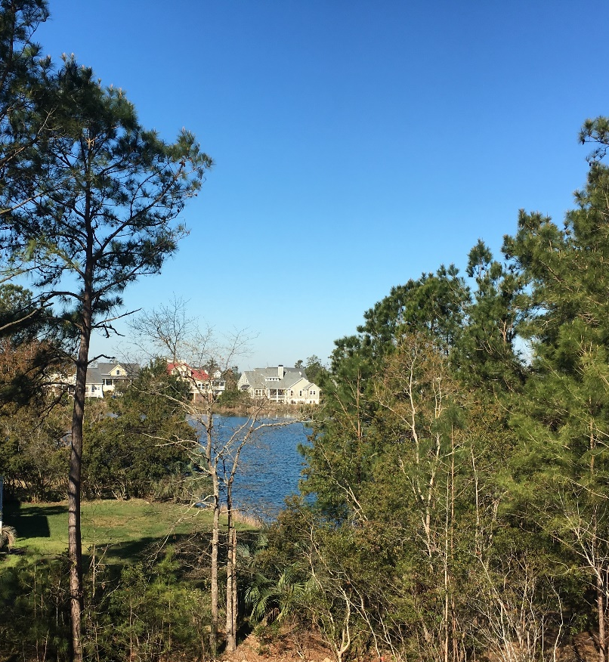
Contact me for more information:
Carrie Newbern
Wilcat Realty
843-557-9001
carrienewbern@gmail.com
Beautiful view from back of home

