JUST LISTED - Mt Pleasant New Construction

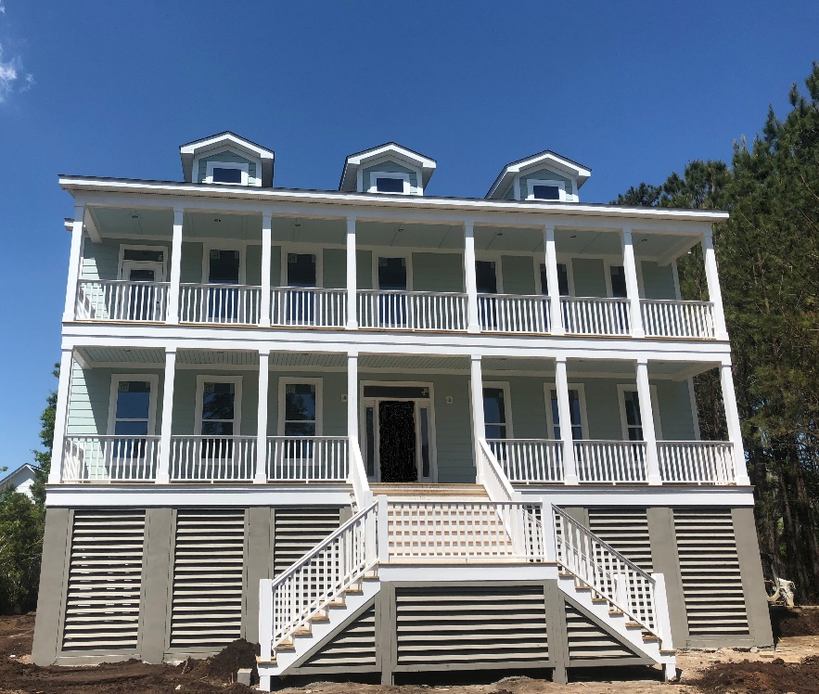
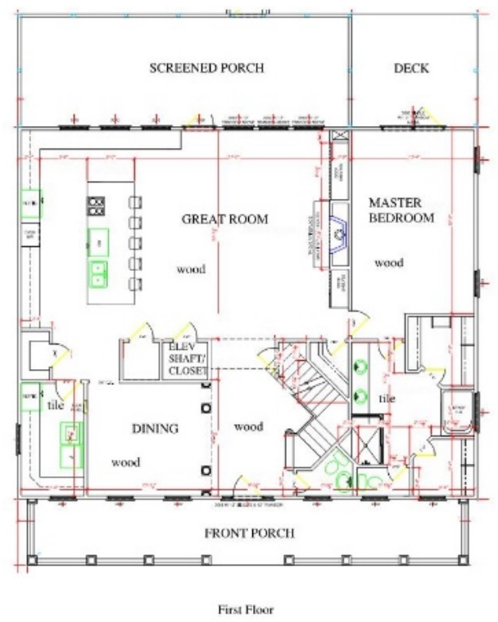

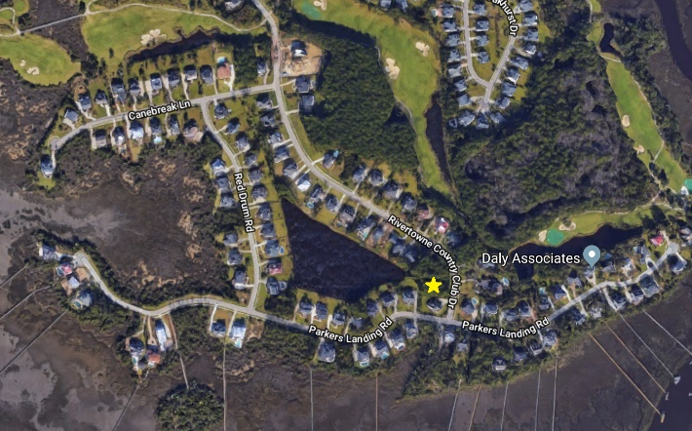
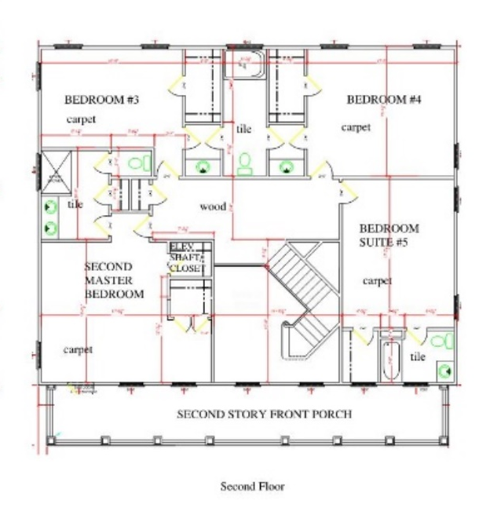

$814,500
MLS # 18011531
1504 Rivertowne Country Club Dr
Mt Pleasant, SC 29466
This new construction home is the epitome of southern living, offering an open floor plan, indoor/outdoor living and a personal design touch. Key features include:
- 5 Bedrooms, 4.5 Bathrooms
- 3,652 SF with elevated foundation and pond view
- Elevator ready
- Andersen Silverline impact resistant windows
- Gourmet kitchen with oversized island, gas cooktop, soft close hinges and more
- Dual master suites, each with its own private porch, are perfect for multi-generational living
- Heavy trim package includes mission style trim and shiplap
- Over 1200 SF of porches and decks
- A 2-minute walk to the passive park and views of Horlbeck Creek – relax with morning coffee, evening wine or a private picnic
- Under 1 mile to Charleston’s only Arnold Palmer Signature golf course and Rivertowne’s robust amenity center
- Estimated completion June/July 2018
- See full listing for more information
Carrie Newbern
Wilcat Realty
843-557-9001
carrienewbern@gmail.com

