Rare Land Tract * Northern Charleston County
100+ Acres Priced to Sell * Offered at $499,900

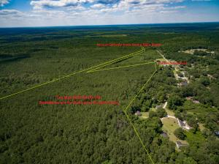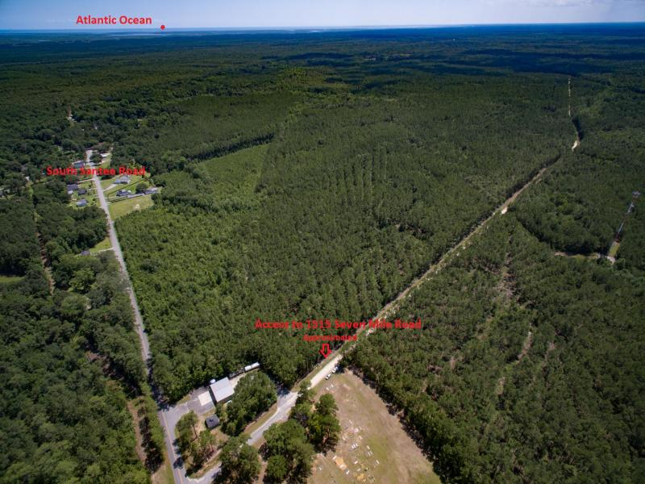
- Private rural land tract near South Santee River, The Wedge and Santee Coastal Reserve.
- Setting offers unique acreage including Natural Longleaf Pine, Natural Hardwood & planted unthinned Loblolly Pine.
- Merchantable Timber Value at over $190,000 - timber cruise 2017 valuation estimates.
- Ideal for quick access to Highway 17 leading to destinations north or south including Georgetown County, Charleston, Berkeley & Dorchester Counties, I-526, I-26, I-95, and points beyond.
1515 Seven Mile Road
MLS# 16011535
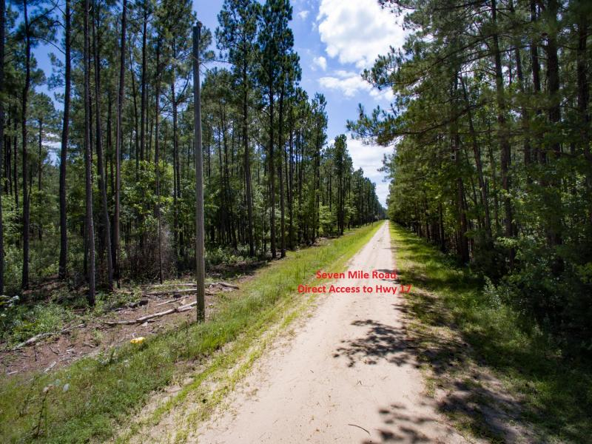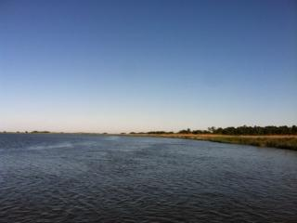
Access at Seven Mile Road to Hwy. 17 + South Santee Road View from Fishing Dock at Santee Coastal Reserve

Bring your Offer Today!
Kay Minson, Realtor, CRS * Carolina One Real Estate * Seller Representative * 843-697-2970 direct

