Broker Open House
Wednesday, December 5th, 12-1:30
Refreshments will be served.
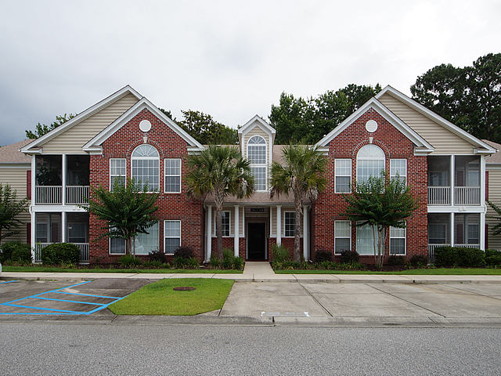
1562 Oxborough Circle
Dunes West ~ Mount Pleasant, SC 29466
MLS# 18030588 ~ $255,000

This second floor unit in peaceful Ellington Woods has just been renovated.
(New photos coming soon!!)

Beautiful and spacious! New flooring throughout, new granite counters, sink, and appliances in kitchen, new granite counter, sinks faucets and shower door in Master Bath, new faucets and shower door in hall bath. New light fixtures. Unit has been freshly repainted. The transformation is dramatic! Gas log Fireplace in Great Room. Master bedroom offers sitting room, ceiling fans, , walk-in closets, and dazzling new master bath. Additional study/storage room at top of the stairs. Washer and Dryer convey. This unit is turn key and ready for quick occupancy. You can be moved in by Christmas!

