Minutes to James Island’s thriving restaurant scene, Folly Beach and downtown Charleston
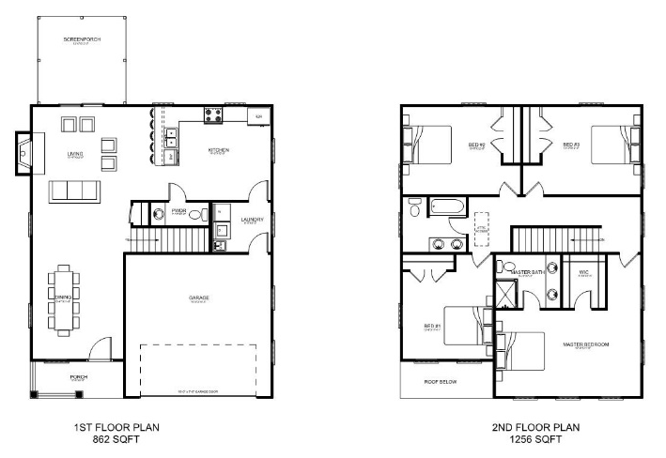
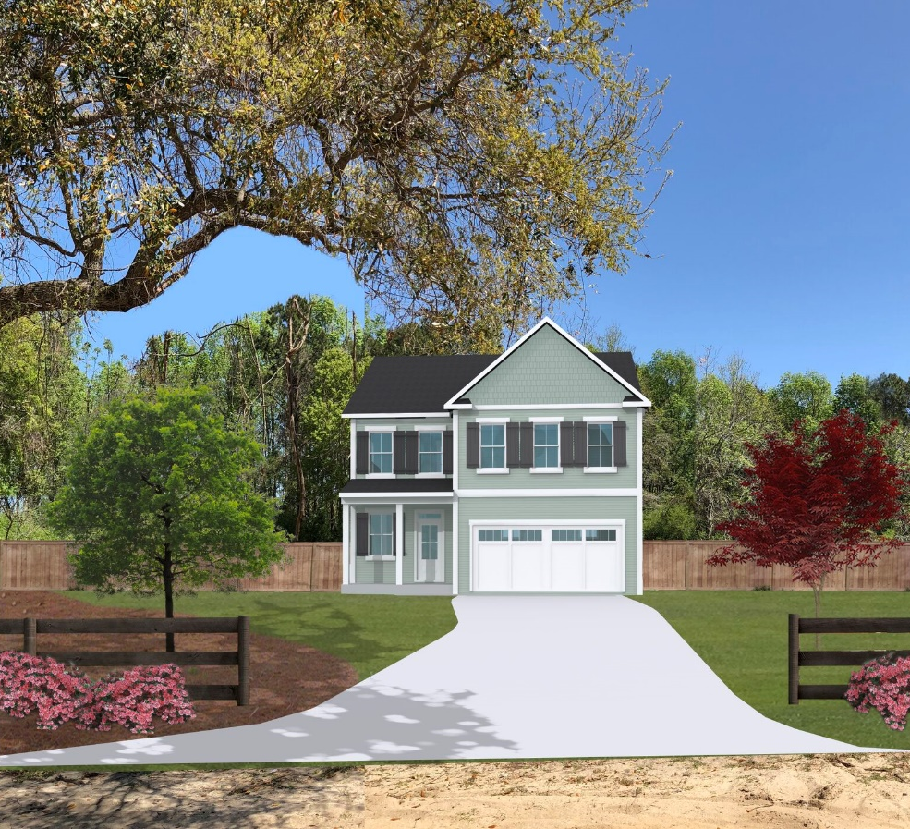

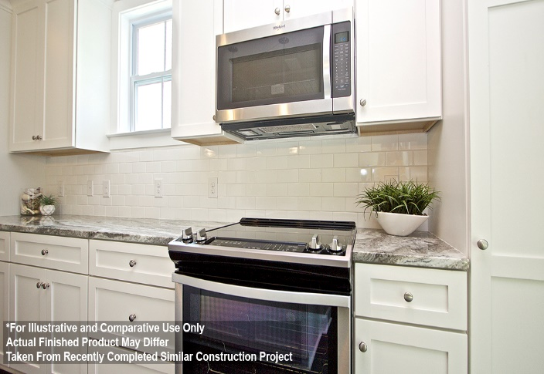
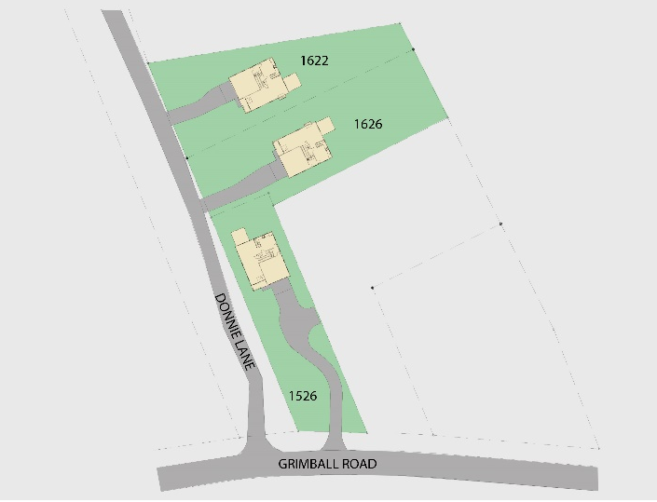
Get up to $3,000 toward closing costs with the use of our preferred lender. Midland Mortgage Corporation has in-house underwriting and special mortgage programs to help all your clients get a personalized product.
Tara Florence
Midland Mortgage Corporation
843-200-0324 tflorence@midlandmortgagecorp.com
3 New Homes ~ Donnie Lane ~ James Island
$368,500
These new construction homes are best in class offering a personal design touch, quality materials and the best value for James Island new construction. Key features include:
- 4 Bedrooms, 2.5 Bathrooms, 2,118 sq ft
- 2-Car Garage
- Andersen Silverline Impact Resistant, Low-E Windows
- Hardwoods throughout the downstairs, stairs and upstairs hall
- Beautiful designer tile in bathrooms and laundry room
- Natural gas range, fireplace, water heater and heat pump
- Gourmet Kitchen with Shaker Cabinets with Soft Close Hinges
- Tiled Backsplash
- Natural Stone Countertops in Kitchen and Baths
- Tankless Hot Water Heater
- Tiled, Walk-In Shower in Master Bathroom
- Screened Porch
- Quiet, lowcountry homesites with grand trees
Visit www.donnielanehomes.com for more information and photos
Carrie Newbern
Wilcat Realty
843-557-9001
carrienewbern@gmail.com

