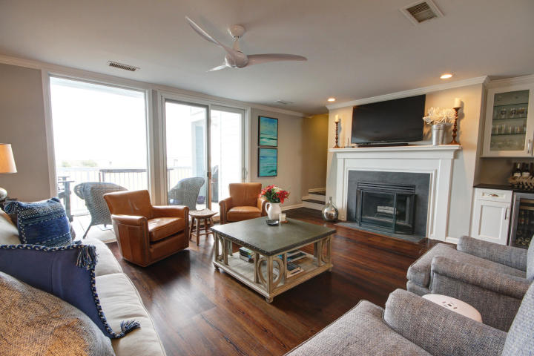

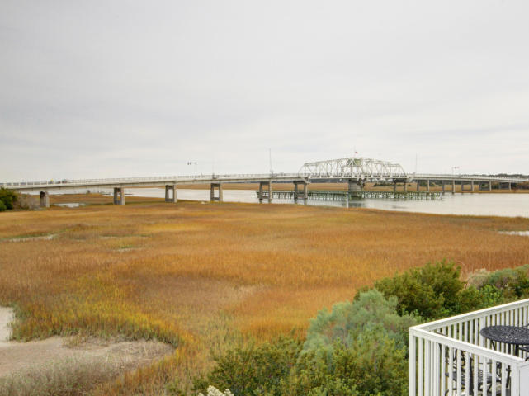
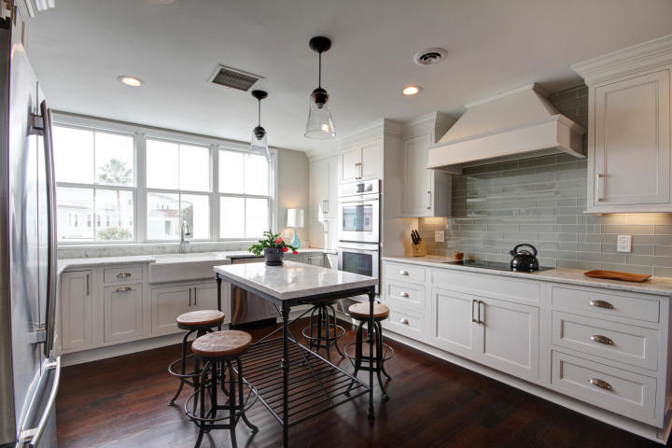


843.810.8398
glipps@carolinaone.com

1669 Marsh Harbor Ln
MLS# 18032924
$540,000
Steps away is the wine bar and fridge with granite counter. Beautiful pine floors throughout main level - wood burning fireplace and a darling updated powder room completes the main level. Upstairs MBR and Guest Suite. Both baths are updated and MBA Renovation JUST COMPLETED. A NEW HVAC and Water Heater in 2018 and this unit is the perfect choice for low maintenance Low Country living at its best. Marsh Harbor home to Tolers Cover Marina, a bike ride to the beach or Old Mt Pleasant restaurants and Farmers Mkt.
Enjoy the Marsh Views from this beautiful third floor unit in Marsh Harbor.
New kitchen complete with quartz counters, new Jenn Air appliances including warming drawer, farm sink and marble island for all your guests to gather.
Mauris odio nisi, bibendum quis, vehicular sed, tempus at, orci. Vestibulum vel dolor non ante bibendum mollis.
Back on the Market in Marsh Harbor
byline
Lorem Ipsum

Praesent pretium lectus a dui.
Suspendisse lobortis, quam ac euismod sodales, diam turpis luctus nunc, vel porta mauris enim quis ipsum. Aenean pharetra elementum augue. Maecenas ante.

