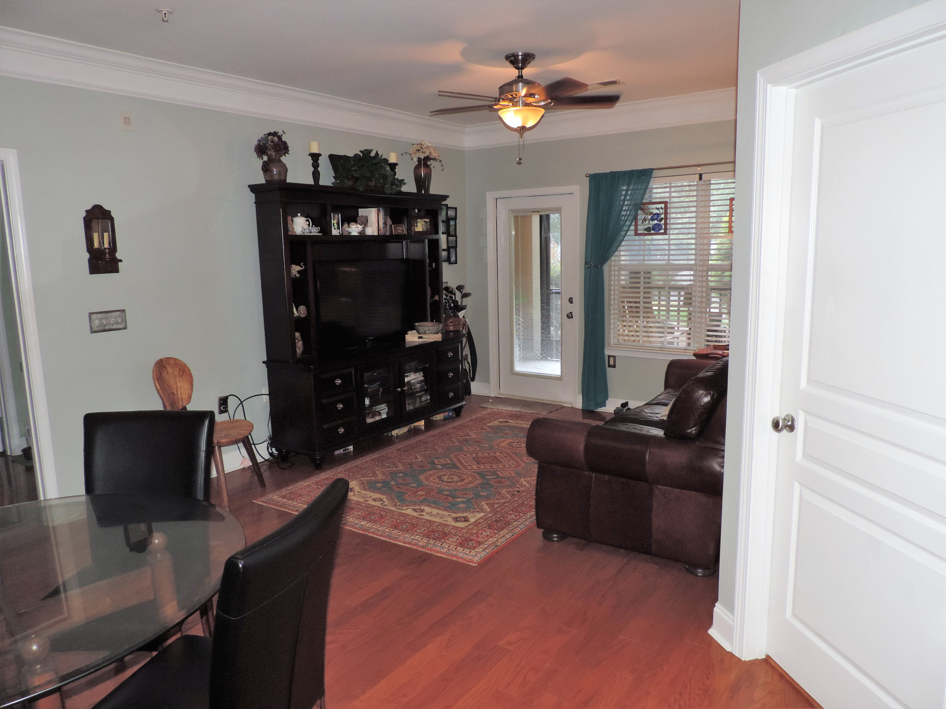
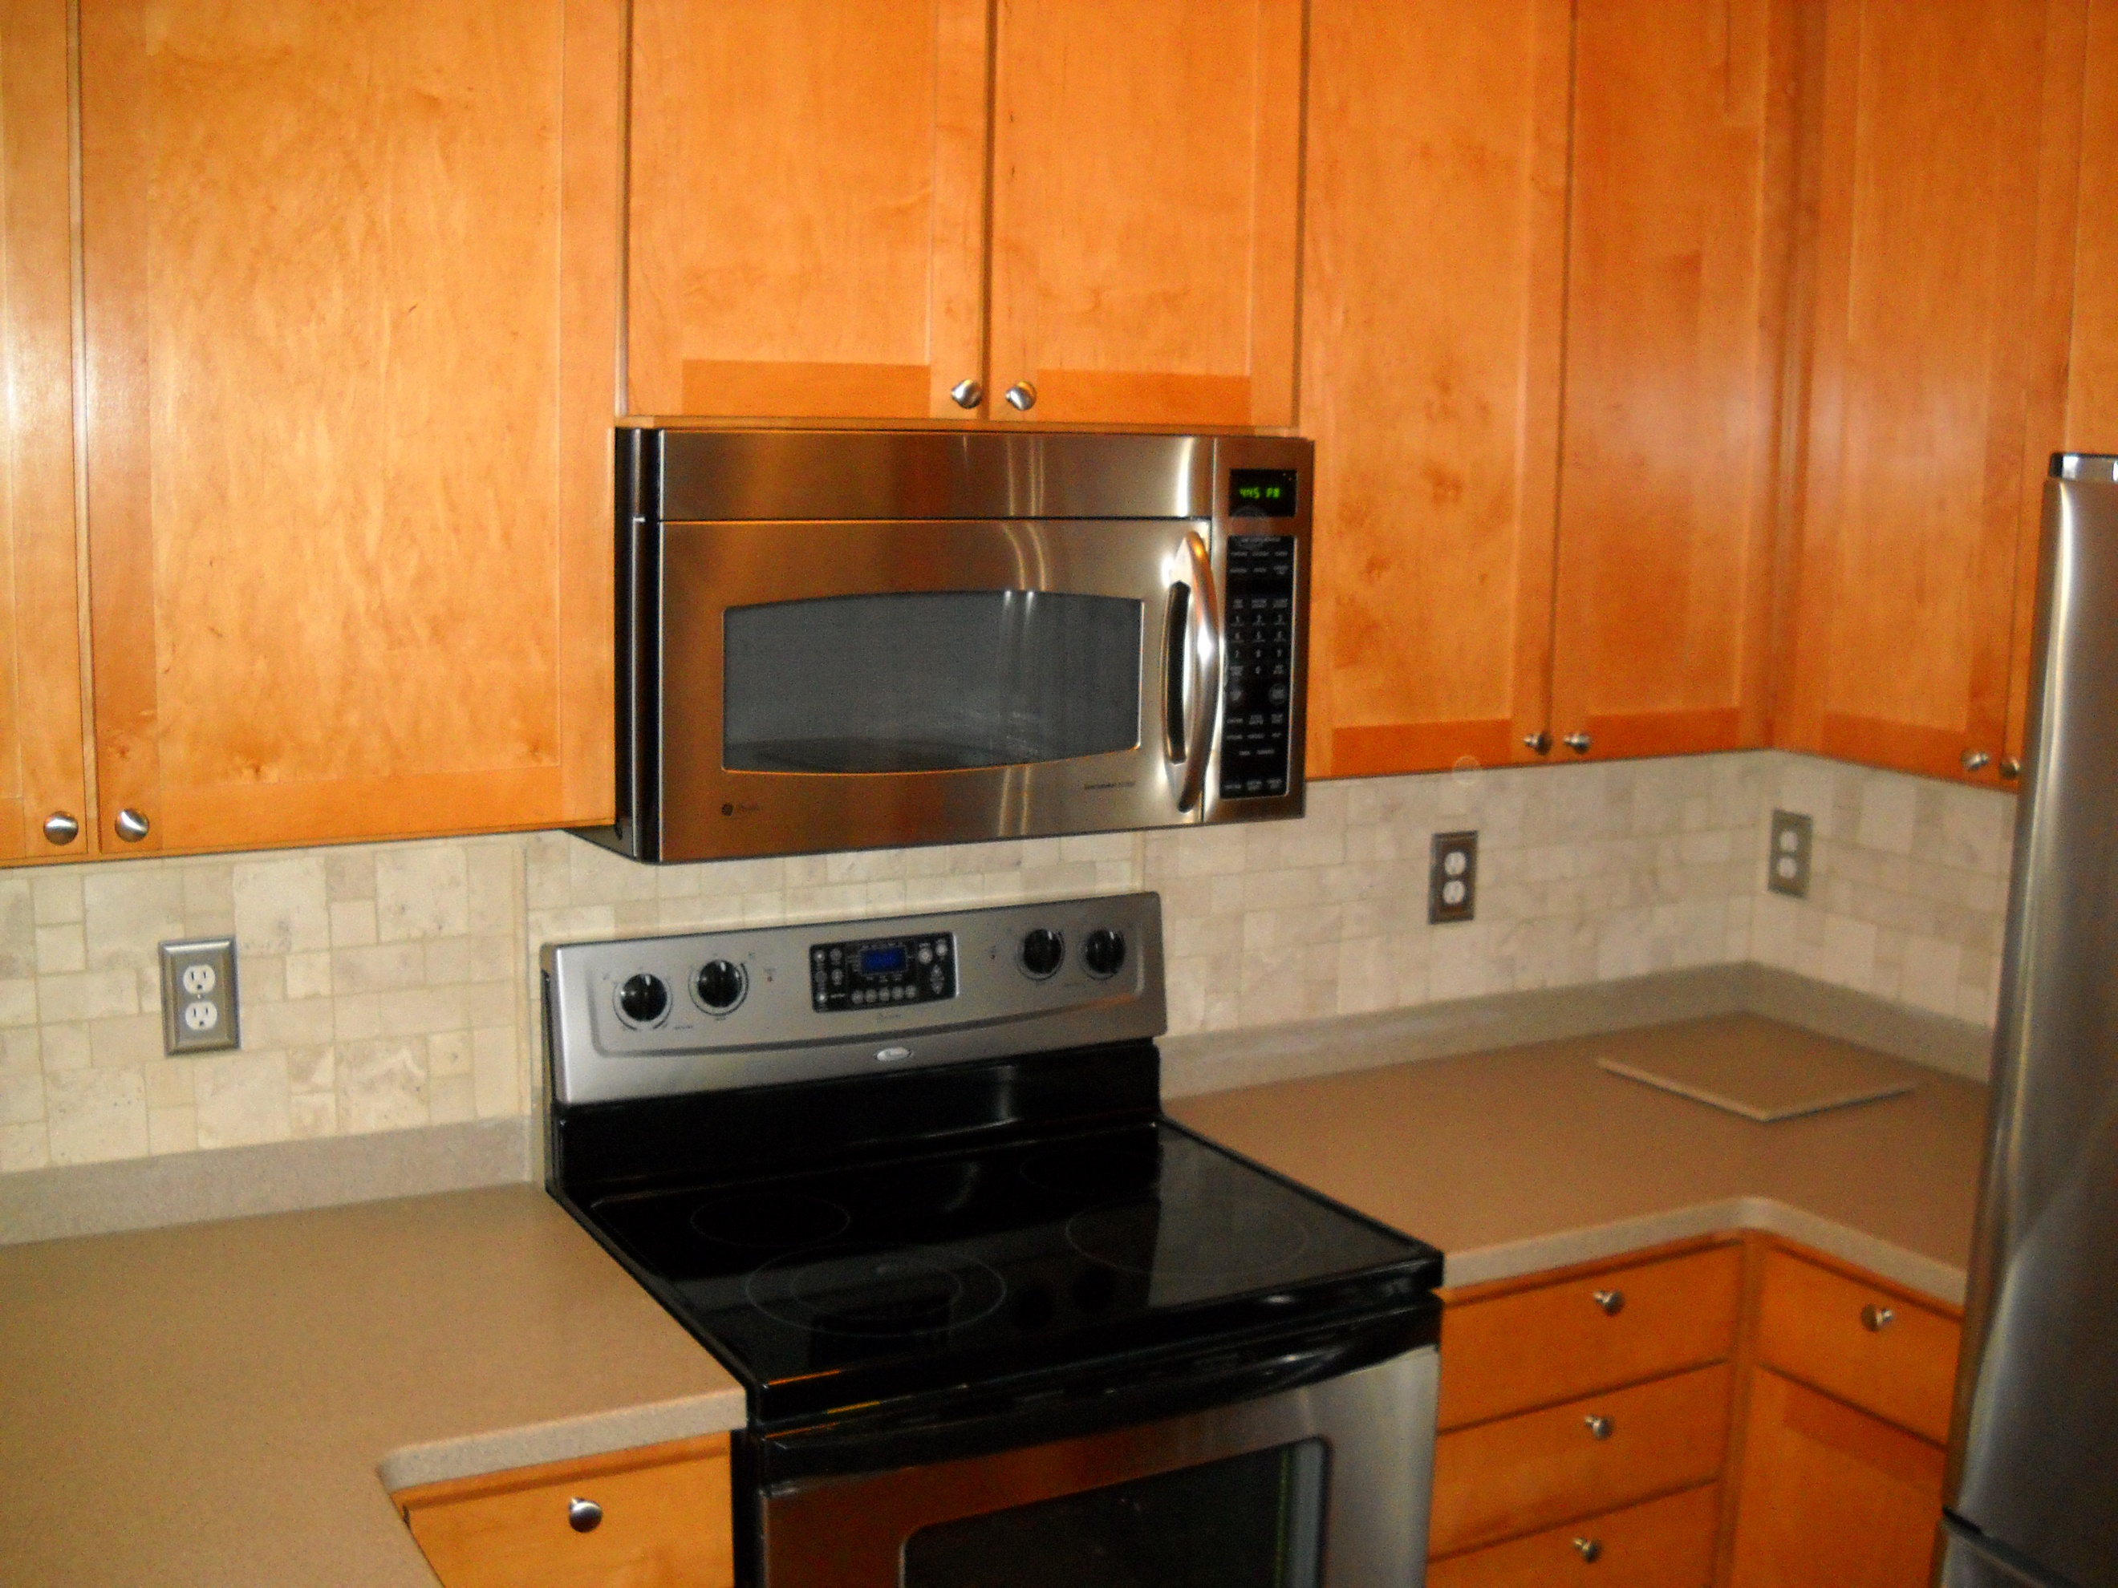
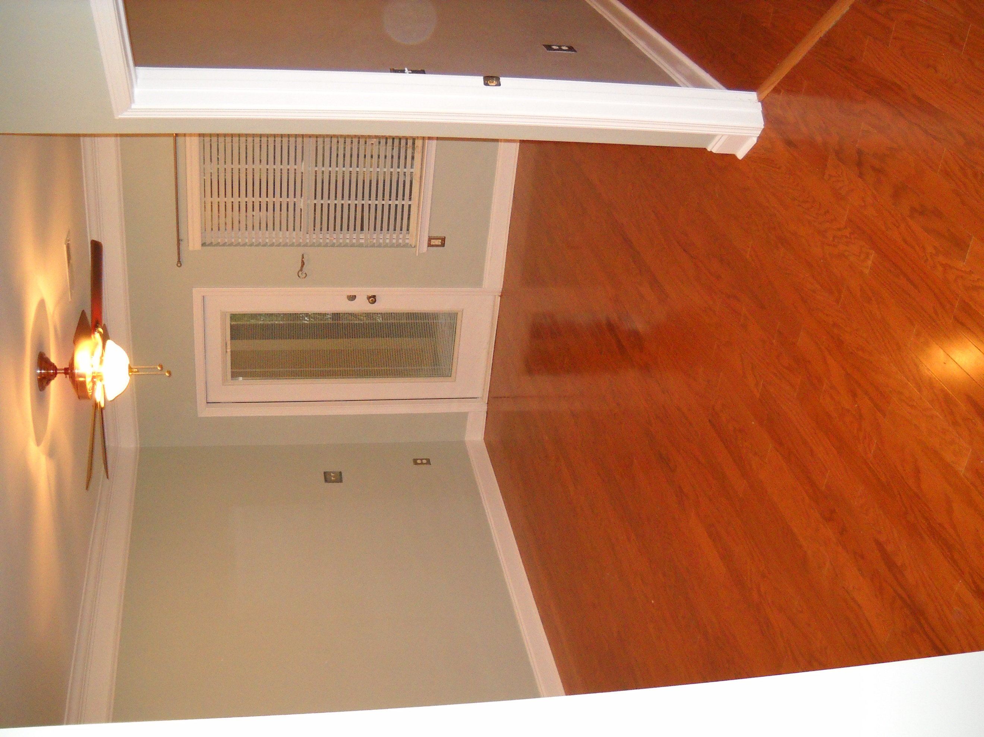
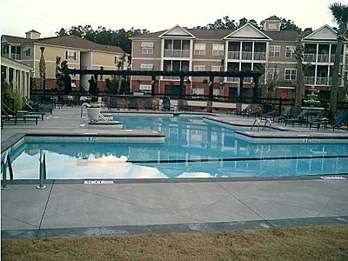
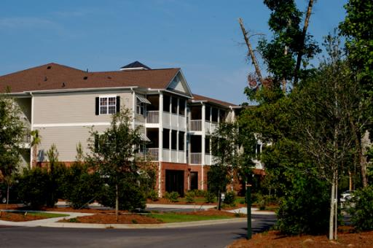
Kimberly Ritter ABR, CRS, REALTOR
(843) 693-8802 ~ kritter@carolinaone.com ~ www.SearchForCharlestonHomes.com
Carolina One Real Estate | 628 Long Point Rd | Mt Pleasant, SC 29464
1707 Basildon Road
The Battery at Park West ~ Mount Pleasant ~ MLS# 16018163 ~ $220,000
THIS TWO BEDROOM TWO BATH GROUND FLOOR, END UNIT, IS A HOMEOWNER'S DREAM. GREAT LOCATION NEAR THE ENTRANCE AND CLUBHOUSE, AND THE BATTERY'S GARDEN. KITCHEN HAS STAINLESS STEEL APPLIANCES, HIGH GRADE ITALIAN STONE BACKSPLASH, AND A MULTI-USE PASS-THROUGH BAR TO THE LIVING ROOM. HARDWOOD AND MARBLE TILE FLOORS THROUGHOUT, WITH A SLATE TILE ON THE SCREENED-IN PORCH. PORCH IS CONVENIENTLY ACCESSIBLE FROM BOTH BEDROOMS AND THE LIVING ROOM, WITH A DOOR TO THE SIDEWALK LEADING TO THE PARKING LOT AS WELL. NEW HVAC AND WATER HEATER. SOUNDPROOF FLOORING AND CEILING. THE BATTERY HAS ITS OWN CLUBHOUSE, POOL AND GRILLING FACILITIES, PLUS A CAR VACUUM STATION, PET STATION, AND WALKING TRAILS, WITH AVAILABLE BOAT STORAGE.

