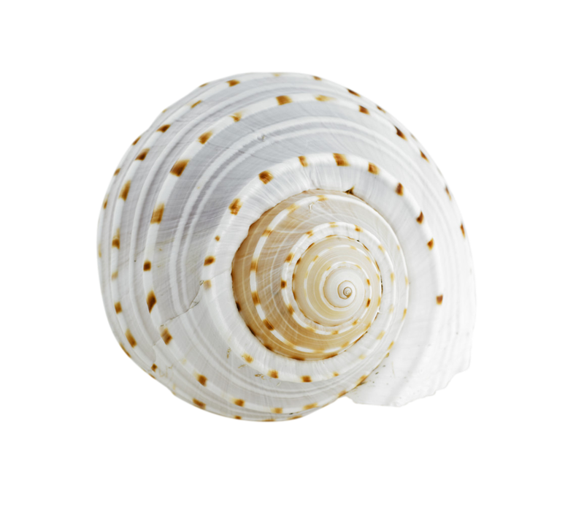
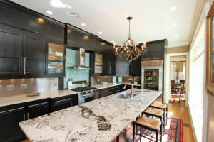
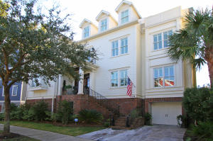
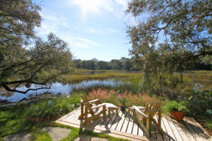
Newer Construction +
On the Water + Downtown!
- 4282 Square Feet
- Elevator to ALL Floors
- 10 Ft. Ceilings 1st and 2nd floors
- Third Floor Entertainment Room with Dining Deck
- Dual Masters
- Views from nearly every room

MLS# 15028811

New Siding

Exterior Freshly Painted

Rebuilt Fireplace and Built Ins

New Rear Deck

Deck on Marsh

Professional Landscaping

Added Features
  - $1,225,000

172 Mary Ellen

Stunning Home

In Longborough
downtown water view

