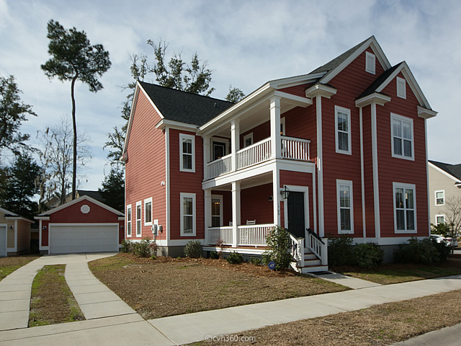
4 bedroom | 3.5 bathroom | 2508 sq ft | Carolina Bay
$345,000
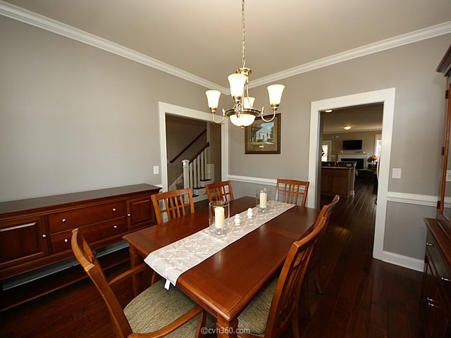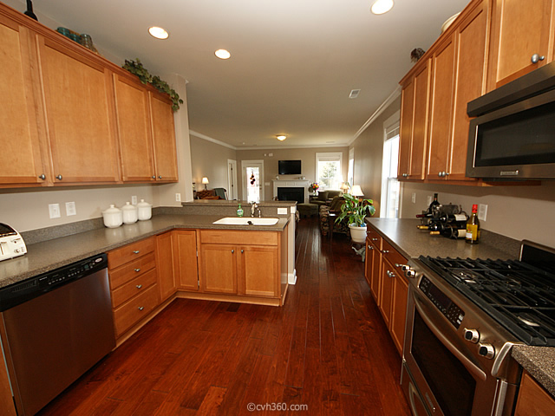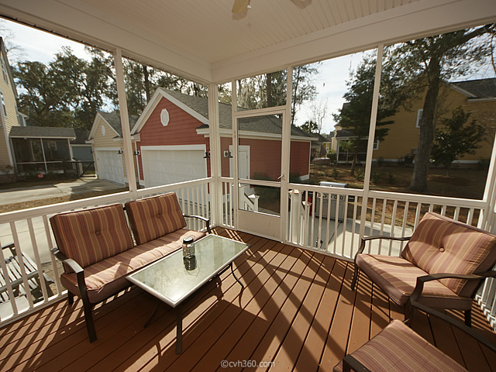
The Buying Process
This beautiful home is a must see! As you approach this meticulously maintained Charleston home, you will love the double side porches. Upon entering, you will notice the open floor plan, hardwood floors, crown molding, separate dining room, downstairs laundry, powder room and gorgeous kitchen. This kitchen has it all: stainless steel appliances, gas range, granite countertops, breakfast bar and plenty of cabinet and counter space. The master bedroom completes the first floor. Upstairs you will find a large loft and three additional bedrooms. Carolina bay amenities include two pools, dog park, walking trails, play park, crabbing dock and kayak launch. Conveniently located just minutes from downtown Charleston, close to beaches, shopping, restaurants, hospitals, universities, and more.

