McClellanville
1792 Breezy Bay Way, McClellanville, SC 29458
Home and Land for sale
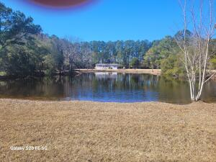

Home & 5 Acres $500,000
Home & 10 Acres $700,000
5 Acres (Land only) $400,000
7 Acres (Land only) $500,000
10 Acres (Land only) $650,000

This is the best acreage available north of Mount Pleasant; located just past the blinking light that accesses the town of McClellanville. The land fronts on a deep-water spring-fed pond that never dries up in the hottest summer heat. Land has been cleared of trees and is a beautiful grassy field. There is a 3 bedroom-2bath home on the property with acreage or just land only available all of which front on the deep-water spring-fed pond. The property is about a 35 minute from Mount Pleasant and 30 minutes to Georgetown by way of Highway 17. McClellanville is known for it’s seafood and access to the coastal waterway. The town also has some boutique shops and restaurant and does not have the hustle and bustle of other waterfront towns.

Rick Willis, Broker-The Group, Llc 843-327-3017 rwillisteam@gmail.com

