New Construction in Convenient West Ashley

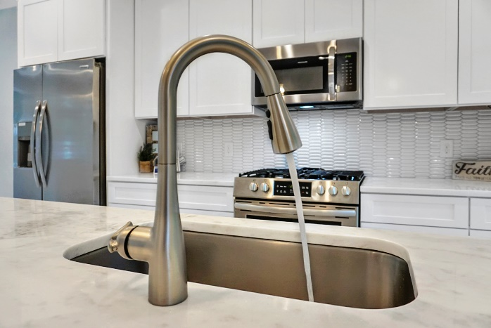
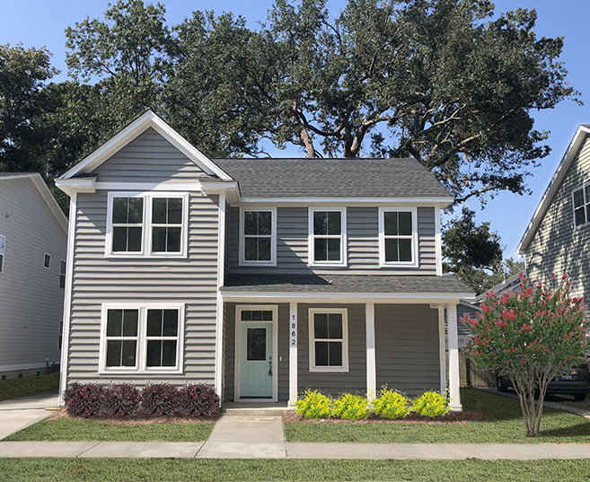

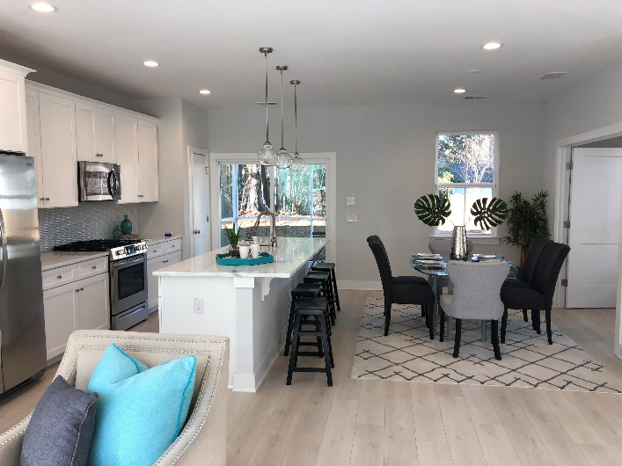
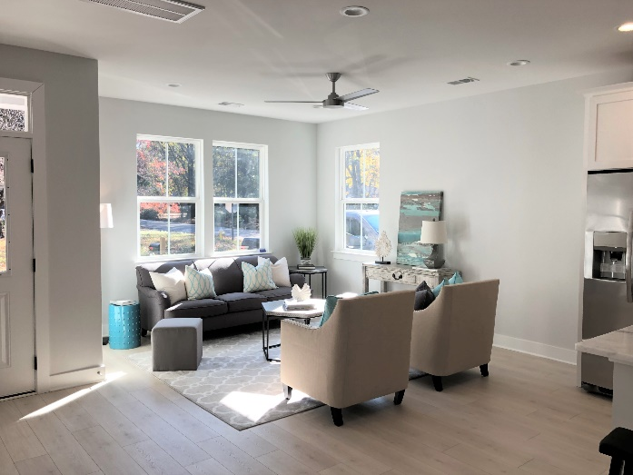
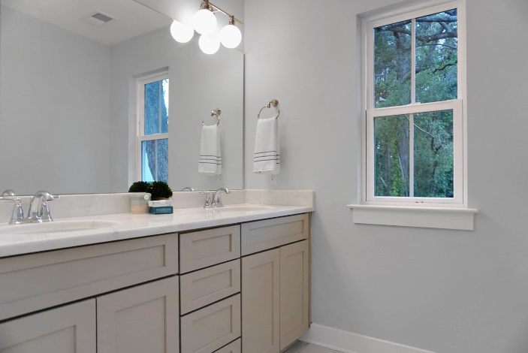
1862 Dogwood Rd, Charleston, SC 29414
$309,900
MLS #19028537
This charming, brand new home has all the extras you’ve been looking for… a personal design touch, quality materials and a convenient location. Key features include:
- Open floorplan, 4 Bedrooms, 3 Bathrooms, 1,818 sq ft
- Bedroom/Flex space and full bath downstairs
- Impact Resistant, Low-E Windows
- Wood floors downstairs, stairs and upstairs hall
- Beautiful designer tile in bathrooms and laundry room
- Natural gas range and refrigerator are included
- Gourmet kitchen with shaker cabinets with soft close hinges
- Tiled backsplash
- Natural stone countertops in kitchen and baths
- Tankless hot water heater
- Screened Porch
- Grand trees and 10 acres wooded HOA property in the backyard
- 1 Car Detached Garage
- Convenient to I-526, Roper, and revitalized Citadel Mall

Carrie Newbern
Wilcat Realty
843-557-9001
carrienewbern@gmail.com

