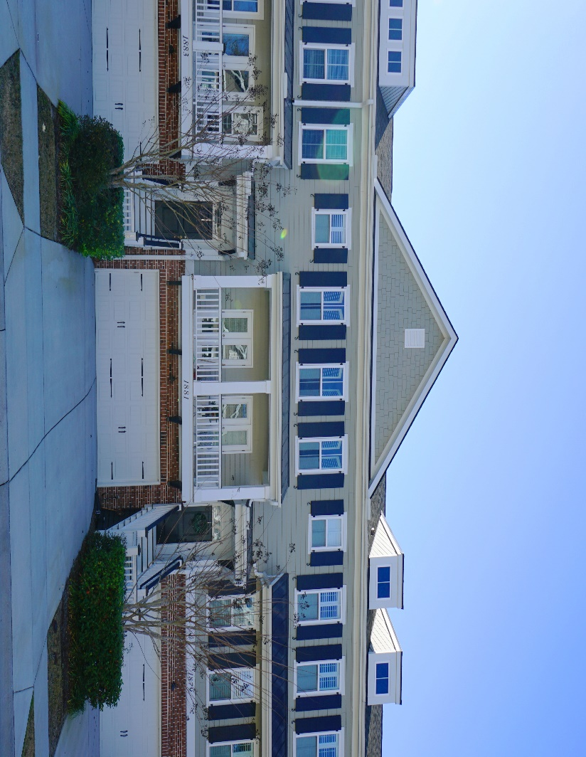
Convenient, Maintenance-Free, Mt Pleasant Living

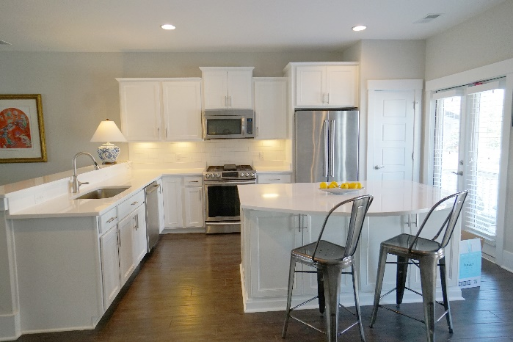

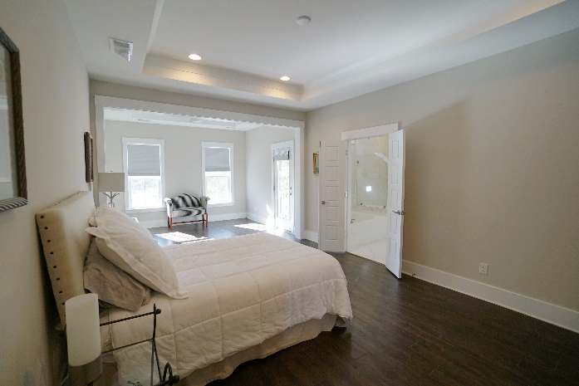
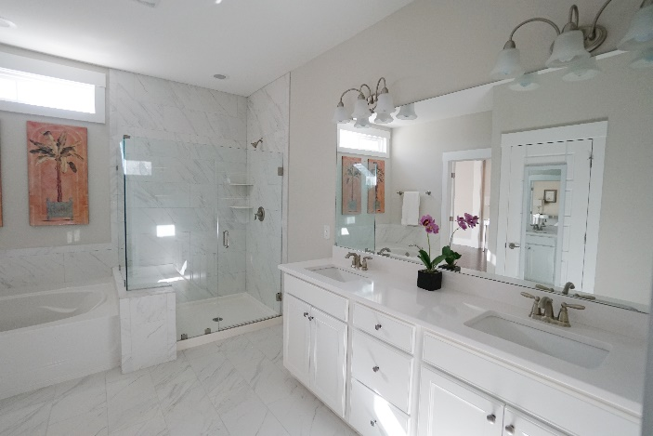
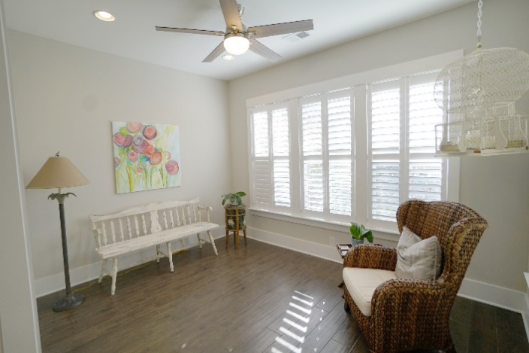
1881 Carolina Towne Ct, Mt Pleasant 29464
$619,990
MLS #21002583
This charming, nearly new home has all the extras you’ve been looking for… a personal design touch, quality materials and a convenient location. Key features include:
- Open floorplan, 3 Bedrooms, 3.5 Bathrooms, 2,443 sq ft
- Top floor master suite with sitting room and en-suite
- Bedroom/Flex space and full bath downstairs
- Hardwood floors throughout
- Beautiful ceramic tile in bathrooms and laundry room
- Stainless Steel appliances, refrigerator and washer/dryer included
- Bright white kitchen with shaker cabinets and great layout
- White subway tiled backsplash
- Silestone solid surface countertops in kitchen and baths
- Custom window treatments throughout the home
- Tankless hot water heater
- Patio, Sun Deck, Front Porch and Screen Porch
- 2 Car Attached Garage
- Convenient to I-526, Towne Center, Shopping, Beaches

Carrie Newbern
Wilcat Realty
843-557-9001
carrienewbern@gmail.com

