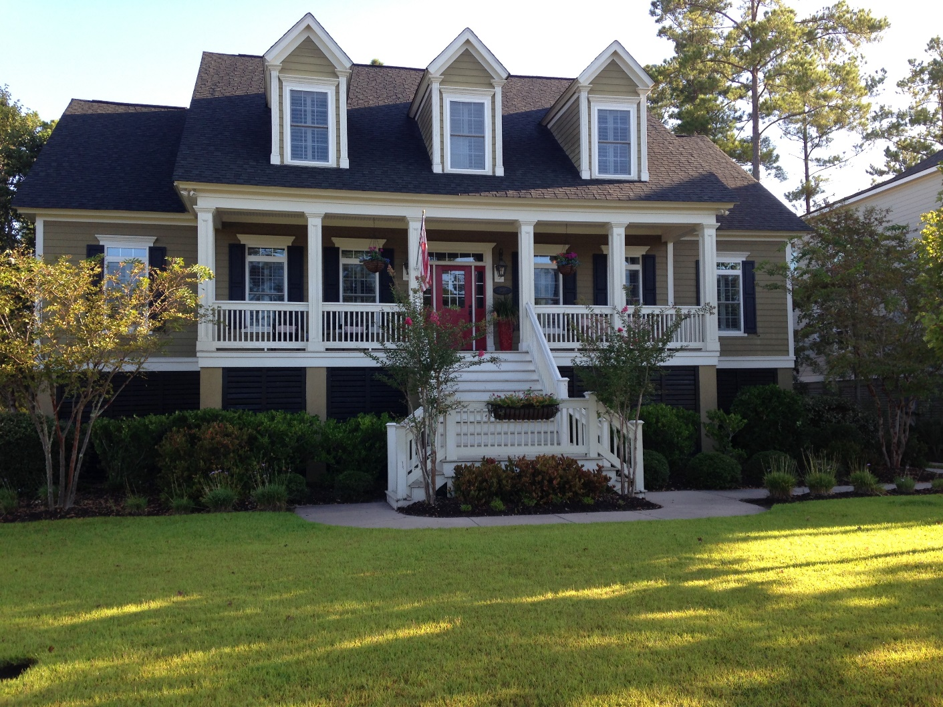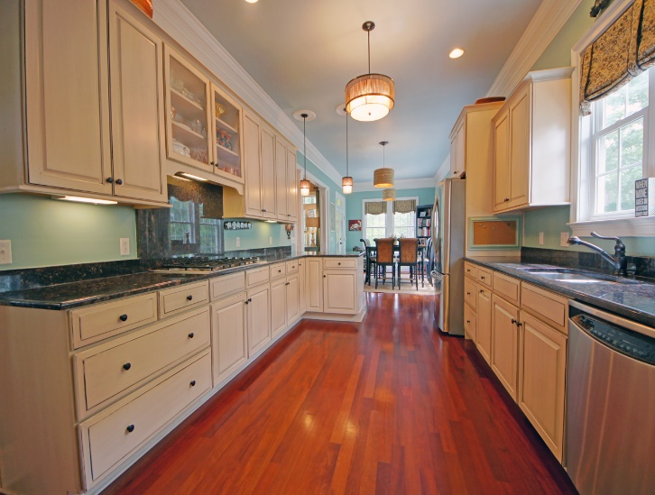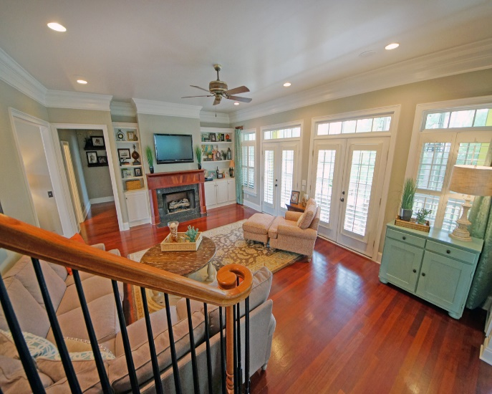

NEW PRICE REDUCTION on 1889 West Canning Drive in Masonborough in Park West!
Offering a $2,000 agent selling bonus on all ratified contracts by 9/30 that close!
5 BR/4BA with almost 3,500 sq ft on almost .5 acres!
MLS# 1412590
$720,000

