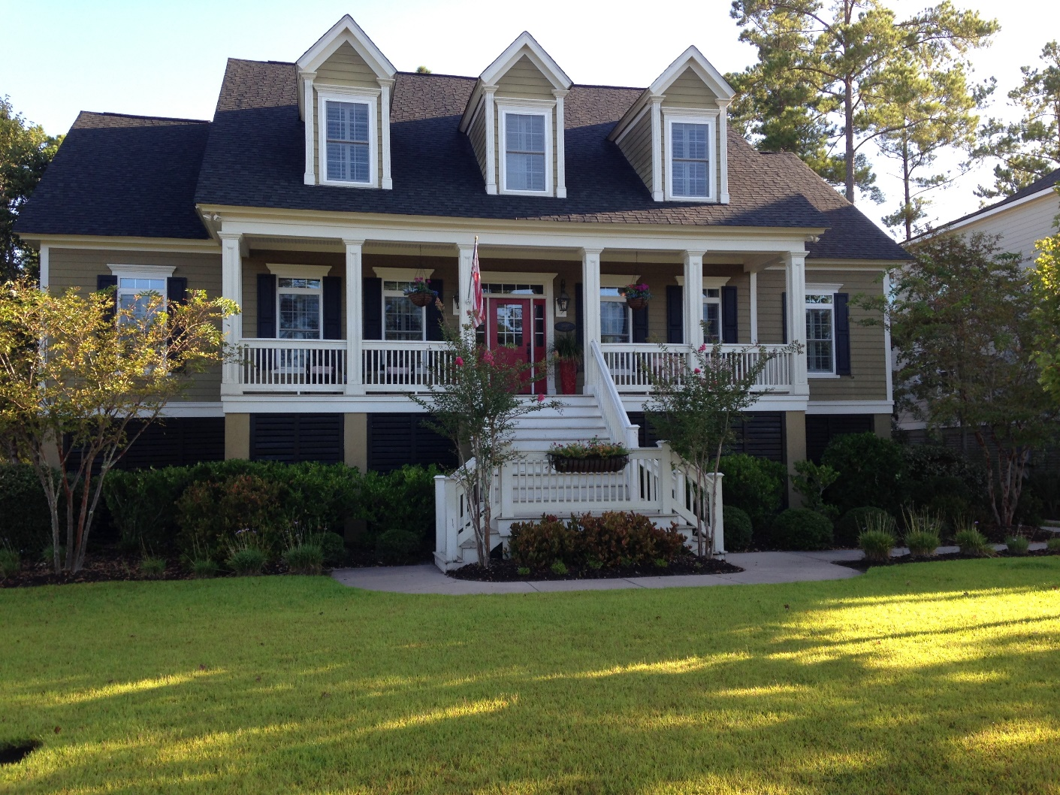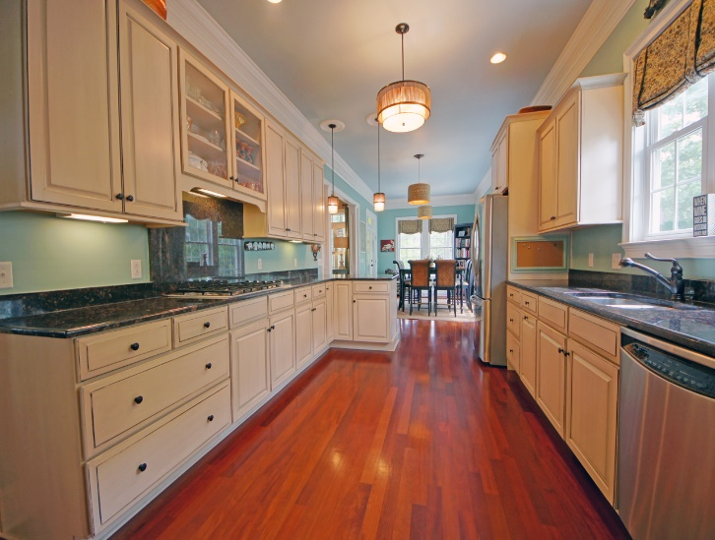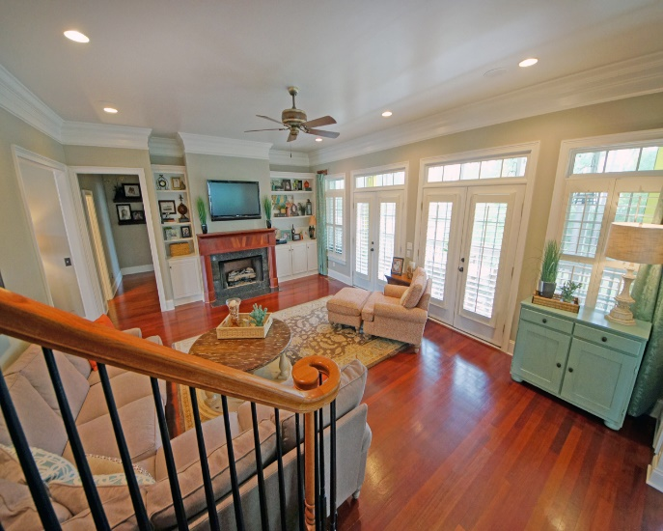

COME HOME FOR CHRISTMAS!
5 BR/4BA with almost 3,500 sq ft on almost .5 acres!
MLS# 1412590
$699,900

