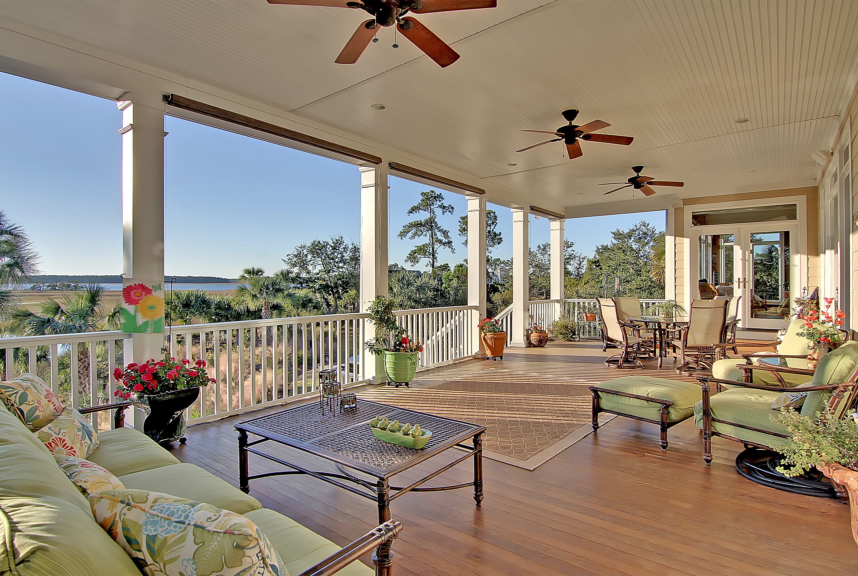  Jan. 13, 2017  Agent Open House 11-2  Home will be available for showings on 1/13/17  Come tour this outstanding waterfront home overlooking the Wando River. Located in North Creek at the Point in Rivertowne Country Club, this custom-built home has never been offered before. Your discerning buyers will truly appreciate the spectacular views they will enjoy throughout this home along with the quality construction, attention to detail and many upgrades.  Please join us for an agent preview on Friday, January 13, 2017 from 11am to 2 pm. A light lunch will be provided.   | 1900 N. Creek Dr.  Mt. Pleasant  Rivertowne CC  ────  Waterfront Home  5 Bedrooms  4.5 Baths  4585 SqFt  ────  $1,650,000  ────  Private Boat Dock  ────  Elevator & More!  Co-Listed By  Lori Claussen  Golden Bear Realty  843-224-8506  &  Darlene Smith Carolina One Realty  843-696-7824  Telephone  Web Address  Dates and Times

