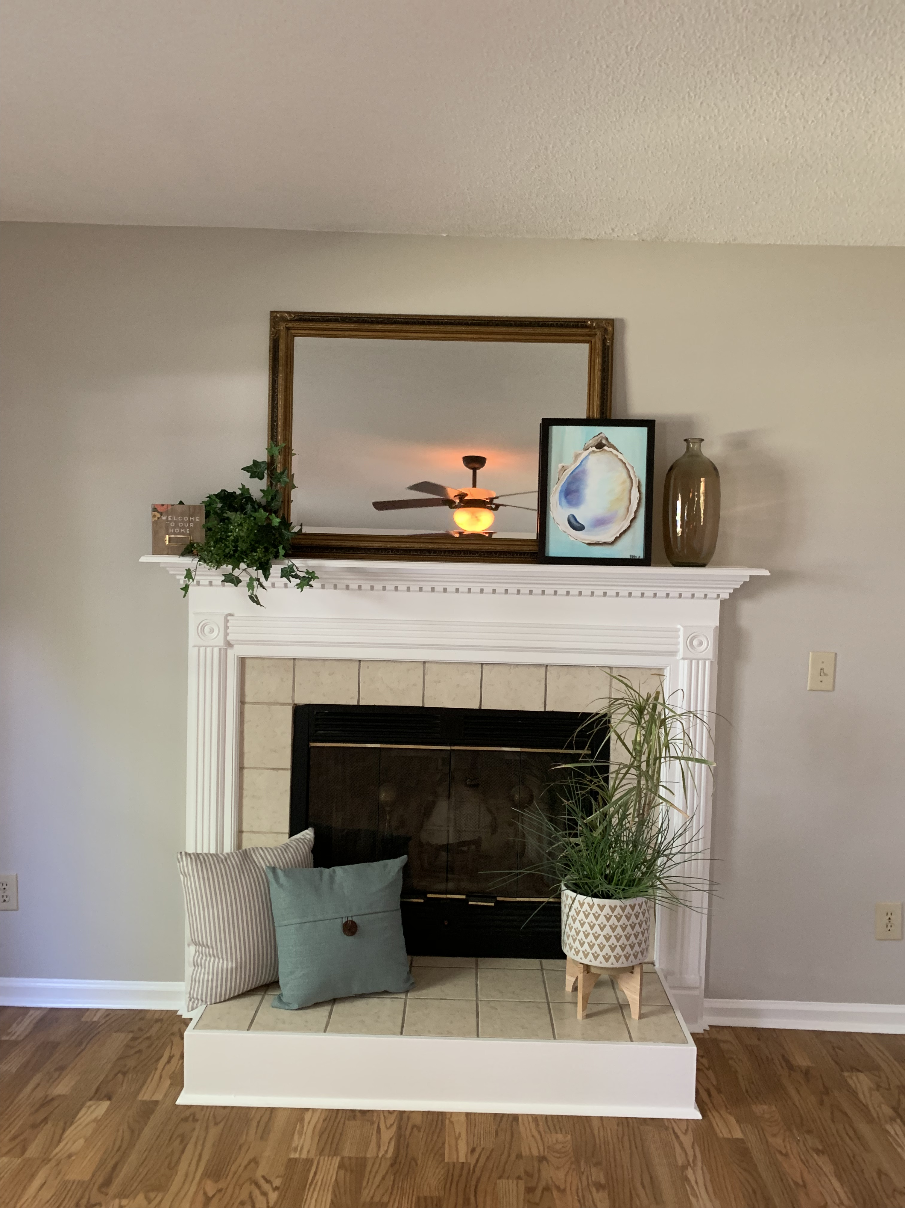
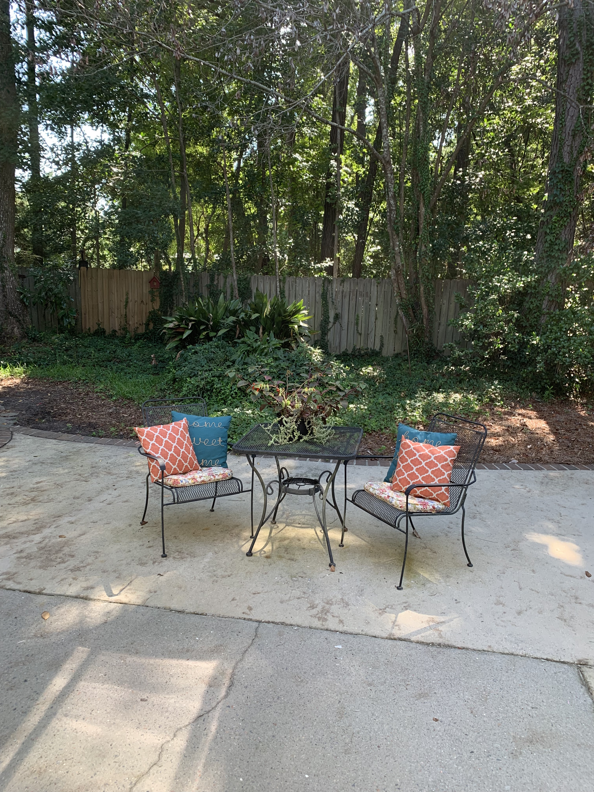
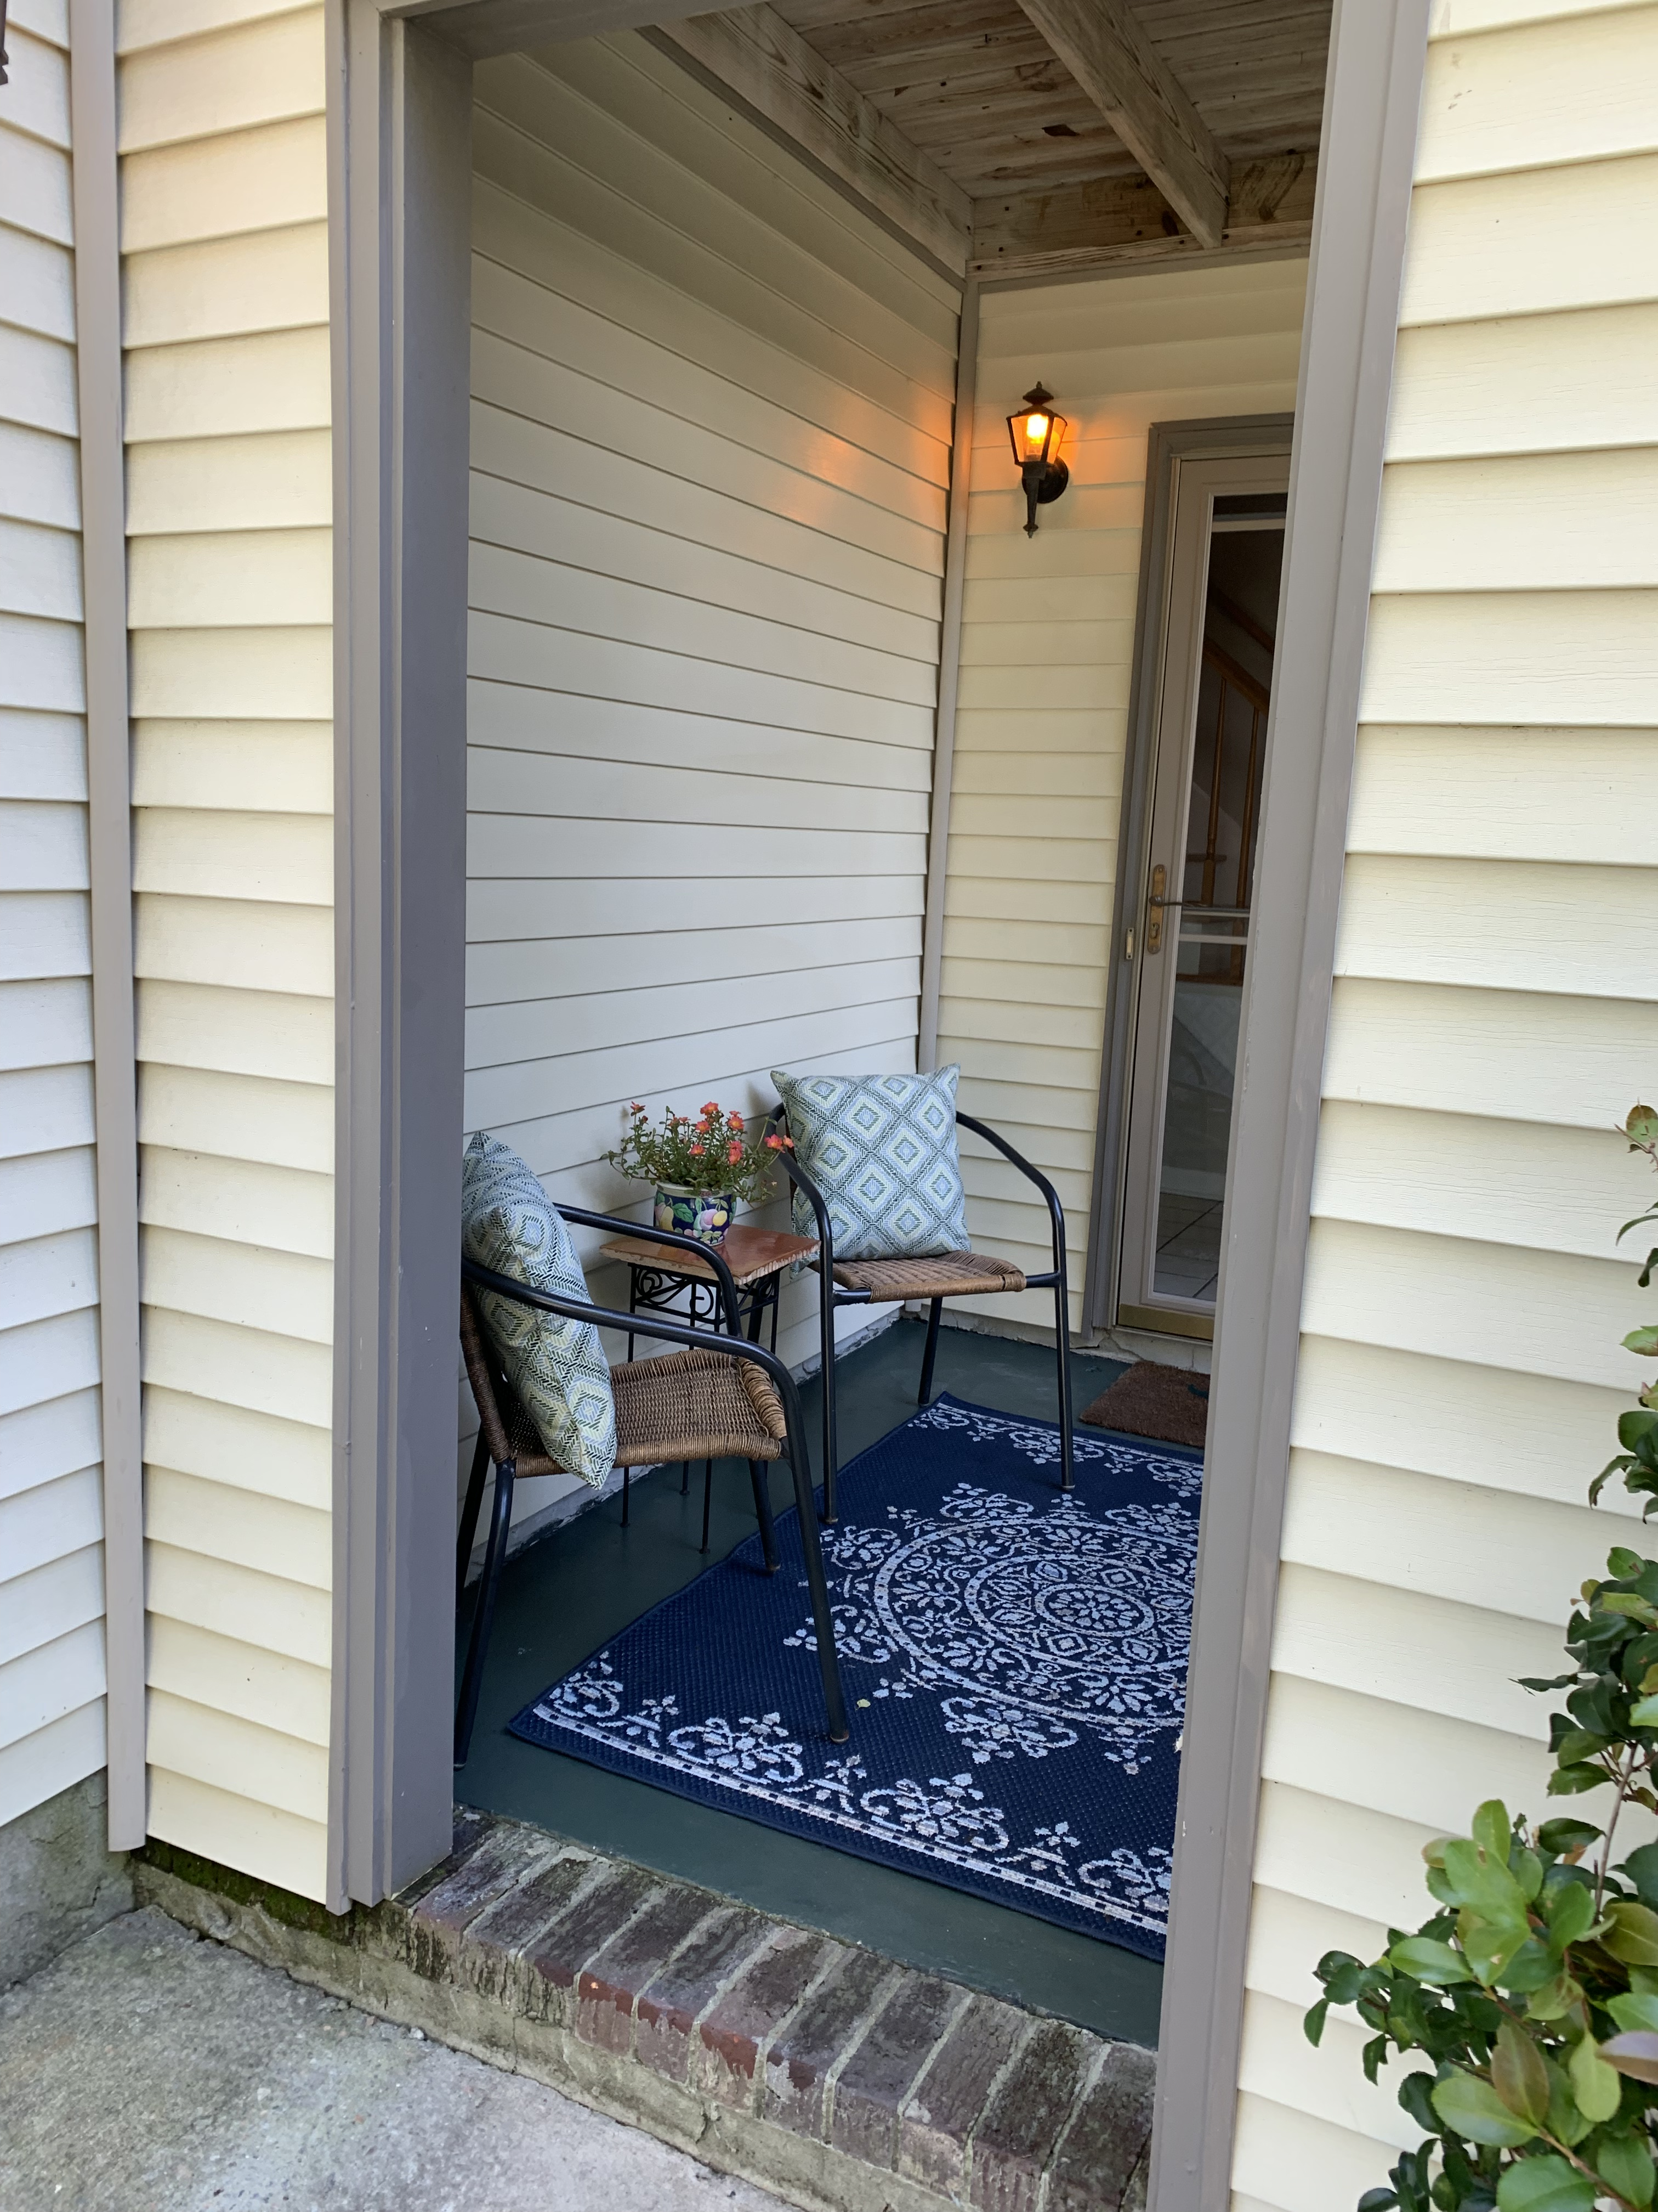
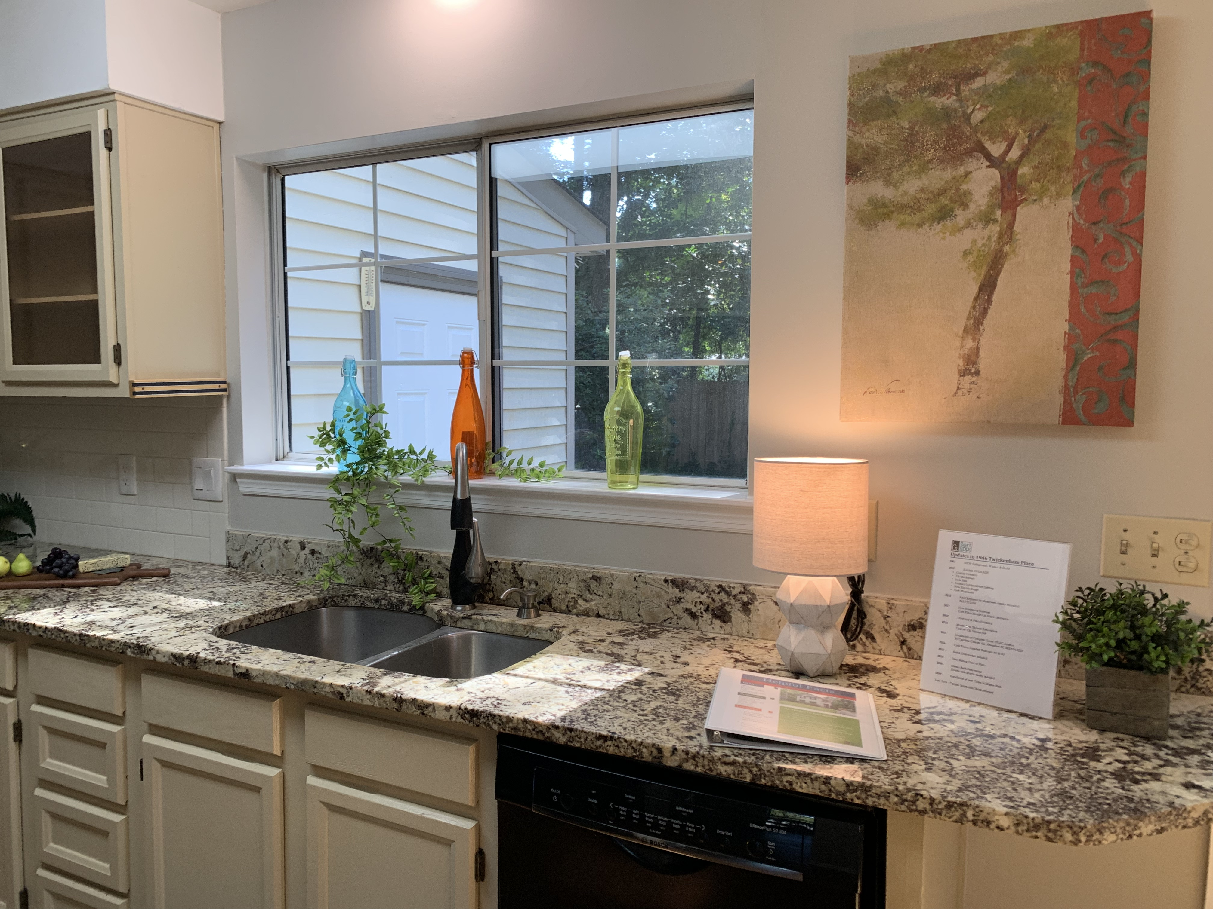



$1800 in Closing Cost Assistance with Use of Preferred Lender.

$339,500
- Charleston Single
- Longpoint Neighborhood
- 3BR/2.5BA
- Fenced Yard
- Granite In Kitchen
- Staged and Vacant
SHOW TODAY!
Fresh Paint Throughout!
Laminate Floors Down
CORK Floors Up
Fenced Yard
HVAC 2016
Roof 2010

1946 Twickenham Place
Geri Lipps 843.810.8398
glipps@carolinaone.com

