




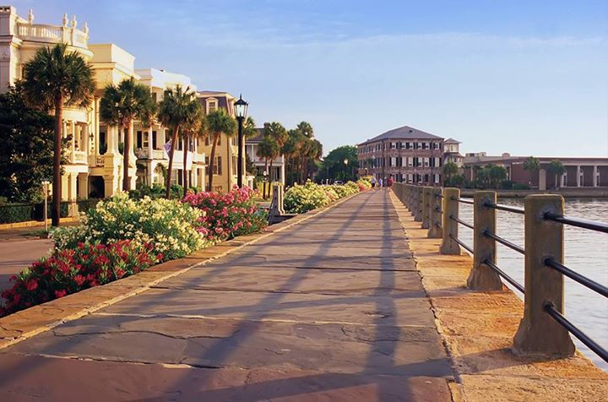
~
1984 Folly Road Unit A213
MLS # 16025099

- 2Bdr / 2 Bath
- 2rd FLOOR UNIT
- ELEVATOR
- ENCLOSED SUNROOM
- CROWN MOLDING THROUGHOUT
- DEEDED COVERED PARKING SPACE

AGENTS PLEASE DO NOT MISS THIS CONDO SO WORTH YOUR CLIENTS TIME AND PRICED TO SELL!

Welcome Home to Pelican Pointe Villas !

WELCOME HOME TO FOLLY LIVING WITHOUT THE FOLLY PRICE TAG!

JUST 2MIN TO FOLLY BEACH and THE ATLANTIC OCEAN ! ~ AND 15 MIN TO HISTORIC CHARLESTON SC! ~ ESCAPE IN THE RESORT STYLE POOL OR TAKE A BREAK & GRILL A BURGER UNDER THE COVERED CABANA.

GREAT LAYOUT ! 2 BEDROOM PLAN ~ PERFECT FOR GUESTS OR A ROOMMATE.

CONVENIENT COVERED PARKING SPACE DEEDED WITH THIS UNIT ! ELEVATORS MAKE ACCESS EASY.

Offered at $209,000
FACTS & FEATURES

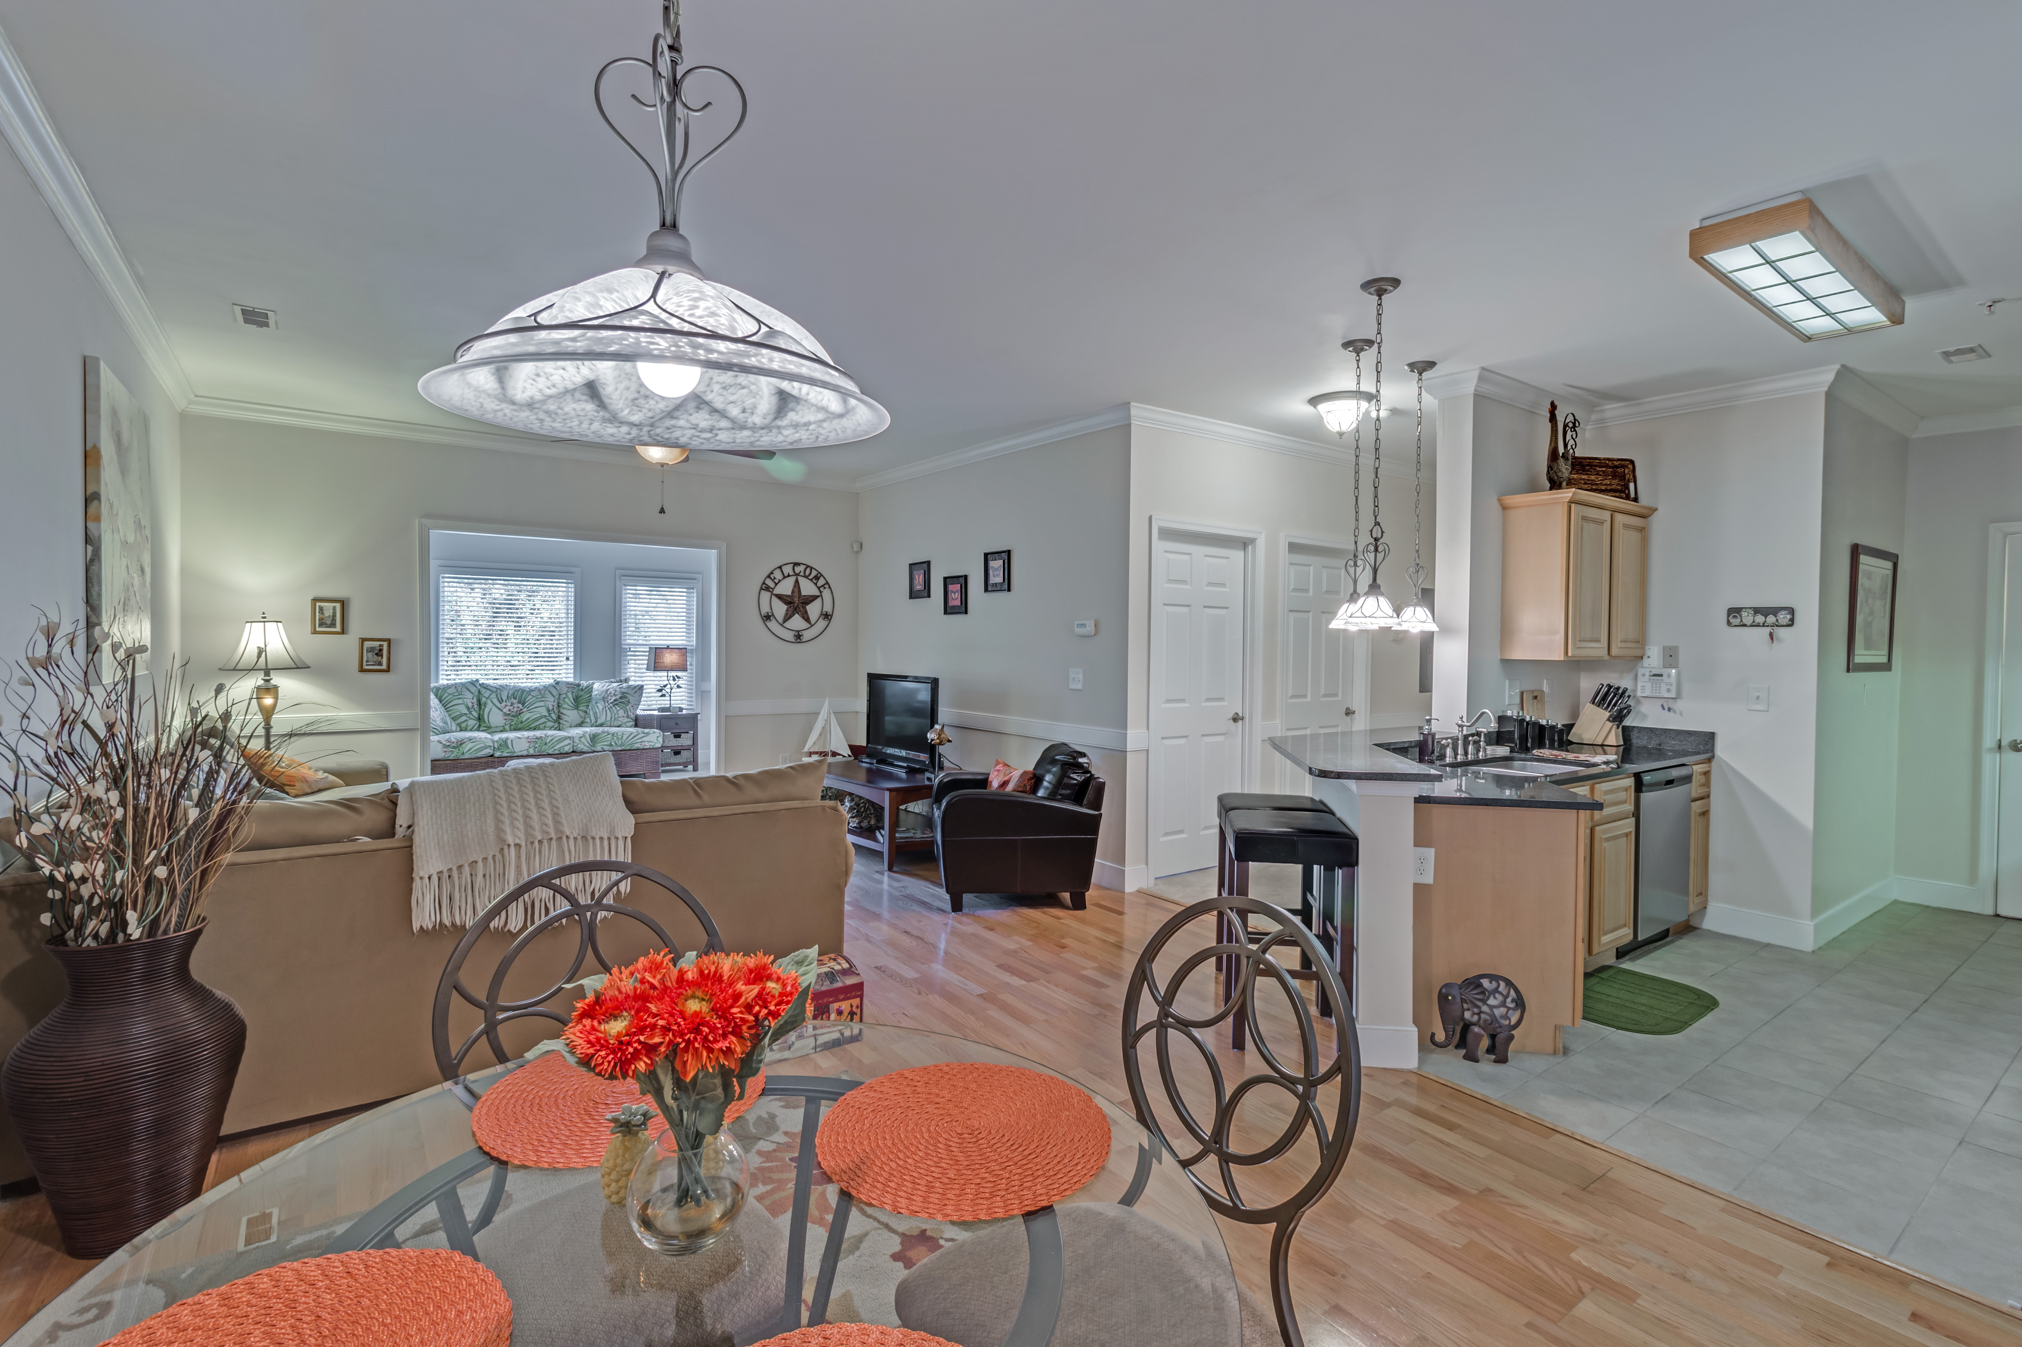
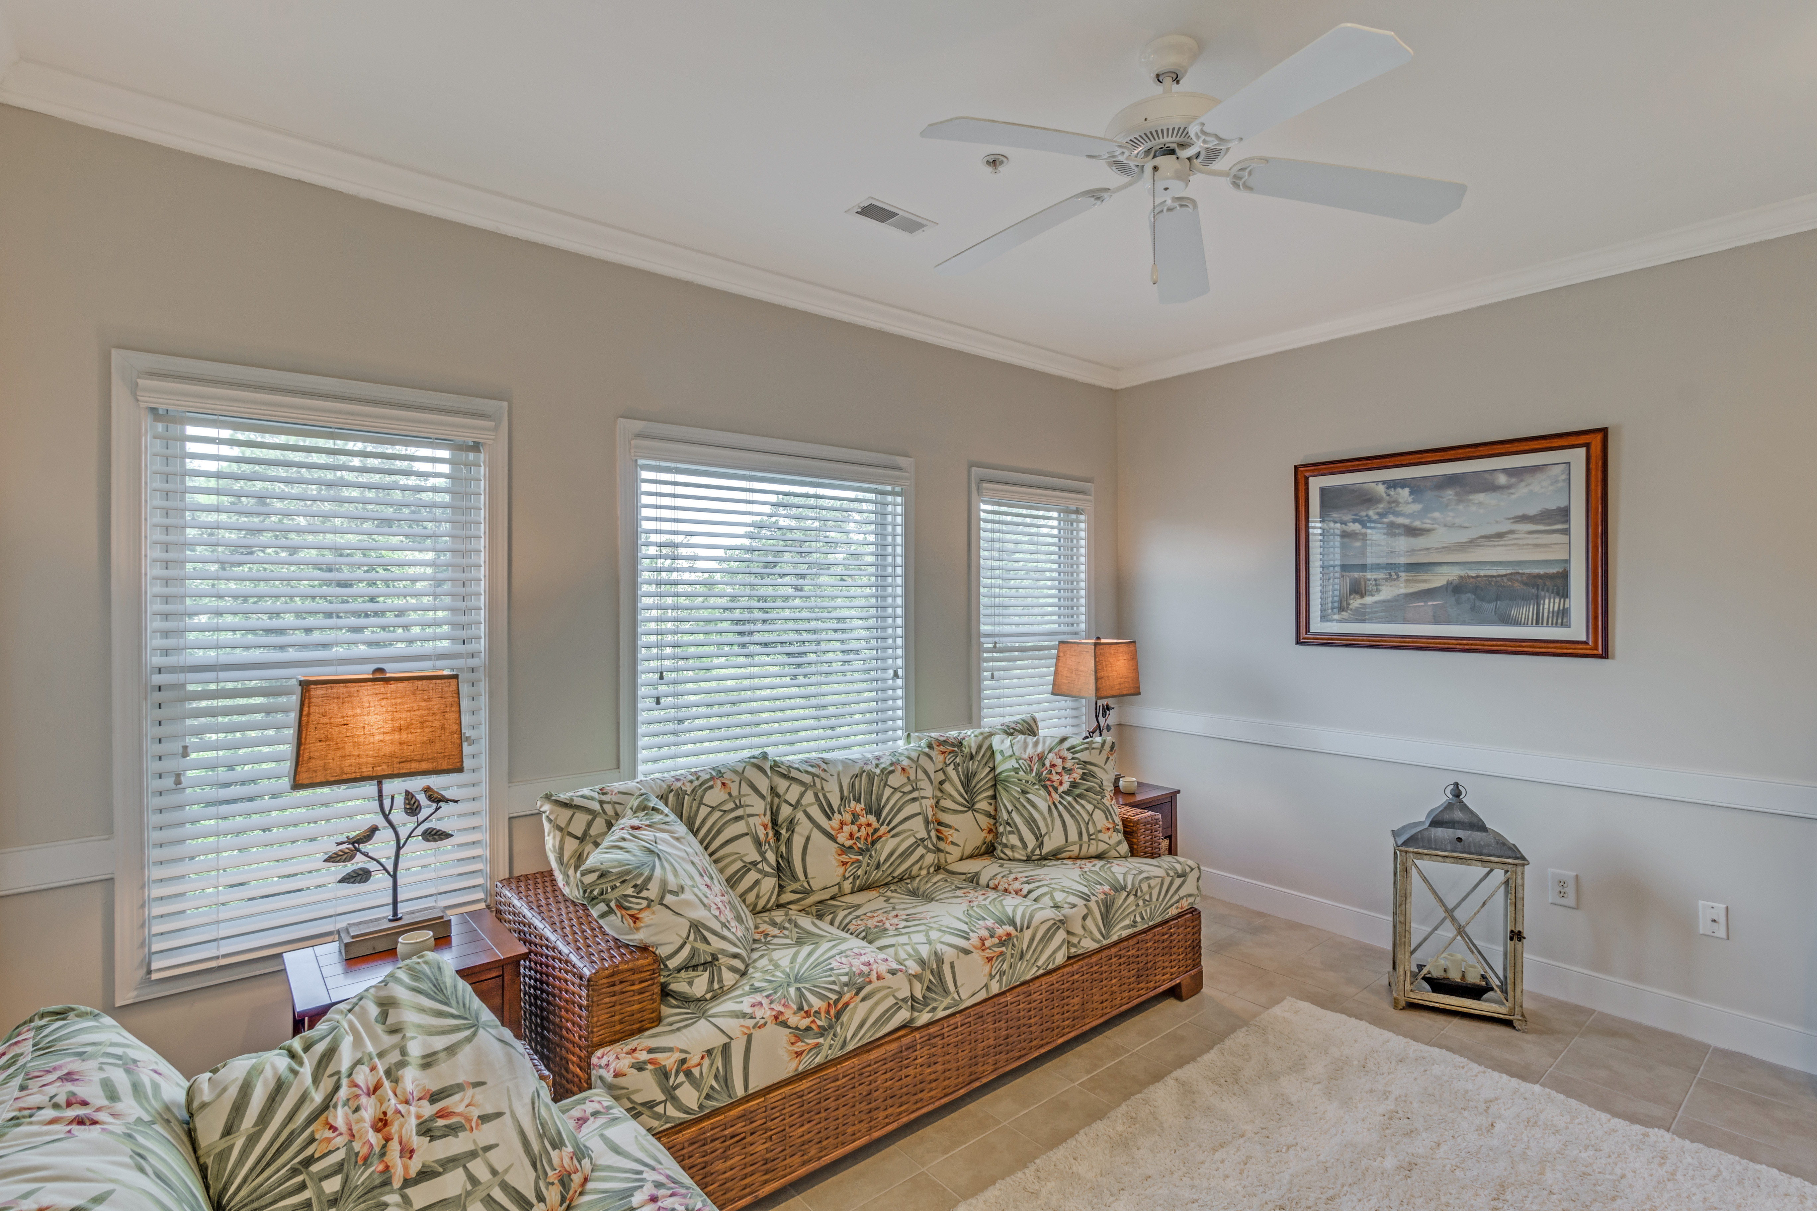
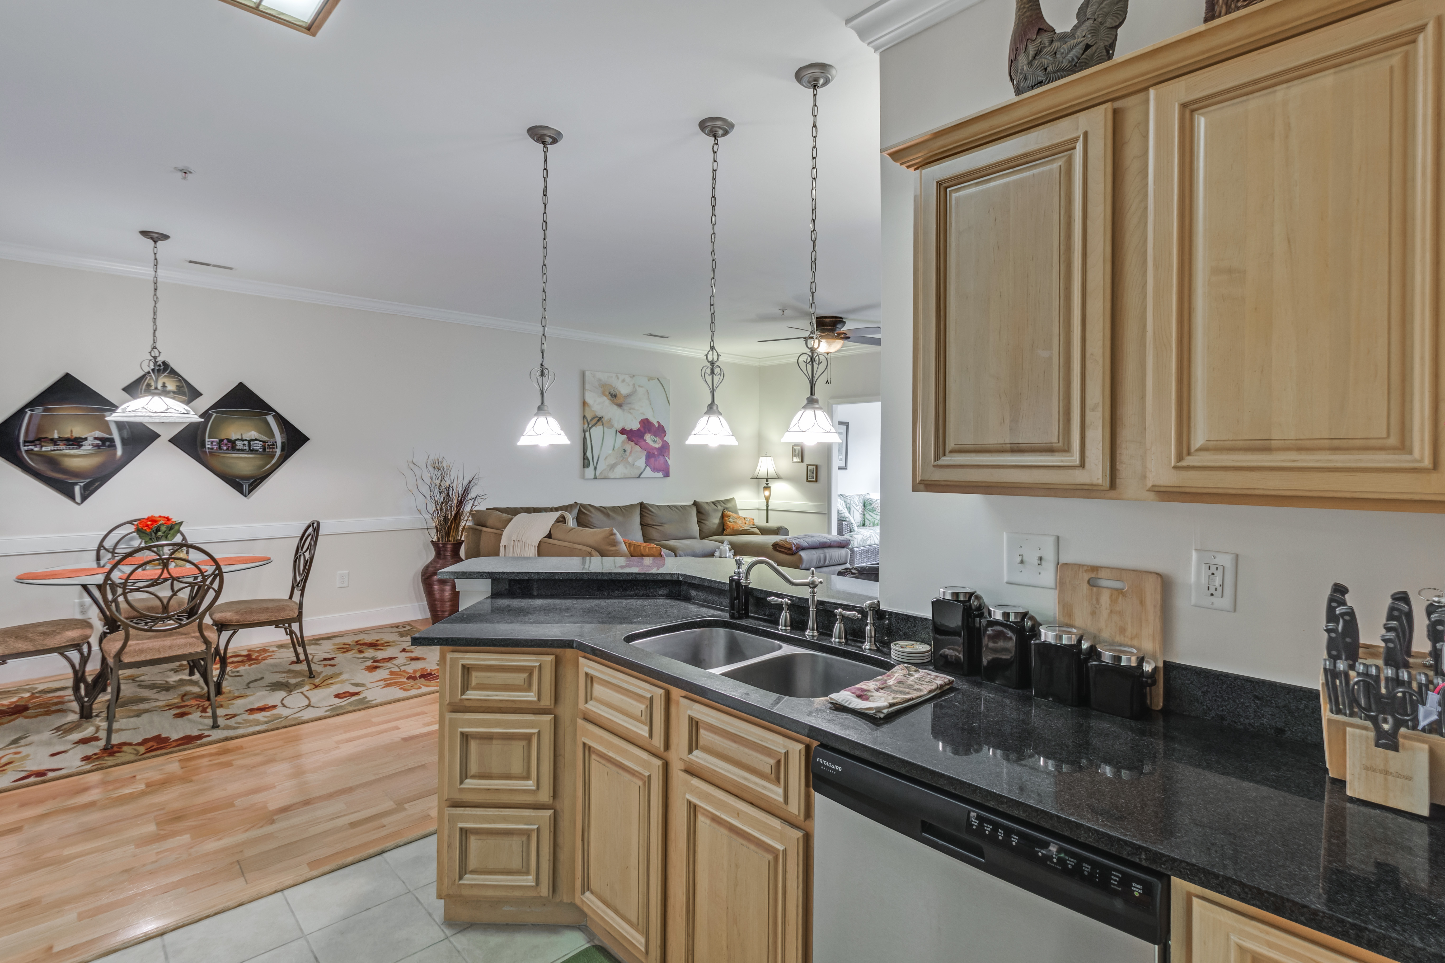
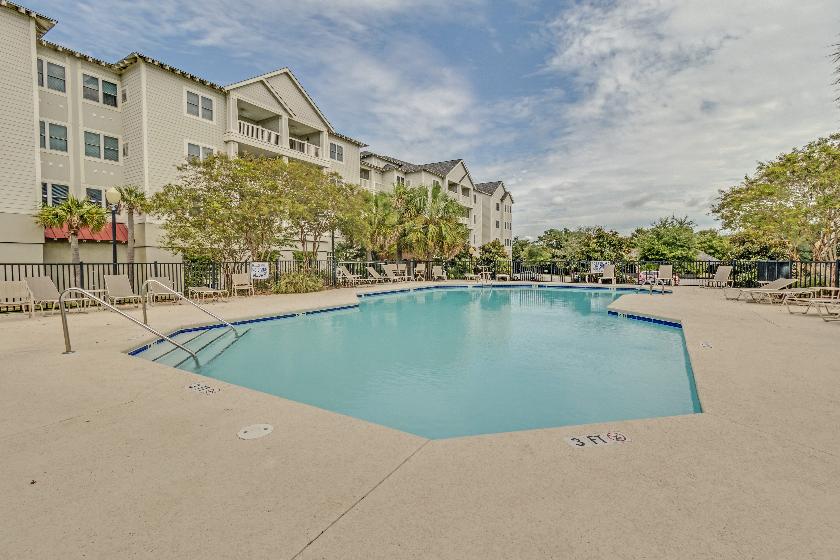
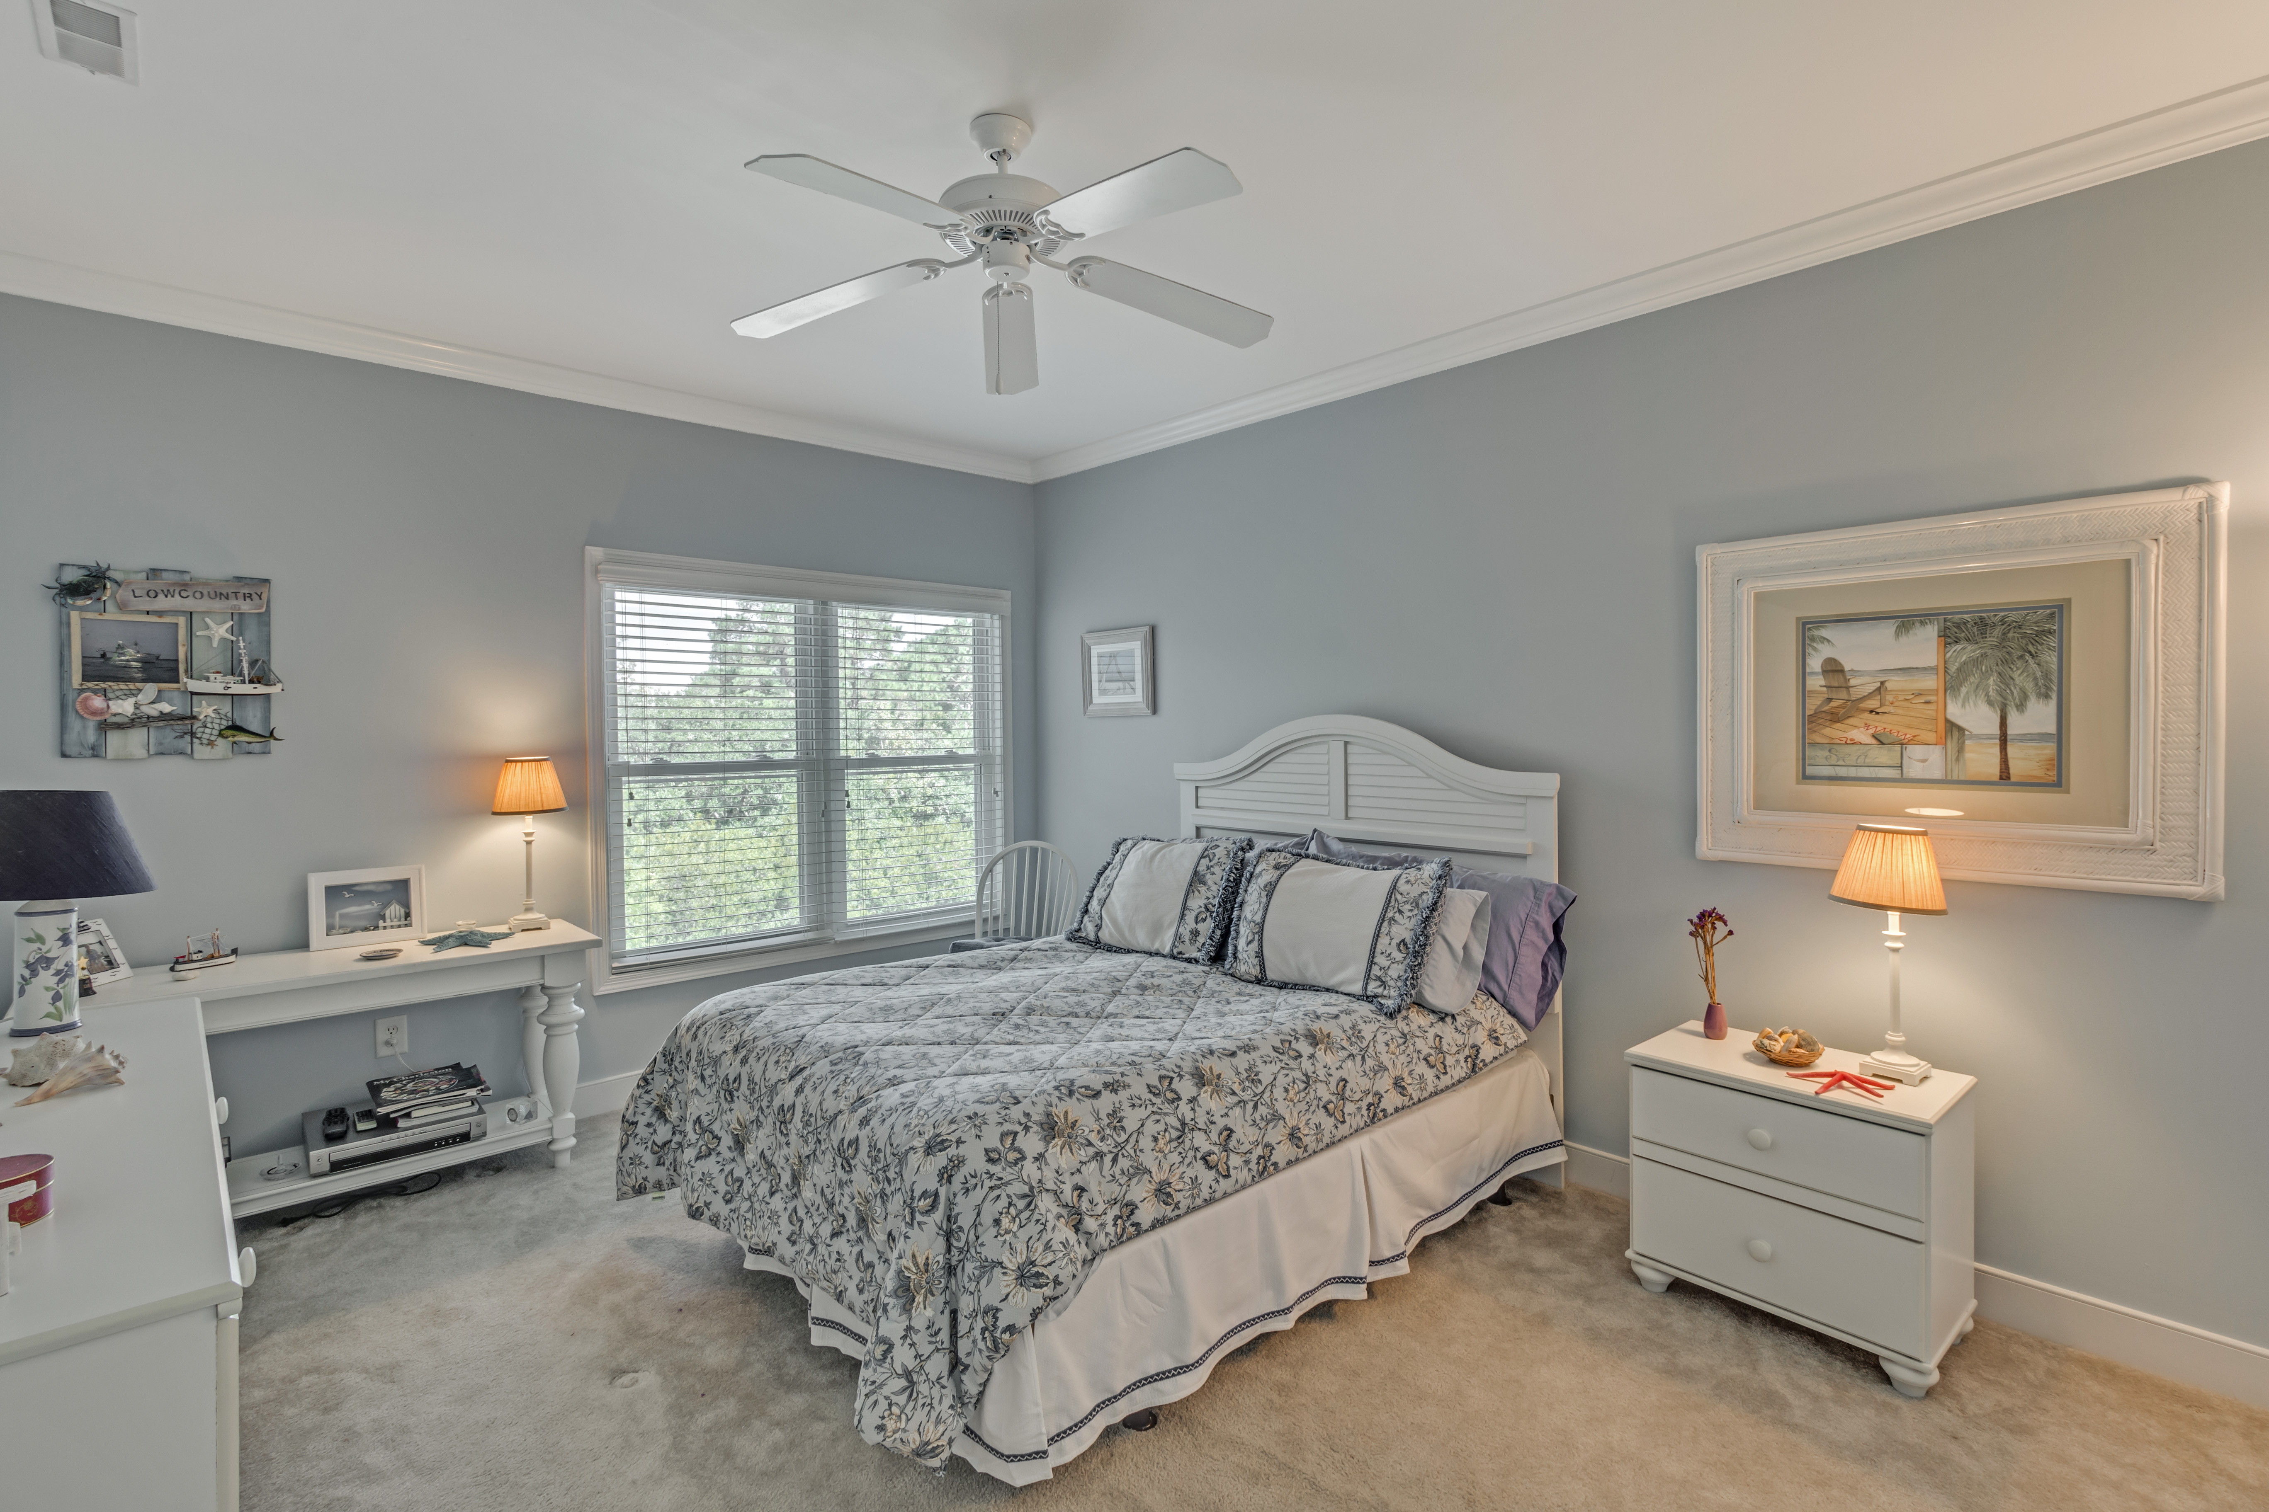
“Charleston is your forever love. It is a perfect blend of character and class. There is always something, but not too much. It is playful and it romances you.”
– Rebekah Phillips
Heather Lord
Broker Associate GRI, e-PRO, RSPS
Keller Williams Realty Charleston
www.heatherlord.com
heather@heatherlord.com
Phone: 843.810.9414

