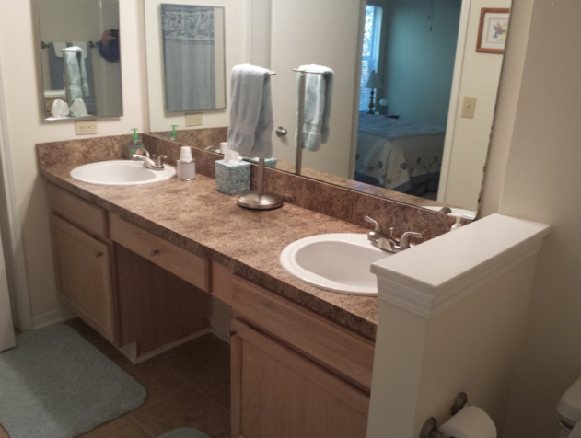
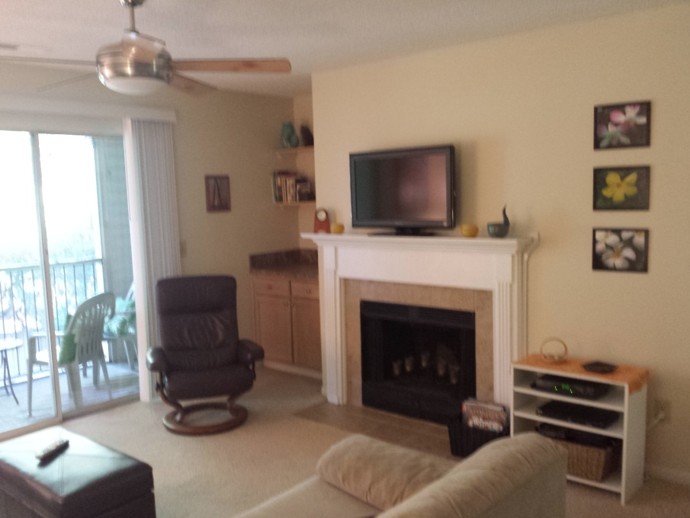
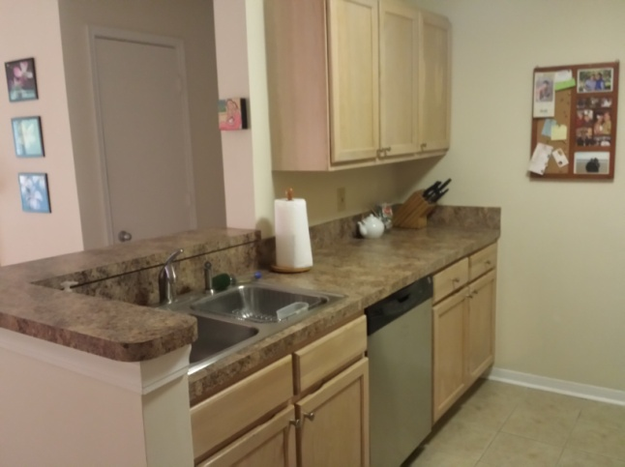
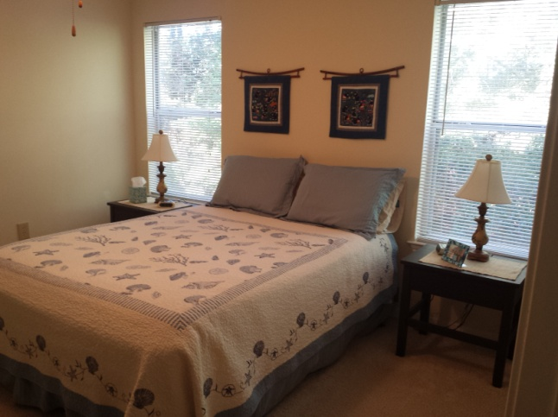

Mt Pleasant
Under 160K
Community Includes
Clubhouse
Pool,
Tennis
Basketball
Sand Volleyball
Play Area,
Fitness Center
On-Site Laundry Facilities
2 Beds - 2 Baths

- Excellent Location
- Well Cared For
- New Air Handler (2009)
- Nice Size Master Bedroom
- Spacious 2nd Bedroom
- Kitchen and Bathroom Tiled
- Fireplace

:

Bob Hood
843-813-8108
bhood@carolinaone.com
Www.lowcountrybest.com
195 W Coleman Blvd
Mt Pleasant, SC 29464

2011 Hwy 17 N 2200H - The Meridian

$159,000

