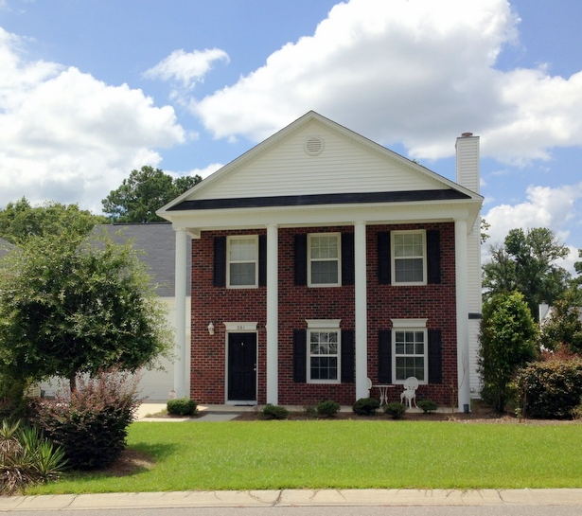
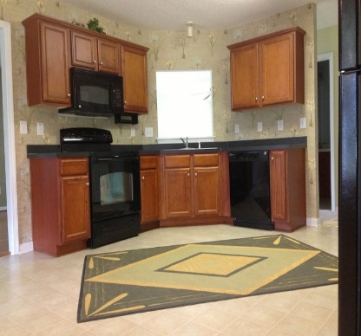
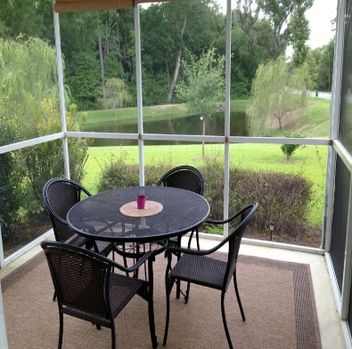
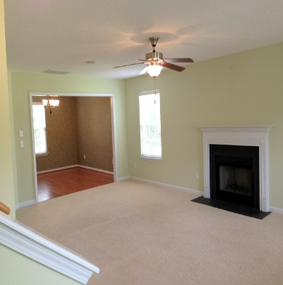

charm
Southern Charm
Southern Charm!
This beautiful Southern home sits on one of the nicest lots in the neighborhood. It is located on a cul-de-sac with woods for privacy, and a scenic pond in back for your viewing pleasure. Not only does it have an incredible lot but the home itself was built to be the model home for the neighborhood and has tons of upgrades.
$205,000

Bric

Brickhope Greens

Single Family Property
Year Built: 2007
4 Bedrooms
2.5 Baths
Approx. 2,344 sq. ft.
New HVAC
2 Car Garage
Hardwood Floors
Upgraded Carpeting
Recessed Lighting
Ceiling Fans
Fireplace
Custom Drapery
Built-In Sound System
Screened Porch
Sprinkler System
MLS# 1425008

201 Green Oak Ct., Goose Creek, SC 29445
Please call to arrange a private viewing - 843-478-1800
COMPANY
REAL ESTATE
SALE
For

