Back on the Market
205 Essex Dr $209,000
Irongate
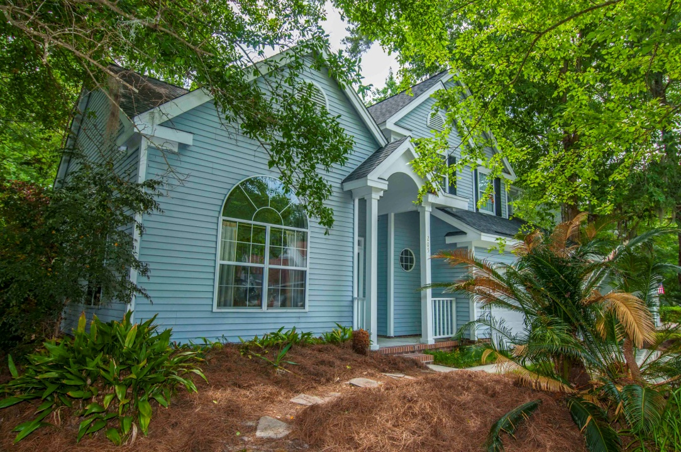
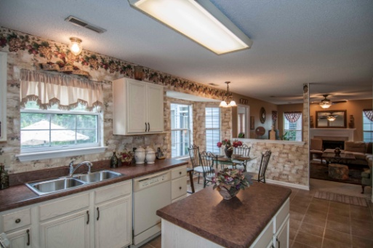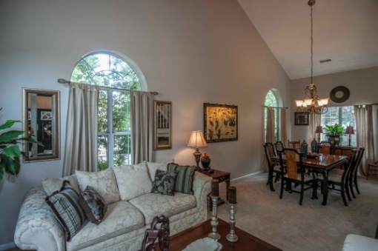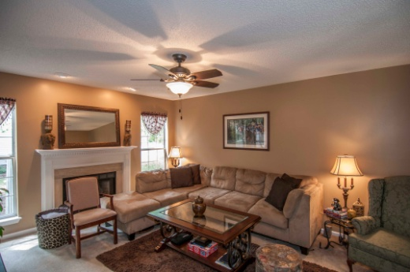

Great Value/SQFT
3 Br/2.5 Baths Aprox 2200 sqft


Bob Hood 843-813-8108
bhood@carolinaone.com
- Established Neighborhood
- Open Floor Plan
- New Roof (2007)
- Good Sized Eat-In Kitchen
- Sunroom
- Nice Size Backyard with Patio for Entertaining
- Large Master Suite with Spacious Master Bath

