




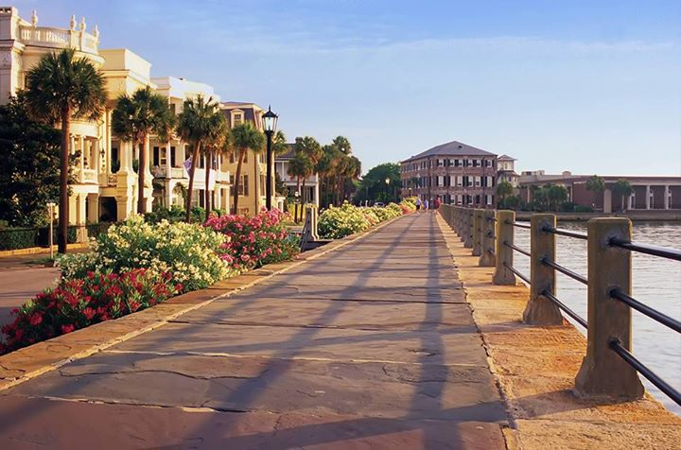
WELCOME HOME TO THIS EXTENSIVELY UPGRADED ~ 2-STORY BRICK FRONT ~ GEM ! LOCATED IN A GOLF COURSE COMMUNITY, THE HAMLETS OFFERS LARGER LOTS – WALKING/BIKING TRAILS, NATURAL SETTING WITH LUSH VEGETATION.

OWNER UPGRADES INCLUDE: SMOOTH CEILINGS, NEW 2015 HVAC INCLUDING DUCTWORK, NEW GARAGE DOOR, NEW CUSTOM FRONT DOOR, GRANITE COUNTER TOPS, TILE BACK SPLASH, FRESHLY PAINTED, NEW CARPET & MORE ….. MOVE IN READY!

CROWFIELD PLANTATION IS CONVENIENTLY LOCATED LESS THAN 3 MILES TO I-26 – MINUTES TO NAVAL WEAPONS STATION, AMENITIES OFFERED INCLUDE GOLF MEMBERSHIP, POOL, CLUBHOUSE, TENNIS MEMBERSHIPS.

206 Hamlet Circle
MLS # 15021165
Offered at $276,900

- 4Bdr / 2.5 Ba 2- STORY
- HUGE .37 ACRE CORNER LOT
- UPGRADES GALORE
- HOA Fee: $380 / Year

- WOODED PRIVACY
- SCREENED , TILED BACK PORCH
- CROWFIELD PLANTATION AMENITIES

AGENTS PLEASE DO NOT MISS THIS HOME WORTH YOUR CLIENTS TIME AND PRICED TO SELL!

FACTS & FEATURES

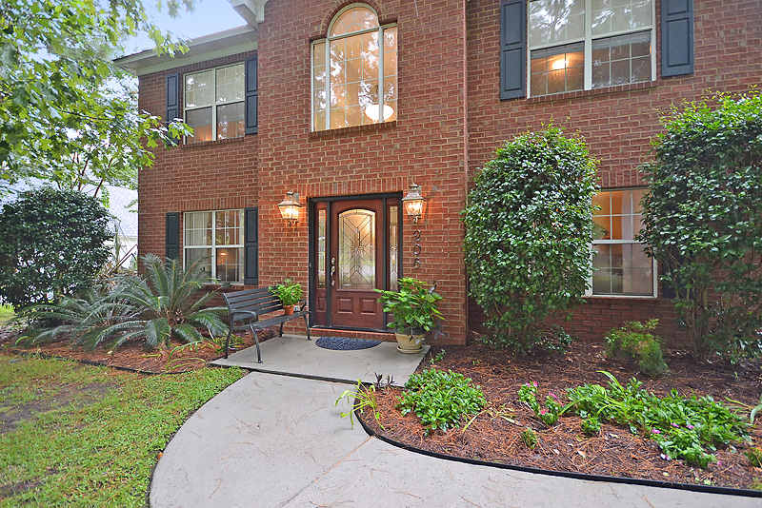
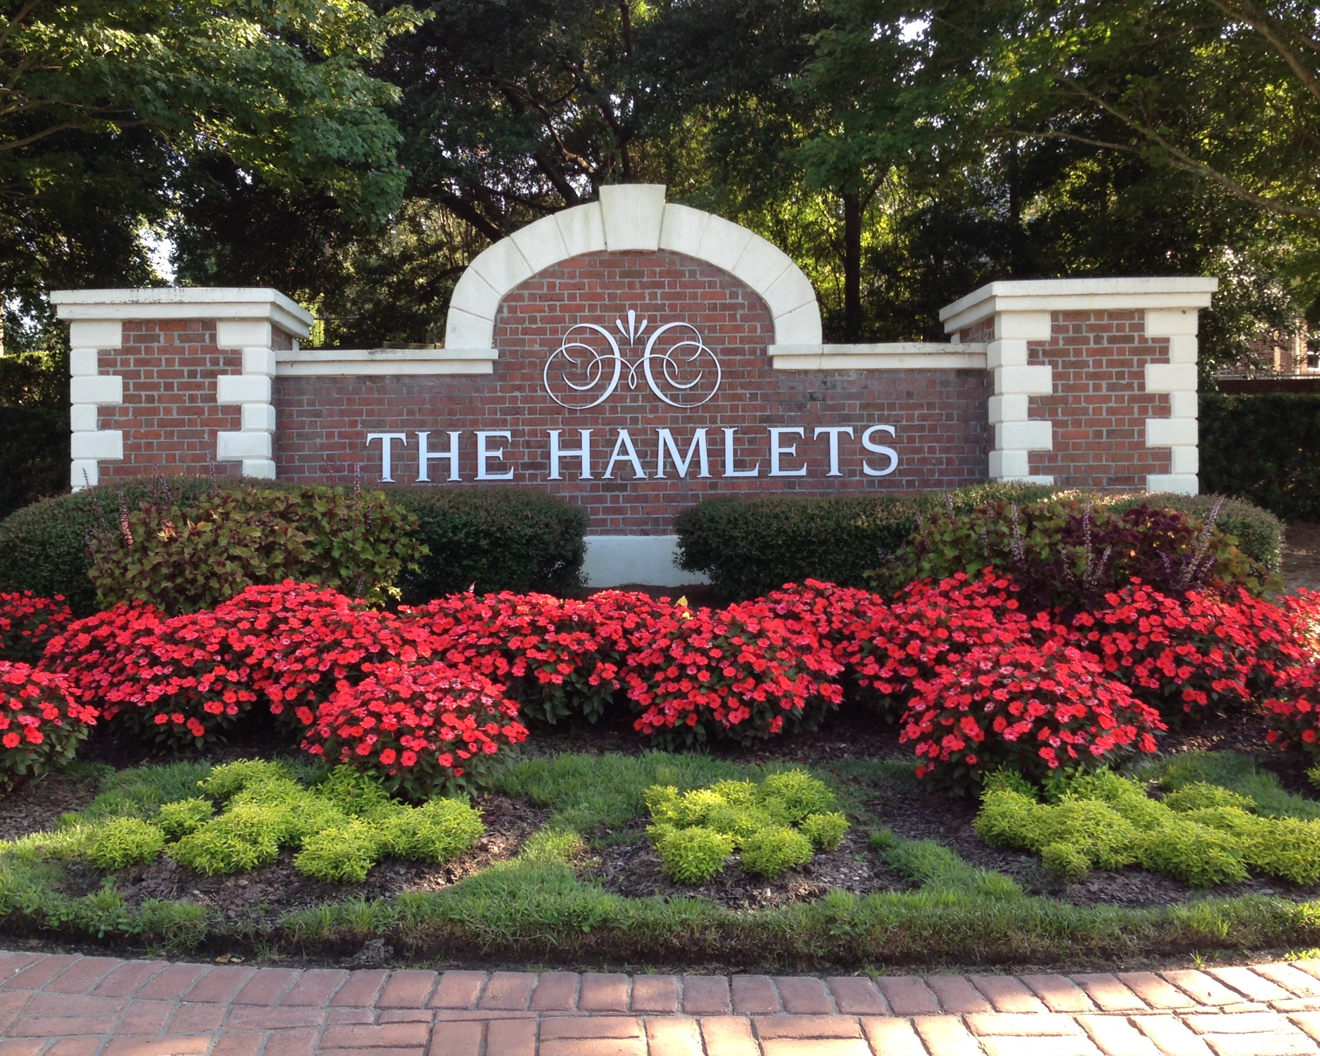
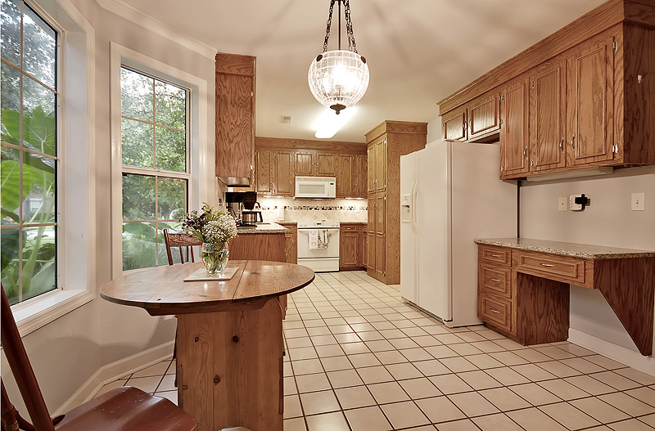
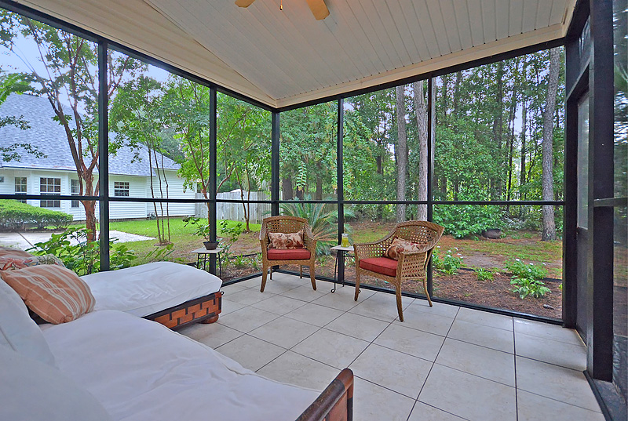
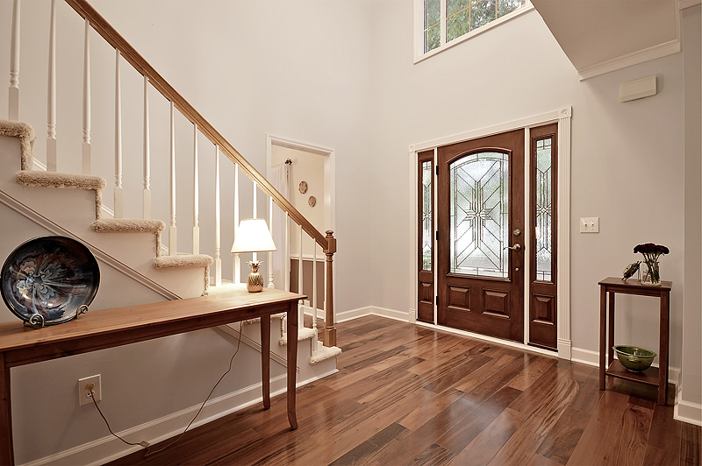
Welcome Home to The Hamlets in Gorgeous Crowfield Plantation
“Charleston is your forever love. It is a perfect blend of character and class. There is always something, but not too much. It is playful and it romances you.”
– Rebekah Phillips
Heather Lord
Broker Associate GRI, e-PRO, RSPS
Keller Williams Realty Charleston
www.heatherlord.com
heather@heatherlord.com
Phone: 843.810.9414

