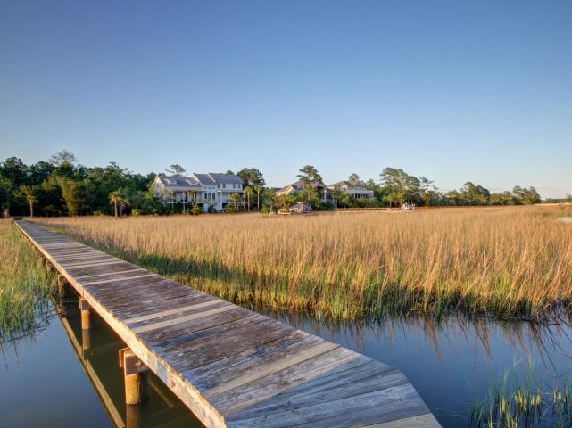

Geri Lipps Carolina One Real Estate
843.810.8398 glipps@carolinaone.com
CarolinaOne Real Estate

Private Cul-de-Sac of Only Two Homeowners.

Beautiful Cleared Lot surrounded by

Protected Wetlands, The Marsh, A Private Pond & Tidal Creek

Sellers have house plans in hand for 3000-5000 SF Home

Enjoy West Facing Views of the Wando River.

Dock and Boat Lift in Place

$515,000

Stunning Marsh and River View Lot in Rivertowne
[Street Address]
[Date and Time]

Build Your Dream Home Today

