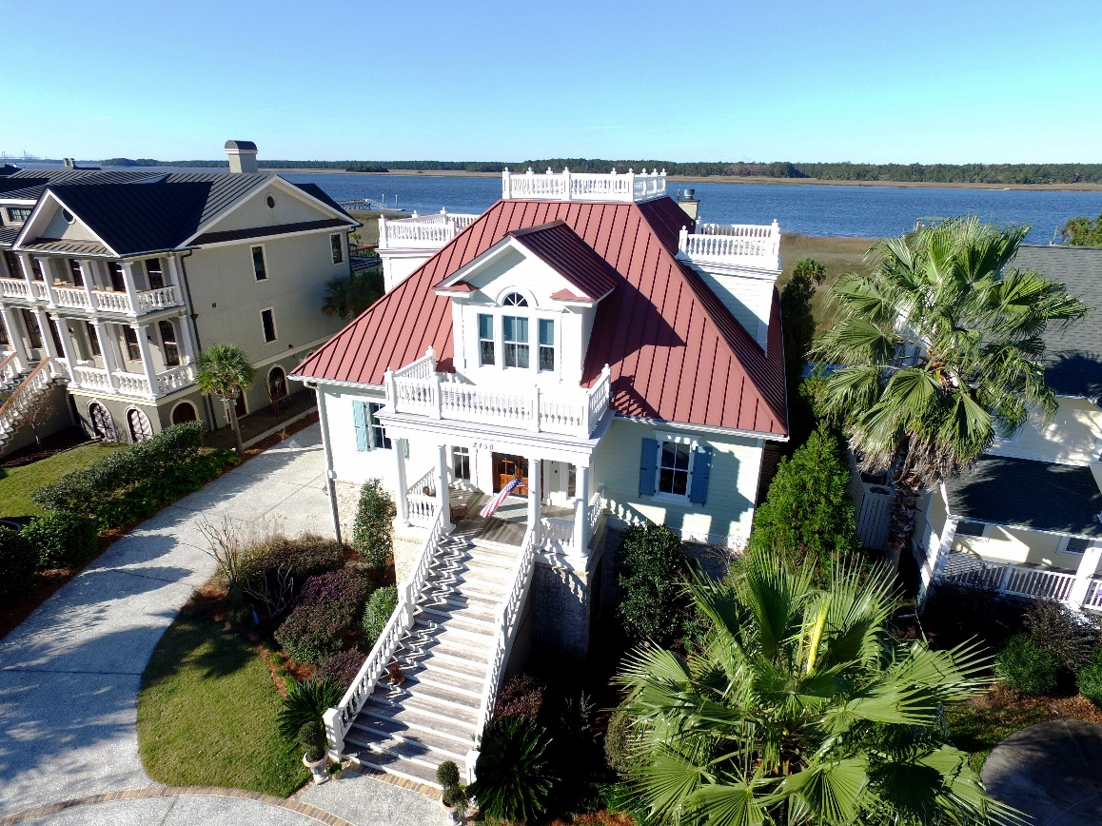
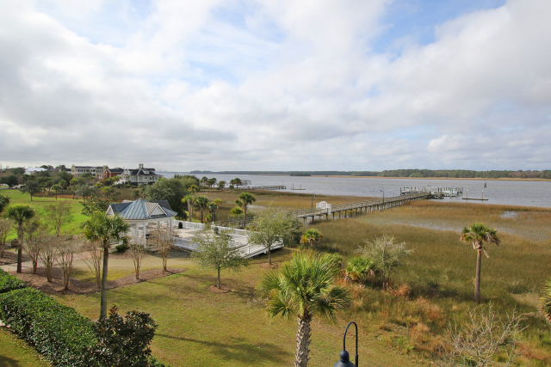
2150 Cheswick Lane in Mount Pleasant is luxurious Lowcountry Living at its best! Located on deep water, with a boat slip and dock on the Wando River, you are engulfed in breathtaking views of the river! Entertain with panache as friends gather around the oversized island with rare Brazilian granite to watch the chef of the household create your feast. Equipped with high-end appliances, this gourmet Kitchen offers the ultimate in beauty and function. Enjoy dinner in the formal Dining Area. Relax in the Great Room or Keeping Room with panoramic views in front of the 2-way fireplace. The downstairs Master Suite is a dream, with beautiful views, a Master Bath with large Walk-In Shower, Shiatsu Massage Tub, and custom his and hers vanities. The Second Floor boasts a second Master Suite with Den, Walk-In Closet, and private Balcony. There are so many special features, such as the elevator that takes you from the Garage to the Second Floor, Hot Tub on the Second Floor Porch, and the Exercise Room with Half Bath on the Lower Level.

